Interviewing Manual for the Housing and Population Census
  - General instructions and Survey Solution CAPI Questionnaire

Version:
Nauru PHC
2021
DRAFT

Table of contents

Table of contents 2
Chapter 1 General information 5
1.1 Purpose and Objectives of the Census 5
1.2 Your Responsibilities as a Census Representative 5
1.3 Terms and Conditions of Employment 5
1.4 Absence due to illness or accident 6
1.5 The Statistics Act 6
1.6 Extracts from the [RELEVANT PASSAGES OF THE STATISTICS/CENSUS ACT] 7
1.7 Privacy 8
1.8 The Census Date 8
1.9 Your Role in the Program 8
Chapter 2 Preparations for enumeration 9
2.1 Census Enumeration Teams 9
2.2 Preparations Before You Begin Enumeration 9
2.3 Ensuring Quality Work 10
2.4 What is an Enumeration Area? 10
2.5 What is an Enumeration Area Number (EAN)? 10
Chapter 3 Dwellings and households 11
3.1 Dwellings 11
3.2 Defining Household: 11
3.3 Defining Head of household: 12
3.4 Household Situations: 12
3.5 The Purpose of the Enumeration Area maps 12
Chapter 4 Conducting enumeration 13
4.1 Initial Preparations 13
4.2 Your Responsibilities during Enumeration 13
4.3 Relationship with the Respondents 13
4.4 Respondents’ Rights and Privacy 13
4.5 Conducting the Interview 14
4.6 Arriving at a Household. 15
4.7 Before Leaving the Household. 16
Chapter 5 Institutions 16
5.1 Defining an Institution 16
Chapter 6 Definitions 16
Chapter 7 Interviewing 18
7. 1 Introduction 18
7.1.1 Data collection using tablets 18
7.1.2 Logging in to the tablet 19
7.2 The Census Questionnaire: Cover section 21
7.2.1 Question C1 21
7.2.2 Location: 1a-1b 22
7.2.3 Dwelling type: 1c-1f 23
7.3 R. Household roster 24
7.3.1 R1 - Persons: 24
7.3.2 R2-R4 – Roster composition 25
7.4 Navigating the questionnaire 28
7.5 C. Population Characteristics 29
7.5.1 C1-C3. Identity and nationality 29
7.5.2 C4. Marital status 32
7.5.3 C5. Faith, religion 33
7.5.4 C6. Residence 33
7.6 D. Functioning Challenges 35
7.6.1 D1-D6. Disabilities 35
7.7 E. Education and literacy 39
7.7.1 E1-E4. Education 39
7.7.2 E5-E8. Literacy & language 43
7.8 F. Economic activities last week 44
7.8.1 F1-F5. Labour force participation 46
7.8.2 F6. Occupation 50
7.8.3 F7-F9. Workplace characteristics 51
7.9 G. Fertility and Mortality 58
7.9.1 G1-G2 Any children 58
7.9.2 G2a-G4c All children born 59
7.9.3 G5-G6 Last child 60
7.10 H. Communications & Internet 62
7.11 I. Housing and household information 63
7.11.1 Completing the Housing and households section 63
7.11.2 I1-I5 Type of housing 64
7.11.3 I6-I12 Facilities 67
7.11.4 I13. Household goods 71
7.11.5 I15-I16 Source of household income 72
7.11.6 I17 Climate Change and Environment 75
7.11.7 I20 Household members no longer living in the household 78
7.12 J. Agriculture and Fishing 80
7.13 K. Food Insecurity Experience Scale 81
7.14 Manual Household location + Photo 85

Chapter 1 General information

1.1 Purpose and Objectives of the Census

A national population census may be thought of as a “stock-taking” of the whole country, particularly of its most precious resource, its people. Statistically it is the most important activity that a country ever undertakes. A great national effort is required to complete a census successfully. Much time, energy and money must be devoted to it. For this reason, it is most important that all persons involved in the census devote their best efforts to the success of the census project. Only a well taken, complete and accurate census meets the national need for essential information about the population that can then support policies that address the needs of the people precisely. The biggest challenge in doing a Census is the capturing of GOOD QUALITY statistics – information which are reliable and timely.

Population census is not just a count of people but has extended to collecting rich information on the structure of the population, the number of males, females and their ages, along with a variety of other characteristics related to their civil, social and economic status, and childbirths. This information is used, with statistical techniques to estimate the forces that change the population, such as fertility and mortality. Besides data on persons, data on housing stock is collected, as well as information about the livelihoods of the persons and households. The questions asked in the Census Questionnaire have been carefully researched and developed, all are necessary and essential and all must be answered carefully and completely.

Successful planning for the future of the people of Nauru relies on information collected in censuses; the needs of children for education, of young adults for worthwhile employment and of older people for health provision are all related to the availability of accurate information on the numbers and characteristics of these groups.

The census collects and collates information as seen to meet the needs of the Nauru Government policy and decision makers and will be the base for government’s Strategic Framework.

1.2 Your Responsibilities as a Census Representative

As an Enumerator, you have the most important role in the success of the Population and Housing Census of 2021. The people of Nauru and the Nauru Government are relying on you to perform as conscientiously, accurately, efficiently and honestly as you are able. No census has ever been successful without the devotion to duty and hard work of its Enumerators. You will be trained on how to do your work and it is important that you make sure that you know how to do it properly. It is essential that every citizen be counted and counted only once.

1.3 Terms and Conditions of Employment

You are employed to carry out the census work for 2021 under the terms and conditions of employment as specified in the requirement by the 1992 Statistics Act, sections 10. Arrangements were made between Nauru Bureau of Statistics regarding your temporary employment for the purpose of the census and by the power conferred to the Government Statistician under the Census Regulation as seen as necessary for the efficient discharge of the census fieldwork.

1.4 Absence due to illness or accident

You should consult your Census Supervisor on the occasion if you are ill or not available to carry out or to complete your census tasks. This will inform him/her to seek a replacement or to the possibility that you need help to complete your census assignment as scheduled. You are required to do that well ahead of time.

You have to inform your Census Supervisor on the event of injury or accident on the job, preferably, on the same day. This is necessary in order that the Census Supervisor can ensure you have taken time to seek treatment following an injury or accident. It would help your Census Supervisor in making fall-back arrangements if needed for the completion of your assignment in case of a more serious illness or injury.

1.5 The Statistics Act

The authority for the questions asked on the census of population is provided under the StatisticsAct-31 of 1978 and as detailed on the Census Regulation of 2011.

The Statistics Act assures that all personal information collected on the census will be kept strictly confidential. This is one of the most important responsibilities of your job, and you are required to enforce this all the time during the census enumeration and after. The act prohibits you to disclose any information regarding an individual to any person, business, agency or other department of the government. This forbids you and warns you not to do so, and all returns and forms containing information collected from the census under the act should be safely kept and guarded to prevent any unauthorized access.

he Government Statistician will make arrangements for you to ascertain your participation in an “oath of office” that would verify publicly your complying with the rule of “no disclosure” of the information and data collected in the census and on your pledge to fulfill your census duties.

You should understand the legislation and policies that permits Nauru Bureau of Statistics to treat information collected as confidential and you should be prepared to explain them in brief terms to the respondent. By law, under the Statistics Act, personal information provided by respondents to Nauru Bureau of Statistics of Nauru must remain confidential.

1.6 Extracts from the [RELEVANT PASSAGES OF THE STATISTICS/CENSUS ACT]

[INSERT RELEVANT TERMS NATIONALLY AS YOU SEE FIT, SEE PREVIOUS TONGA EXAMPLE. PART MAY BE OMITTED IF DEEMED IRRELEVANT]

Oath of Office- The Government Statistician and every person employed or deemed to be employed pursuant of the Statistics Act shall before entering upon his/her duties, take and subscribe the following oath or affirmation:

I ………………………….. do solemnly swear (or affirm) that I will faithfully and honestly fulfill my duties as an employee of Nauru Bureau of Statistics in conformity with the requirements of the Statistics Act 1978 and of all rules and instructions thereunder and that I will not without due authority in that behalf disclose or make known any matter or thing that comes to my knowledge by reason of my employment.

Personal information is never released - Except in respect of a prosecution under this Act, any return made to Nauru Bureau of Statistics pursuant to this Act and any copy of the return in the possession of the respondent is privileged and shall not be used as evidence in any proceedings whatever, and no person having made the declaration under Section 7 shall by an order of any Court, tribunal or other body by required testimony in any proceedings whatever to give oral or to produce any return document of record with respect to any information obtained in the course of administration this Act.

Confidentiality of the Information - Subject to this Section and except for the purposes of a prosecution under this Act –
- no persons, other than a person employed or deemed to be employed under this Act, and sworn under Section 7, shall be permitted to examine any identifiable individual return made for the purposes of this Act; and
- no person who has been sworn under Section 7 shall disclose or knowingly cause to be disclosed, by any means, any information obtained under this Act, without the authority of the Minister or the Government Statistician in exercise of their powers under this Act;
- all returns and document containing information obtained under this Act which enable identification of individuals or establishment shall be kept at all times in a manner reasonably calculated to prevent any unauthorized person having access thereto.

Failure to fulfill or false declaration - The Statistics Act makes misrepresentation of information by you as a census staff, or do not fulfill your duties as set out on the “oath of Office” an offence that can result in a fine not exceeding $200, or in imprisonment for up to six months, or both.

Failure to provide information - Section 17 (a), (b) and (c) of the Act warns you as a Census Enumerator that any person who refuses or avoid to answer truthfully or falsely answer any question as a requisite for obtaining any information sought under this act or refuses and neglects to provide information or to fill in the schedule or form to the best of his/her knowledge and belief or provides misleading is guilty of an offence and can be convicted to a fine not exceeding $100 or to imprisonment for up to three months or to both.

1.7 Privacy

The respondent has the right to expect that any information he/she gives you will be kept private. As the census representative, you must respect this right.

1.8 The Census Date

The main objective of the census is to record the people in Nauru at one particular point in time, i.e. the night of 30th of October, 2021 or exactly, the 30th of October before it changes at midnight to 31st of October. All persons alive in Nauru on Census night are to be included. Babies born before midnight on 30th of October are to be included, and persons who die before midnight on Census night are to be excluded. It is impossible for an Enumerator to visit all households on Census Night, and certainly not just before midnight, so enumeration must spread over a longer period. However, the aim should be to record the population as if, suddenly, at midnight on Census Day, everything came to a complete stop and the population stood still ready to be counted. In reality you should not be disturbing people this late at night.

1.9 Your Role in the Program

As a Census Enumerator, we’re counting on you to enumerate all residents of Nauru. You with your colleagues are the Nauru Bureau of Statistics’ direct link to the many thousands of households all over the country. You are THE MAIN PLAYER, and the fundamental contributor in the census.

You are placed in a team to carry out your census fieldwork. Your team comprises of 5 to 7 fellow Census Enumerator and under the supervision of 1 CS. All Census Enumerator and Census Supervisor are placed under the Statistical Officials and you must keep them advised on problems as well as things that are working well during your census fieldwork.

You should be aware of the following and must take precautions:

- Be aware of the public’s attitude towards the census and of any negative media coverage in your area. Notify your Census Supervisor immediately if you encounter any negative publicity that casts Nauru Bureau of Statistics or the census in an unfavourable light.

- Notify your Census Supervisor if you are asked to speak to community organizations. During the census period, community groups or organizations may request that you talk to them in a meeting or such smaller groups. You should contact your Census Supervisor who will make the necessary arrangements.

- Refer media people and interested groups to the Statistics Office. Whenever you receive a media request, or other requests concerning the importance of the census, you should refer it immediately to the Statistics Office. They are responsible for making official statements on the census to reporters and to any political and religious groups and interested parties. You are not allowed to make any statement about the census to media people, politicians and religious groups. Your duty is mainly to collect data and information from the households of Nauru.

- Do not make any commitment on behalf of Nauru Bureau of Statistics for any promotional materials including advertising on radio, television and in newspapers.

- Never, under any circumstance, solicit any product, service, business opportunity, political view or religious belief or any ideology while you are visiting households, this is strictly forbidden and will cause immediate termination and penalties.

- Keep tablets secure at all times. Make sure that the places where you keep the tablets are always secure and locked and they are kept out of sight. Never leave any census information, especially the tablets, in a public place.

Chapter 2 Preparations for enumeration

2.1 Census Enumeration Teams

Since we are using tablets for the first time for data collection, some field processes have changed compared to the paper-based interview as quality checks and monitoring work are done concurrently with the actual field enumeration. Team composition now will be roughly about 5 Enumerators with one Supervisor and one Headquarters for about three supervisors.

Each enumerator will only be assigned one Enumeration Area to ensure efficiency in the collection and monitoring of the field operations.

2.2 Preparations Before You Begin Enumeration

You must study the relevant topics of this Guide. Ensure you fully understand the questions that need to be asked and what kind of information is needed. This requires practice, communication skills and how well you present yourself while conducting the interview.

You must plan your enumeration route well; Ensure you have the correct maps for the Enumeration Area that you have been assigned to. Study carefully the area, the roads and common landmarks on the map as this will really help in accessing all the houses in your area as well not skipping boundaries and accidentally entering into another Enumeration Area.

Ensure you tablet is fully charged and you have the correct tablet with the correct label. Also check that your internet is working. Each Enumerator will be assigned a username and password to login – please do not forget them and don’t share them with anyone. Make sure you have your ID badge with you and have blue ballpoint pens.

With a working Internet connection, synchronize your application before you start enumeration each day and when you have completed and returned to your base.

2.3 Ensuring Quality Work

The success completion of the census will rely on the quality of your work and your ability to enumerate in your Enumeration Area. You will perform the fundamental role in achieving a high level of quality census work. As quality is very important, your work will be frequently checked to ensure that the expected census standard is achieved. Your Census Officials will perform supervisory checks at each stage of your work and at the completion of your census enumeration.

Your work has to meet the required standards. It will be returned to you with the problem areas identified if your work is not within standards. Such deficiencies may include:

- not completing the expected workload -- questions are found to have no answers and/or are not properly answered -- not enumerating dwellings that are occupied
- not doing your job according to the set census procedures
- not asking the questions exactly as they are written
- not including every person in the household roster e.g. babies, visitors, children, old people, etc
- not including or counting those who are mobile (move around on activities such as fishing or farming the land).
- any other issue flagged by your Census Supervisor finds out and returns to you must be corrected and completed.

2.4 What is an Enumeration Area?

For administrative purposes, Nauru’s geography includes both Districts and Enumeration Areas (EA).

Enumeration Area (EA) For census purpose districts and villages are divided into Enumeration Areas. The Enumeration Area is the basic unit area for census enumeration. An Enumeration Area is usually assigned for a single Census Enumerator to enumerate all households in that Enumeration Area.

You will enumerate on the average 50 to 60 households in a single Enumeration Area with an average population of 250 to 300 persons. There are exceptions where more than one Census Enumerator will enumerate one Enumeration Area or one Census Enumerator enumerating more than one Enumeration Area. You will be informed if you are in that situation and you will be issued instructions and related documents.

2.5 What is an Enumeration Area Number?

Each Enumeration Area is numbered by a unique set of numbers, numbering the Enumeration Area according to its geographic location in a settlement, district, and island division. Every set of questionnaire relates to a household or institution in an Enumeration Area. Each interview will number each questionnaire in use with the Enumeration Area assigned to you and you must issue a household number to each household you will enumerate in an orderly sequence in relation with the provided Enumeration Area map and listing. For each set of census questionnaires the EA is the identifier of a household in the Enumeration Area.

Consequences due to Wrong numbers You must ensure that correct census enumeration area are correctly used. Each questionnaire in use for each household can be identified and correctly linked to its correct geographic location. Wrong identification numbers will cause serious problems as it would not correctly locate and identify the households in your Enumeration Area.

You need to ensure that such mistakes do not arise as it will produce other problems such as double counting, no enumeration and confusion in completion of the census questionnaires delaying work between you and your respondents. Cautionary note: If you are responsible for more than one Enumeration Area, be absolutely sure that every questionnaire in each Enumeration Area has the CORRECT number for that Enumeration Area.

Chapter 3 Dwellings and households

3.1 Dwellings

A dwelling is a set of living quarters, designed or CONVERTED for human habitation, in which a person or group of persons resides or could reside. In principle, all structures (buildings) that look as if they were designed to serve as a residence is a dwelling (even if vacant, or if used for some commercial purpose at the moment – which also counts as vacant in terms of residence, as long as you make sure that nobody usually resides in the dwelling) count as dwellings. In other instances people occupy structures that were not originally built for residential purposes, those structure also count as dwellings. One of the key activities of the enumeration is to establish, within the Enumeration Area, a list of all dwellings, occupied or vacant. Some dwellings are institutions, which is discussed in Chapter 5.

3.2 Defining Household:

For the purpose of this census, a household is defined as “Those persons who usually eat together and share the work of preparing the food and/or the cost of work for providing it”. Normally household members live and sleep in the same building but experience has shown this is not always true, which is why the definition is based on eating together rather than on living or sleeping in the same building.

3.3 Defining Head of household:

The purpose of identifying the head of the household is solely to establish a reference point for all members to show their relationship with the head. The household members themselves need to designate who they consider the person with the primary authority and responsibility for household affairs. In traditional households, where there is a mother, father and children with perhaps other relatives, the person who provides the chief source of economic support for the household is often designated as head.

Due to child rearing and related household and family responsibilities of the mother, this person is usually the father. However, in many households, spouses are treated as equal in household authority and responsibility and may share economic support. In these cases, the household members need to willingly designate one person as the head for reference purposes only and understand that this has no implication of that person being head in the traditional sense.

Be mindful: To reduce errors in population and housing counts, it is very important not to miss hidden dwellings and additional households within identified dwellings. Your work is to identify all group of people who eat separately as a household. Be alert to existing households within existing dwellings and not visible by a house structure (for example cohabiting servants, who do not eat with the family).

3.4 Household Situations:

A household may be found in a variety of forms. It may spread over more than one building. Members of a family may sleep in two or even more buildings but share one place to cook and eat. They should be enumerated as one household.

Two or more households can be found in one building. Two or more families who share the same building but who do not normally prepare food and eat together should be enumerated as two households, e.g. blocks of flats or servants who have their own quarters. Households may be found in buildings intended primarily for other purposes.

A family may live in the back of their shop for instance. Boats tied up to a dock or even pulled up on shore may be permanently lived in and be counted as households. Enumerators should look out for such dwellings and enumerate their occupants as a household if they meet the definition. In doubtful cases, instead of grouping people into one household who should perhaps be separated, it is better to use two households.

3.5 The Purpose of the Enumeration Area maps

The entries you make on the map will be used to:
- update and verify maps for surveys;
- produce maps for the next census; and
- verify households and head of households with the population count.
YOU MUST RETURN YOUR Enumeration Area MAP at the end of your assignment. When your Census Supervisor visits you on the field and checks your work, he/she must review your map with your Enumeration Area listing to ensure that appropriate entries are made, complete and correspond with census mapping instructions.

Chapter 4 Conducting enumeration

4.1 Initial Preparations

Your program should allow for the possibility that you may encounter bad weather or may have other delays that may affect your census fieldwork. If you are in such a situation, please arrange with your Census Supervisor on how best to complete your census fieldwork. In special cases where households are very isolated or are on remote islands, it will be possible to get permission from your Census Supervisors to make only one visit and complete all the forms at one time.

In such cases, you must be quite sure that your enumeration is as close to the situation as it will been the Census Date.

You should always carry your ID badge. That should be shown to the persons you interview when you introduce yourself and before you begin enumeration.

Usually, Census Enumerator and Census Supervisor are appointed to communities which they know well and in which they are well known. Efforts were made to assign Census Enumerator and Census Supervisor to work at the Enumeration Area he/she usually lives. This has great benefits for the accuracy and completeness of the enumeration and usually, the friendly atmosphere in which it is conducted. Occasionally though, past history may make your dealings with an individual or family embarrassing, to you or to them. If you are in such a case, please inform your Census Supervisor at your earliest so that your Census Supervisor could make arrangements for someone else to enumerate that Household.

4.2 Your Responsibilities during Enumeration

The census reference period is the night of 30th of October, 2021. You are allowed 2-3 weeks to complete your Enumeration Area and let your Census Supervisor know you have some difficulties in completing your Enumeration Area within this period.

4.3 Relationship with the Respondents

It is important that the census be conducted in a professional, efficient and friendly atmosphere. Due to the extensive public communications prior to the census day, there should be no doubt in the minds of your respondents about your right to ask the questions specified in the census questionnaire. You should show your ID badge to people you interviewed and they also have the right to see the questionnaires (uncompleted) to make sure that the questions you ask are relevant to the census. Make sure that you have studied the Questionnaire Manual prior to asking the questions and be certain that you refer back to the manual when you are not clear on a question.

4.4 Respondents’ Rights and Privacy

You must only ask from respondents, questions as required on the prescribed census forms. You have to respect the privacy of the respondents and try not to argue with them. You should also try to respect the privacy of the household as a whole.

It will not always be possible to question directly all people and in some cases, such as children, it is not even desirable, but plan your interview to obtain a high proportion of adults, particularly women, to answer questions for their own data. First-hand information is usually more accurate than hearsay or second-hand information although the latter is better than nothing. This applies particularly to adult females who are likely to have much more accurate information about their own children’s date of birth, and other fertility information concerning them, than anyone else. You should be very careful in reminding mothers to remember all their children, particularly their young children.

4.5 Conducting the Interview

Your success in collecting census information will depend on your knowledge of what to do in each household and in doing it quickly and efficiently.

What is the right enumerator behaviour: the two words describe the desirable enumerator behaviour the best: polite and neutral. Enumerators must show genuine interest in the opinion of the respondent, and must avoid expressing their own. They must never judge the answers of the respondent, neither positively or negatively, not with words and not with gestures. They should, however, give constant feedback to the respondents expressing a level of gratitude for their cooperation (i.e. thanking the answers before the next question, giving general positive feedback i.e. “that was very clear, and now how about …”).

Dress code: the appropriate attire may change by region and between urban / rural areas, but a good approximation is to dress like a schoolteacher in the given area. Overdressing may intimidate respondents, while underdressing may undermine the enumerator’s credibility.

Key guidelines that you must be aware of concerning your interviewing duties:

- Confine your interviews to the responsible member of the household. The Head of the Household must be interviewed and adult members of the household should also be interviewed if possible. Do not interview children, servants or neighbours of a household about its members except to find out the best time to call back if no responsible member is available on your visits.

- Never permit the person you are interviewing to examine a form that was filled out for another Household. Explain that it is not allowed and not even possible to access those through the tablet for them to see.

- Ask all questions neutrally and professionally. That is, do not express any emotion – besides a general friendly manner -- at any answers you may get to the census questions (surprise or disapproval), including the way you look or by the tone of your voice. Your job is to record the facts, as they are reported by the respondents. The only exception is when you are asking about deceased children and members of household, where you will need to show basic courtesy and compassion, allowing respondents to handle their own distress/emotions.

- Do not reveal your opinion of the census questions to respondents. The respondent should feel that these are serious matters and that their answers are important. Ask the census questions as if you are confident that you will receive an answer.

- Ask the questions in the exactly as they are worded on the questionnaire and exactly in order in which they appear on the form. The tablet will help observing the skip patterns and will skip questions that are only to be asked of certain respondents (to persons of a certain age or to women only). Your job, as an Enumerator, is to read out all questions in the order they appear on the screen of your tablet, and obtain a response for each of those.

- Maintain a friendly but professional manner during the whole visit. Avoid getting into argument or controversial discussion. Do not discuss controversial or political events. Remember you have a lot of work to do, it must be done well and many people must be interviewed in the time available.

Probing: It happens that some respondents have problems understanding a particular question or answer categories. If these respondents ask for clarification, the enumerator’s standard response must be to read out the question once again – ideally slower. If the respondent is still unsure about the content or the meaning of the question, it is best to call for the help of other household members who seemed to understand the given question well, to maybe explain it for the respondent with the difficulties, or answer it for him/her. Some questions also allow enumerators marking that the respondent “does not know” how to answer this question. Such feedback is a better help for the researcher team than a response resulting from the enumerator interpreting the question for the respondent. Analogies should not be used at any point.

Telescoping, time anchoring: Several questions of the census invoke a time interval of interest for the prevalence of certain phenomenon (that is most often the past 12 months, but sometimes the past 5 or 10 years). Unfortunately, not all respondents are equally able to use these time references; there are people for whom this task is cognitively too challenging. Such anchoring may be aided by providing events that frame the period for the respondent. It is recommended that Nauru Bureau of Statistics put together a list of events that correspond to the time spans used in the survey that most people in the country likely remember, and help them anchoring time. So, for example when enumerators perceive that the time referencing does not work with the respondent, they may use references like since the volcano erupted, or the big tsunami, or when the country won a major sports event – whatever works in the national or even in the subnational context.

4.6 Arriving at a Household

Knock at the door and be sure that there is someone inside to answer the door and to receive you. When you introduce yourself, take care to say, “The census is carried out by Nauru Bureau of Statistics of Nauru,” clearly so that the respondent understands you. You should prepare your introduction, by stating your name and your reason for visiting. You should know what you are going to say when the door opens or when you talk to someone in that household. You need to stress how important the questions on the census to the government and that they need to try and answer every question carefully and truthfully.

Reason for Your Visit. You have to explain to the respondent the reason he/she should answer your questions on the questionnaire.

Listen to the Respondent. Respondents should answer any questions accurately and truthfully. Be sensitive to issues the respondent may or may not be expressing, such as confidentiality or privacy concerns. If you indicate you are sympathetic to their concerns you will increase your chances of success.

4.7 Before Leaving the Household

You should ensure to the respondent that he/she has provided you with valuable information and that you and the Government of Nauru appreciate the time and effort given. When you leave, be sure to thank the respondent on behalf of the Nauru Bureau of Statistics for taking part in the census. Ensure to inform the respondent that you will need to capture the photo of the house as well as take the GPS location for the final section in the questionnaire.

Chapter 5 Institutions

5.1 Defining an Institution

Some Households will be based in Institutions such as hotels, motels, in-patient hospitals, guesthouses, dormitories, prisons, nursing homes or military institutions. An Institution, for census purposes may be defined as an organisation providing specified services or performing some general function for a group of residents or inmates who will normally be unrelated to each other. In listing households for these Institutions, the common eating arrangement still applies, so that it is possible, for instance, that more than one household will occur in the grounds of one Institution. Where a group of unrelated, institution-based persons have common eating arrangements, they should be treated as one household and the Head of Household identified as the one who has administrative responsibility, supervises or by common consent, seems to have some leadership authority.

Arriving at an Institution or Guesthouse You should consult the manager or speak with the manager if necessary. You should present yourself at the desk and state your business. You can make an appointment to see the manager later if he/she is not available; particularly in prison camps, the officials will screen visitors. Show your ID to the person in charge to prove the legitimacy of your visit.

Reason for Your Visit. You have to explain to the respondent the reason he/she should fill in the questionnaire and/or answer your questions on the questionnaire.

Chapter 6 Definitions

Absent Household is a household for which there is no member at home. A household is considered absent if, after the first or subsequent visits, the Census Representative establishes that the household will not return before he or she completes enumeration and either the information to allow the questionnaire to pass edit cannot be obtained or a questionnaire cannot be obtained from the household.

Absent Individual is a household member who is not at home. An individual is considered absent if, after the first or subsequent visits, the Census Representative establishes that this person will not return before he or she completes enumeration and the information to allow the questionnaire to pass edit cannot be obtained from other household members.

EA Number is a set of numbers that identifies and numbers an Enumeration Area. This number comprises of 6 to 7 digits that represent the island, district and village and the EA location in corresponding with the census map.

Census Day is Saturday night, 30th of October, 2021. If a more specific time is required, use midnight between 30th of October and 31st of October.

Institution consists of one or more collective dwellings of a substantial size such as a large hotel, a hospital and staff residence or another large institution. It has been established as a separate enumeration area. It may consist of more than one type of collective dwelling and it may contain private dwellings. All military establishments, except permanent married quarters are institutions.

Dwelling A dwelling is a set of living quarters, designed or CONVERTED for human habitation, in which a person or group of persons resides or could reside.

Household A household is defined as “Those persons who usually eat together and share the work of preparing the food and/or the cost of work of providing it”. Normally household members also live and sleep in the same building but experience has shown this is not always so, which is why the definition is based on eating together rather than on living or sleeping in the same building.

Enumeration Area is a geographic area for which a census representative is responsible. Enumeration Area Map Block is the smallest geographic area for which census data are collected and disseminated. Map blocks are bounded on all sides by roads, census boundaries that follow other visible features (such as village boundary, etc.) and/or census boundaries that do not follow visible features. For collection purposes, it is defined as a two-digit identifier and may extend to 3 when a block is split for census collection purposes.

Respondent is the person who completes the questionnaire or who provides the information to complete the questionnaire.

Target Population The target population of the Census includes persons living in Nauru and persons living outside Nauru on Census Day, as on Nauru Diplomatic Missions overseas.

Usual Resident of a household in Nauru is any person in the target population for which the dwelling is his or her usual place of residence.

Village or city is an area which has a legal name, legal boundaries and is incorporated under an Estate Holder.

Chapter 7 Interviewing

7. 1 Introduction

7.1.1 Data collection using tablets

Data collection using tablets is different from using the paper-based questionnaire as information is recorded directly into the tablets where the structure of the questions is designed in a different way to ensure efficient flow of information through the skip patterns and logic checks in-built in the system. This manual describes the steps on how to capture information and a brief description of each question on why it has been asked and the correct type of information needed to be captured from the respondents. The questionnaire was designed using the Survey Solutions application. The Household and Population Census questionnaire has the following Sections:

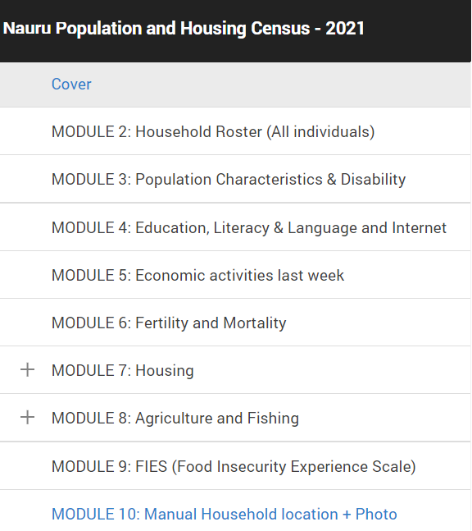

This document provides detailed introduction of each of these modules, drawing your attention to certain difficulties involved with finding the right answers to the questions asked. The flow of information during interviewing follows the above structure. Some Sections include sub-sections and/or rosters (list of persons for example) for easy referencing while doing data capture.

7.1.2 Logging in to the tablet

To begin the interview, login into the application to access the questionnaire. Tap (click) on the interviewer icon:



This will open up the login page for the enumerator to type in the name of the server, login username and password
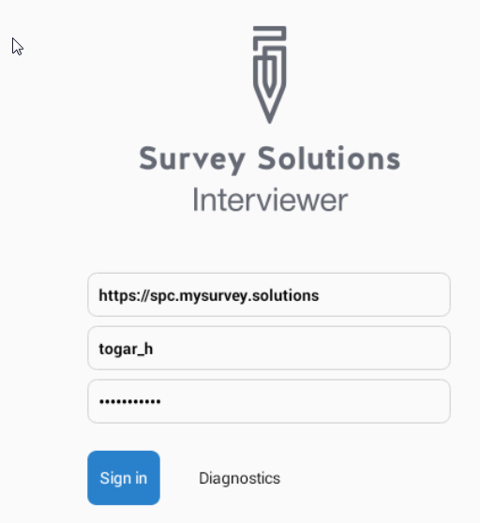

A few screen colours to be aware of while capturing data:
- BLUE – means the section/question is still to be filled or in progress
- RED – there is an error or rejected
- GREEN – means the section/question is filled (completed)

Signing in will open up the following screen which you will need to ‘synchronize’ to load the questionnaire.

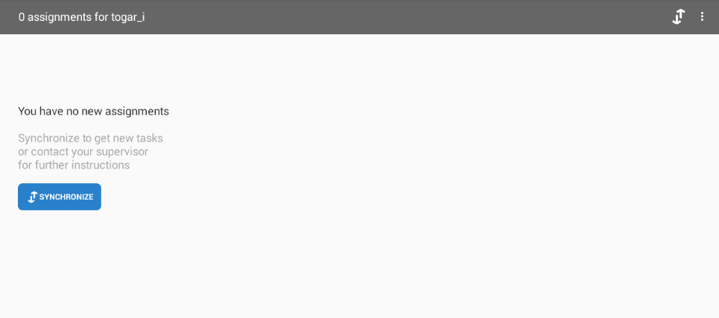

Tap on ‘SYNCHRONIZE’ blue button will enables the following screen.
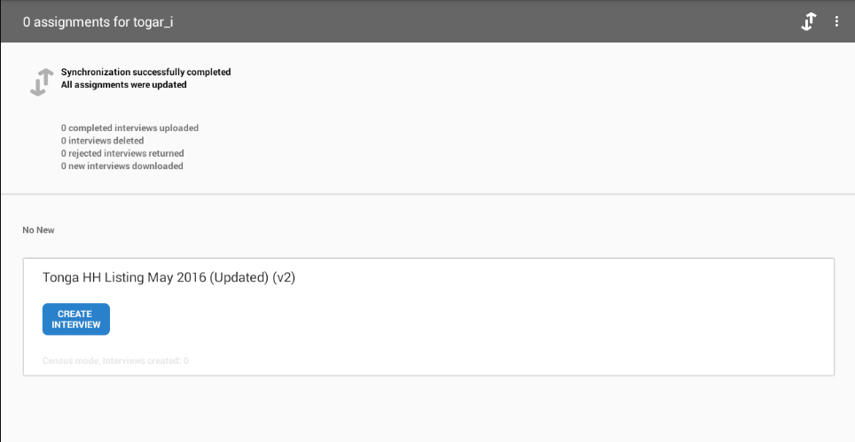

Tap the blue button ‘CREATE INTERVIEW’ to begin interviewing a new household.

7.2 The Census Questionnaire: Cover section

The introductory section of the questionnaire is called the “cover”. Cover page of the questionnaire provides the summary information of what the questionnaire contains. The cover entry page contains information about the Geographical ID of the interview. There is an initial GPS location section followed by other Geographic information.

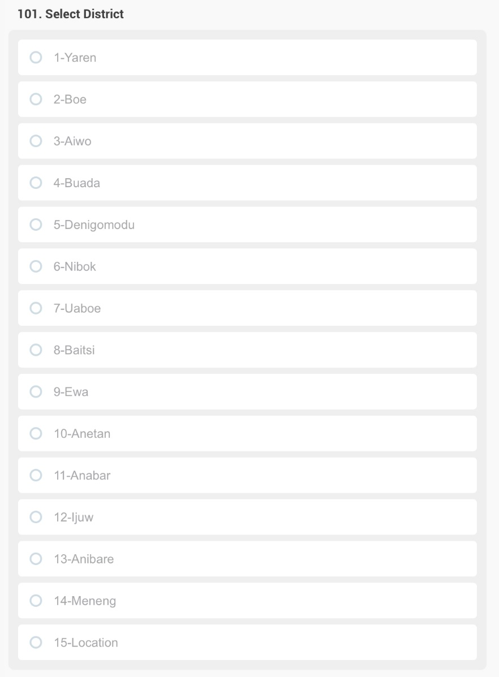
These require you to record the District and the Enumeration Area into categories set up by the census team. Please first select the District of the interview location from the list provided by the app. This question is not to ask the respondent, it is only for the interviewer to fill in.

Once you selected the district, that enables the Enumeration Area selection, that you also need to designate. Please refer to your map to find the EA designation information.

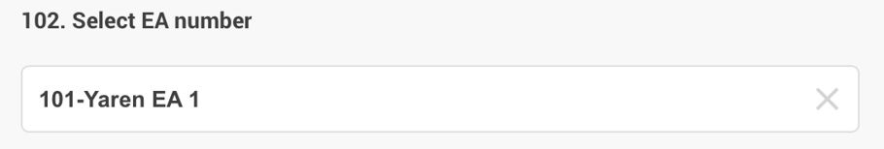

Finally, the Dwelling number and the Household number need to be entered to identify the dwelling and household.
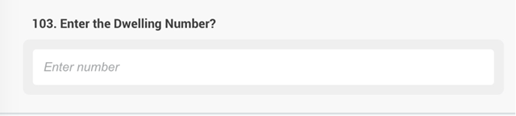

103. Enter the Dwelling number. In these questions, these will require you to seek the basic information of head of the household or its reference person. Please input the correct data for these will be used for contact information purposes. Collect the reference person’s dwelling number, full name, and its contact number if possible. Read all the instructions provided by the app.

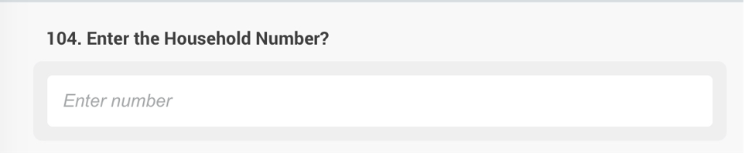

105 Question GPS

The next question records the digital geographical location of the house in the enumeration area.

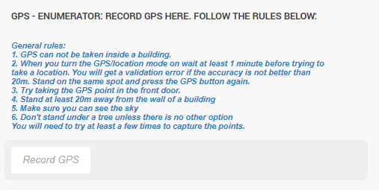

You need to press the Record GPS button to obtain the GPS location of your position. In order to retrieve the correct GPS location, please stand outside, at arms’ length from the front door of the target structure / dwelling and try to obtain the GPS location before entering the home. Note that it may take a couple minutes for the GPS to connect.

In case of error message: Accuracy needs to be less than 20m, try collecting the GPS again. If necessary go into settings and set GPS to less than 20m If that location does not provide a sufficiently accurate GPS reading, please make sure that GPS precision is set to less than 20m in the Settings of your table (select Settings > Location). If this does not help, please search for a location within 20 meters of the target structure / dwelling where the sky is not blocked by trees or other objects and try to obtain a more precise reading there.

In the exceptional case when no proper reading can be done after 4 attempts at different locations (within 20 meters of the dwelling), please proceed with the interview and flag the problem for the Supervisor so that a solution could be found. It is essential to record the location of the interview.

Immediately after the interviewer has correctly filled the IDs, the next section will be Section 2 which contains the following questions (shown below). These are the filtering questions to the next modules to be answered.

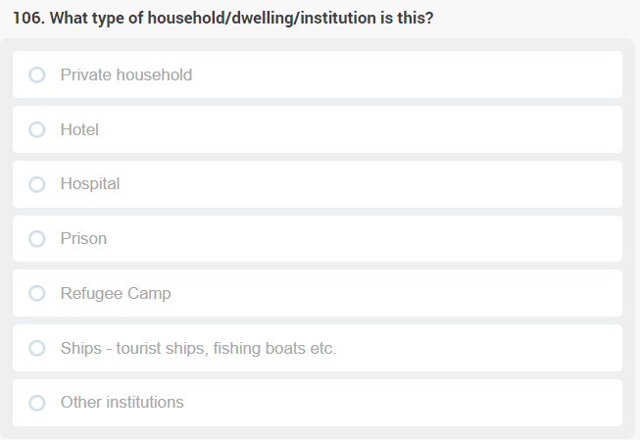
106: What type of household is this? Dwellings may include several types of households, they may be private households, where the dwelling houses an individual or one or more family/families, or the maybe living quarters, providing accommodation for a larger number of unrelated individuals. These living quarters are called institutions, and there are several types of these such as hotels, motels, guesthouse, military barracks, hospitals etc. Please chose the appropriate code from those given.

BE MINDFUL: if the answer to the occupancy question is “vacant”, tapping on ‘Next Section’ tab will take you straight to the last section, for capturing the GPS locations and taking photo of the dwelling/ institution. Make sure that the dwelling is indeed vacant, by peeking in the windows, asking the neighbours and if still in doubt, verify at a next visit.

Note that your task is to enumerate all residential structures that were built with the purpose of a dwelling (i.e., they look like a residential dwelling). Some residential buildings may be used for non-residential purpose (doctor’s office, communal space, small office, museum, etc.). Those structures must also be enumerated but classified as ‘vacant’ in terms of permanent residency. You need to make sure in these cases that there are indeed no persons usually sleeping in those dwellings, especially not on census night.

107: Is this dwelling currently occupied? Select the correct answer here whether the dwelling is either occupied or not. whether the dwelling is either occupied (code 1) or vacant (code 2).

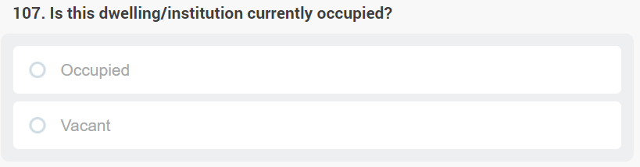

108. Name of the Head of the Household / Institution Please type in the name of the Head of the Household if the structure / dwelling is a residential private household, or type in the name of the institution if it is an institution. The name only serves the purpose of later identification of the dwelling (for you, for your revisits, and for your supervisors and colleagues who may need to verify or take over your job if you can’t continue for some reason). For vacant houses try to capture the name of previous owners from an old mailbox, or from an old sign or from neighbour information. If there is no identifier, you need to type ‘Vacant’ in the name field, too.

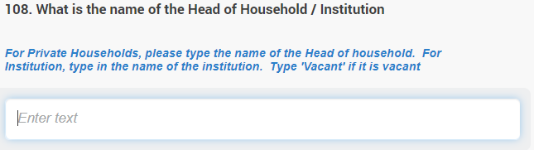
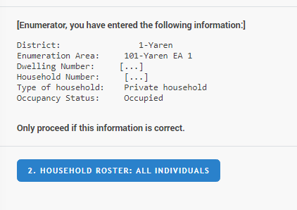

The cover section ends with a recap of the information recorded about the dwelling you are enumerating: its location, type and occupancy. Please double-check if the information is correct, and proceed to the household roster.

7.3 R. Household roster

When you do the roster, you will list all persons in the household to the tablet, who slept in the dwelling on the reference date.

Before you list all members of the private household, it is important to have a clear understanding on who do you include and exclude from the list. The following definitions and clarifications would guide you on this:
- Members of the household – A household may be one person or a group of persons who usually live and eat together. They share the same arrangement for all their household’s social and economic expenses and other welfare.
- Visitor – A visitor is someone who is not a usual member of the household but who stayed in the household the night before the enumeration / census night and is not intending to stay in the house for more than 6 months. This person should be listed in this house as part of this household.
- Usual residents – those residents who lived continuously as part of the household for most of the last 12 months (that is, for at least six months and over), considering temporary absences for holidays or work assignment outside the country. Also include those visitors who are intending to stay for at least more than 6 months as usual residents of this house. These people should all be listed in this house
- Head of the household – let the household identify the head of the household, however the head of the house may be acknowledged as the main provider/breadwinner of the households.
- A new-born baby who was born and still staying at a hospital, but whose mother is a usual resident of this household.
- Please note the same applies to institutions where all persons currently staying in the institution has to be listed here as well, irrespective of their status as a visitor or resident.

7.3.1 R1 - Persons:

The list of persons present on Census Day should be in an orderly manner beginning from the head of the house (assuming that (s)he spent the Census Night in the dwelling). When you finish typing the name of the first person, a new text box will pop up where you can continue listing the members of the household. You must enter the person’s name beginning with the last name (see below). The names are usually used for reference in the questionnaire, and for consistency during and after the enumeration when required. Write the person’s name neatly and clearly. Write the person’s name with an initial or a number (for example using their age) if there is more than one person with the same name.
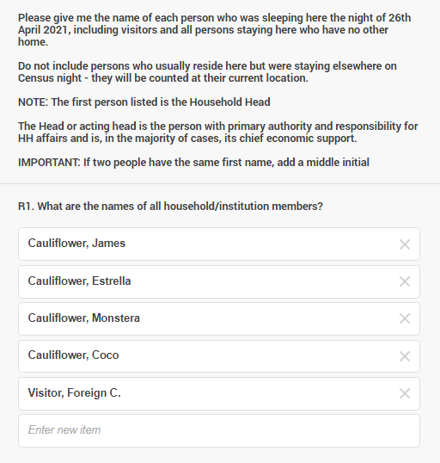
BE MINDFUL: if you fail to list each and every one of the usual residents AND each of those visitors who slept at the dwelling at census day, the population count produced by the census will be incomplete. Similarly, if you list usual residents of the dwelling who slept elsewhere on census night, the census will have that person double counted – once by your colleague who works where she or he in fact slept and was already enumerated, and now, the second time, in the household where she or he normally belongs. This would be a mistake. Make sure that you list all persons, regardless of age and their usual residence, who slept at the dwelling on census night, and nobody else. Your work is the guarantee for the accuracy of the statistics.

7.3.2 R2-R4 – Roster composition

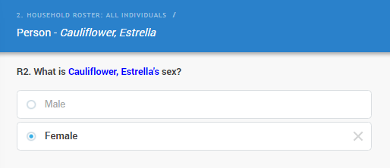
The household roster also contains some fundamental questions about each person enumerated in the household roster, related to sex, age and their relationship to the head of the household. You will have to complete this section first before continuing to other sections of the questionnaire. Remember that persons on the list are those to be enumerated during the census. A full complete listing of all persons present at the dwelling ensures a good coverage of the Household and Population Census.

R2. Sex: Mark the sex of the person by tapping the right selection. Always confirm the sex of a person since many names are given to both male and female. In rare cases of doubt, refer to the sex of the person that is on his or her personal documentation (passport, ID, etc.).

R3a-b. Age: The age of every person in the household list must be recorded in two formats. First, the date of birth must be given (R3a).

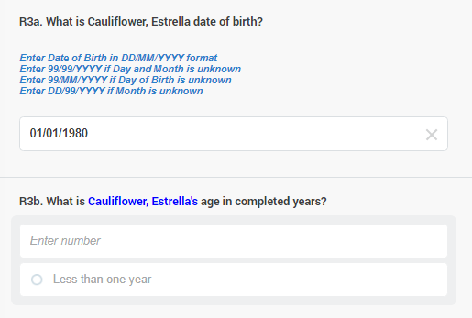
BE MINDFUL: a valid year of birth must be indicated, even if the day and the month of birth is not known. If day or month is not known, ‘99’ should be entered in those fields. Make every effort to collect a full birth date from each person on the roster, to have a precise age for all persons on the household roster. If a birth year cannot be recovered (for example of a visitor who slept there on census night but is not anymore around), it must be estimated by an informed household member.

The age of the persons is also recorded in completed life-years in R3b.

Age in completed years refers to the person’s age in his/her last birthday and must be recorded in full years only. For instance, 13 years and 10 months should be recorded as 13 only. For infants less than one year old, there is a separate code (‘less than one year’) which should be selected.

You must make sure to obtain the most accurate age of the person. i.e. age in his/her last birthday. The computer will flag if the age in completed years does not match the age retrieved from the birth date, the two must be consistent.

TIPS AND TRICKS: Consider the following methods to probe for the age when the person is not aware of his/her age and birth date:

- Ask the respondent how old he/she was during the most known historic events of the country, for example when did Nauru gain independence.
- Ask the respondent how old he/she was when got married or had their first child and then use the date to estimate her/his age.
- Relate the person’s age to that of someone else in the household whose age is more reliably reported.

R4 - Relationship to Head of the Household: The relationship refers to the relationship of each person listed in the household roster to the Head of the household (HH Head). Record how the person listed in the house related to the head of the house by tapping the appropriate answer category. If the person you interview is not the head of the household, make sure that you record the relationship of each person to the head of the household and not to the person answering the question.

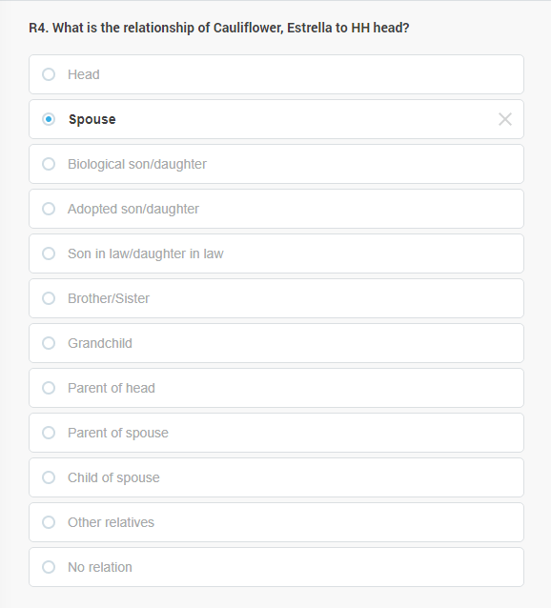

7.4 Navigating the questionnaire

Once you complete each person, that person will be enabled for the whole questionnaire. Look at the below example: note that James’ and Estrella’s tabs are GREEN

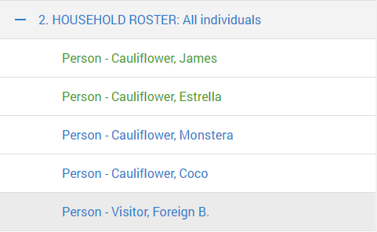
You continue the same process for the other persons whose tab is still BLUE until all person are filled, their colour is all GREEN then you may continue to the next Section.

The application is user-friendly and flexible where you can skip between Sections according to how you want to ask the questions. For example, all questions in a section is asked to each person and once all persons are completed, then it goes into the next section and again all questions in that section are asked to each person and so forth. The application is flexible as you can ask all sections to the first person and once you have finished then continue to the second person and so on.


For example, in the above screen you have completed the first section for Estrella, you can continue asking for Estrella’s particulars for the other section and then come back and fill for the other persons. To do this, just tap on the three lines on the top left of the screen, and this will show all Sections in the questionnaire as shown below. This will allow you to continue asking questions from other Sections to Estrella.
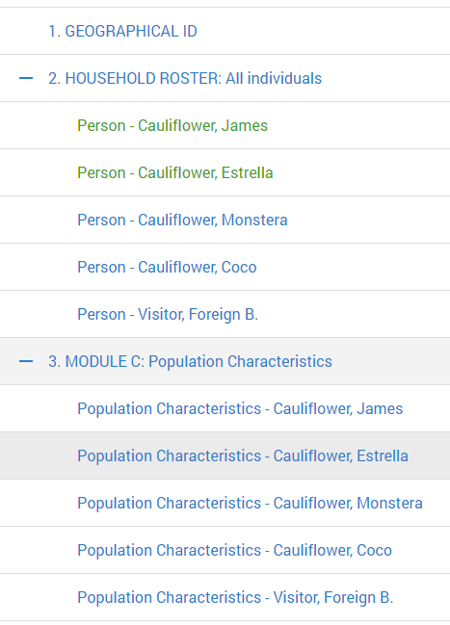
Note in Section 2, Estrella’s name is in GREEN which means this Section has been completed for her (and for James, the head of the household) whereas the other three persons are still pending. Tapping on the + sign in each Section will open up the subsections (see Module 3. opened) with the names of each person eligible for that section. You can continue asking questions for Estrella in the different sections and then move on to another person on the household roster.

7.5 C. Population Characteristics

This section contains basic characteristics of each person in the household roster which are some of the most important population indicators used for demographic analysis. Information range from ethnicity, birthplace to migration information like usual place of residence. These questions, similarly to those in the subsequent sections, should be asked from the person on the household roster directly, unless it is a child (in which case a parent should answer in his/her name) or someone who is incapacitated (due to, for example, an illness, inability to hear or speak, or due to not understanding the language of the enumerator).

7.5.1 C1-C3. Identity and nationality

C1. Ethnicity: With which ethnicity does person on the household roster identify? The person’s origin and identity are important background characteristics as those are associated with the person’s customs and behaviour, and how to make decisions in their life. There should be one answer only for this question. Ask the question and tap the right code. If there are multiple backgrounds for one person (s)he must be invited to select which is the most important in his/her life.

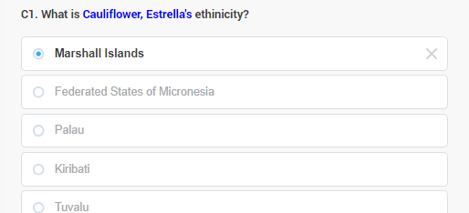

The question includes all the frequent ethnicities in the country. At the bottom of the list, however, you may select another ethnicity/origin, for those whose answer is not already included in the list. If selected, it will open an input box where you have to type in the response given:

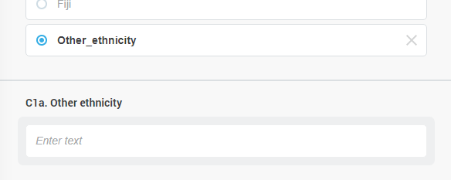

C2. BIRTHPLACE – In C2 record if the place of birth for the respondent is the same where you interview him/her, as recorded at the beginning of the interview, in the Location section. If not, then a new question opens: C2a, where you are requested to indicate where else in the country (for example another District) or in which other country the person was born. In our example, Estrella was born on another District.

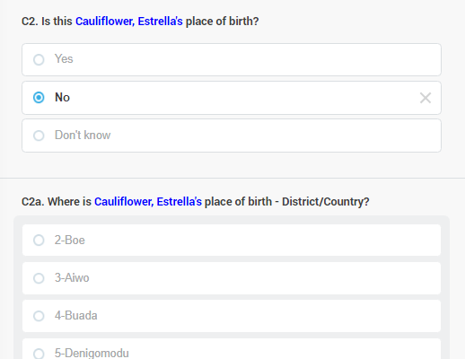

BE MINDFUL: The place of birth is usually referring to the mother’s usual residence at the time when the person was born. Be mindful of cases where the mother gave birth in the health centre. You should not record the health centre’s location as the place of birth, but the place where the mother usually resided at the time the person was born.

C3. CITIZENSHIP – What is the Country of Citizenship of the person on the household roster? Being a citizen of a country means having certain entitlement or right to do in a country such as the right to live, work, vote and right to have access to services and others. The information collected from this question would allow the estimation of the total citizens and non-citizens of the country. You should record one answer only.

BE MINDFUL: If one is the citizen of the Nauru as well as another country, record Nauru citizenship.

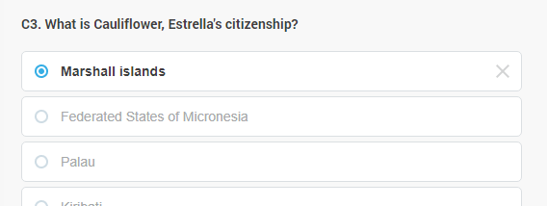

7.5.2 C4. Marital status

C4. MARITAL STATUS – What is the marital status of the person on the household roster? The person’s marital status is one vital information to collect as it has implications on the person’s decision and behaviour. The data collected in this question would enable the calculation of the marital status of the population. Separated and divorces are describing the same concept (not anymore living in a communion with a partner as previously) but “divorce” also includes a legal act of separation, to end a legal marriage. Record one correct answer only.

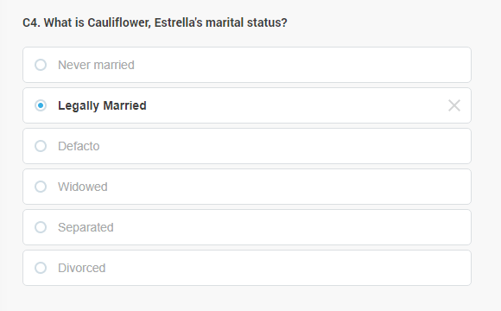

BE MINDFUL: If the roster indicates that the head of household lives with a spouse (like Estrella here was marked as the spouse of James in R4), they both have to have the same marital status: either legally married, or de-facto married / living together. In any other case, the questionnaire will give an error.

7.5.3 C5. Faith, religion

C5. RELIGION – What is the Religious Affiliation of persons on the household roster? The person’s religion is an indicator of lifestyle and community affiliation. It is often associated with particular attitudes, beliefs and behaviour that have demographic, social and economic implications. Record one answer only.

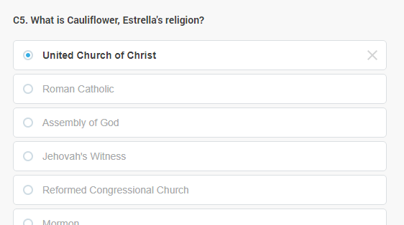

The question includes all the frequent religions in the country. At the bottom of the list, however, you may select another religion, for those whose answer is not already included in the list. If selected, it will open an input box where you have to type in the response given:

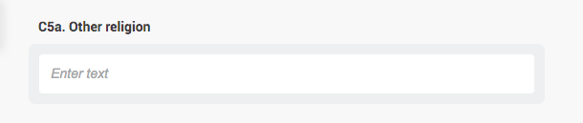

7.5.4 C6. Residence and migration

C6. USUAL RESIDENCE – Is this your place of usual residence? A usual residence of the
household refers to the person who has lived in that household continuously or for most of the last
12 months and longer. It also refers to the person who just moved in with the intention of staying
for more than 12 months. Ask the question politely and record the answer accordingly. If the
person reported ‘No’ then just simply skip to question C6a.

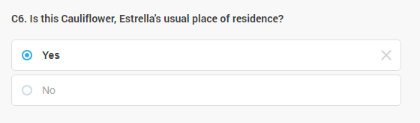

C6a. PLACE OF USUAL RESIDENCE – What is the usual place of residence for persons on the household roster who do not usually live in the dwelling interviewed? This question is enabled if C6 is answered by “no”. Select the person’s usual residence, i.e. the place that he/she usually stays. Write the correct name of the place or the geographical codes of the place in the space provided. It may be somewhere else on the District or in another District (in that case you will also be requested to enter the name of the locality on that other District, in C6c.)

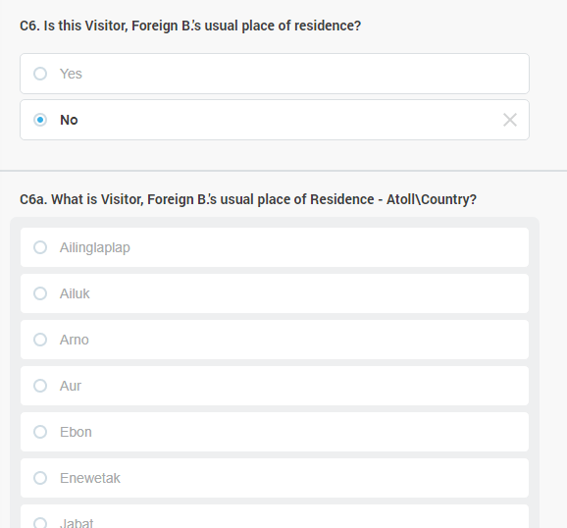

If usual residence is on another District or the same District, somewhere else:

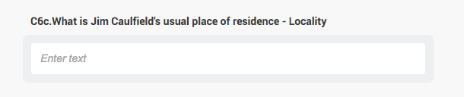
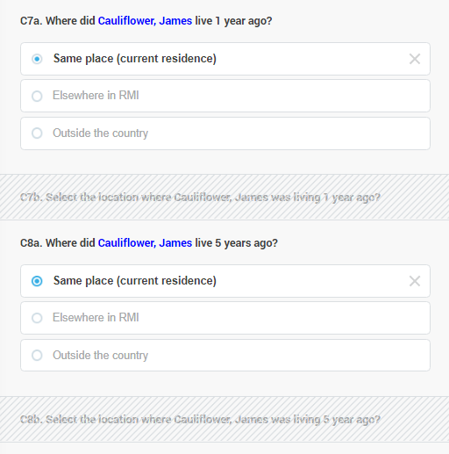
C7-C8 PREVIOUS RESIDENCE – C7 and C8 are asking where each person on the roster were living one year ago (specifically on the census date one year ago) and five years ago (again considering the census day five years earlier).

They may have lived in the same dwelling where they are currently enumerated or elsewhere in Nauru (other dwelling in the same District or other District) or in another country. Please code accordingly.

If the person had a previous residence in the country in any of the time periods, a subsequent question will come up (shown as hidden on the illustration) to select the District of this previous residence (C7a for one year ago and C8a for five years ago).

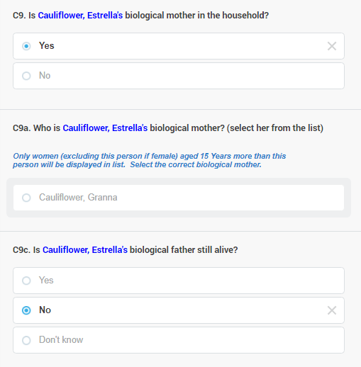
C9 PARENTS – C9 clarifies if the biological mother of the person lives with her/him in the household. If yes, the software will offer all the (other) women 15 years and older in the household, and you have to select the mother of the person enumerated (C9a).

C9c clarifies if the mother, if does not live with the household, is still alive or not, and C9d clarifies the same for the biological father, irrespective of his residence. Note that the illustration only contains C9d, C9c is the same question except it mentions the mother instead of the father, and it only comes up if “No” is selected in C9 .

All persons on the household roster aged 5 years or older will be asked a series of disability-related questions regardless of their sex. Parents or other adult members of the household could provide information for young children of the household and for incapacitated adults.

Disability refers to health-based problems or conditions, such as impairment, activity limitation or participation restrictions that indicate the negative aspects of functioning, that may make one’s life difficult. This section of the questionnaire helps in identifying persons who are at greater risk than the general population of experiencing restrictions in performing tasks (such as activities of daily living) or participating in roles (such as working).

7.5.1 C9-C14. Disabilities

The answer categories for the six questions that ask about functional challenges represent a scale with the following levels:

- No, no difficulty: meaning that usually the person does not have any challenge with that particular function that would bother him or her going about their life.
- Yes, some difficulty: meaning that the person does have some challenges with the particular function. This may be severe difficulties but only periodically, for shorter time, or mild difficulties permanently. These challenges may bother this person, but do not usually prevent her or him to do the things other people in their age normally are able to do.
- Yes, a lot of difficulty: meaning that the person has severe, persisting challenges in the particular function which mostly prevents the person doing all, or some of the things other people in their age normally are able to do.
- Cannot do at all: this is when for example someone lost his or her vision completely or both of his/her legs are missing hence cannot walk without aid (such as prosthetic legs or a wheelchair) at all.

When people answer to these questions their responses sometimes need to be matched with the above categories. People aren’t always sure how much difficulty is considered to be enough for a ‘yes’ answer. So they usually qualify their ‘yes’ with comments about their experience such as ‘yes’, I have a little problem or ‘yes sometimes’, or, when the problem is very serious, they indicate ‘Oh, yes, a lot’. These answer categories try to capture that process. They may have to be repeated for the first one or two questions in order for the respondent to get familiar with the choices.

You are required to ask and complete C9-C14 for all persons on the household roster. You may choose the order in which you interview persons in the roster. The colour of each person completed will turn green on your screen as soon as they are finished with. You will be ready with the section, when all persons on the roster will be “greened out”.

C9. VISION - Does person on the household roster have difficulty seeing, even if wearing glasses? The purpose of this question is to identify persons who have vision difficulties or problems of any kind even when wearing glasses (if they wear glasses). They can have a problem seeing things close up or far away. They may not be able to see out of one eye or they may be only able to see directly in front of them, but not to the sides. Any difficulty with vision that they consider a problem should be captured. Normally impaired vision is associated with things like difficulty with reading books or recognising people from a small distance.

BE MINDFUL: Note if the person is wearing glasses and make sure that they understand that the question refers to difficulties they may have while they are wearing their glasses.

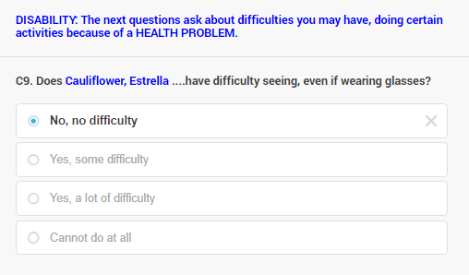

C10. HEARING - Does person on the household roster have difficulty hearing, even if wearing a hearing aid? The purpose of this item is to identify persons who have some hearing limitation or problems of any kind with their hearing even when using a hearing aid (if they wear a hearing aid). They can have a problem hearing only when they are in a noisy environment, or they may have problems distinguishing sounds from different sources. They may not be able to hear in one ear or both. Any difficulty with hearing that they consider a problem should be captured.

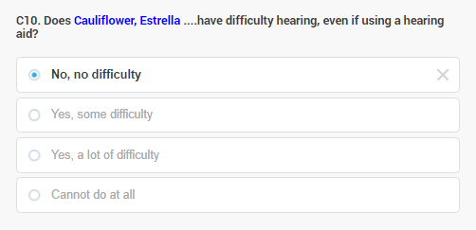

Note if the person is wearing hearing aids, make sure that they understand that the question
refers to difficulties they may have even while they are wearing their hearing aids.

C11. MOBILITY - Does person on the household roster have difficulty walking or climbing steps? The purpose of this item is to identify persons who have some limitation or problems of any kind getting around on foot.

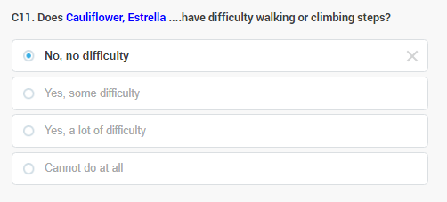

This may or may not contribute to difficulty in doing their daily activities. They may have a problem
walking more than a block, or short or long distances, or may not be able to walk any distance
without stopping to rest or they may not be able to walk without using some type of device such as
a cane, a walker or crutches. In some instances, they may be totally unable to stand for more than
a minute or two and need a wheelchair to get from place to place. Difficulties walking can include
those resulting from impairments in balance, endurance, or due to any type of pain. For overweight persons problems with walking may include an impaired ability to carry one’s own weight for long enough distances.

Any difficulty with walking on flat land as well as walking up and down the steps that they consider
a problem should be captured.

BE MINDFUL: The capacity to walk should be without assistance of any device or human. If such assistance is needed, the person has difficulty walking. We do not consider an infant’s inability to walk as a functional challenge, until it is considered broadly age-appropriate by their caregivers.

C12. MENTAL CAPACITY - Does person on the household roster have difficulty remembering or concentrating? The purpose of this item is to identify persons who have some problems with remembering or thinking that contribute to difficulty in doing their daily activities. They can have a problem finding their way around, or the problem can be that they can’t concentrate on what they are doing, or they may forget where they are or what month it is. They may not remember what someone just said to them or they may seem confused or frightened about most things. Any difficulty with remembering, concentrating or understanding what is going on around them that they or family members (if the family member is the respondent for the person) consider a problem should be captured.

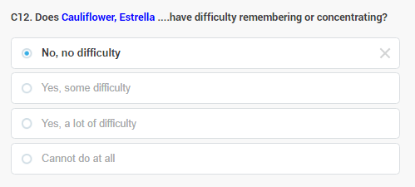

BE MINDFUL: We do not intend to capture difficulties remembering or concentrating because of common everyday situations such as high workload or stress, or as a temporary result of substance abuse which passes. Also, we do not consider small children’s inability to focus or remember as a functional challenge, until it is considered broadly age-appropriate by their caregivers.

C13. SELF-CARE - Does person on the household roster have difficulty with self-care, such as washing all over or dressing? The purpose of this item is to identify persons who have some problems with taking care of themselves independently. Washing and dressing represent tasks that occur on a daily basis and are very basic activities. For small children difficulties with these activities are not to be considered as a functional challenge, until their (lack of) abilities are broadly age-appropriate. Any difficulty with self-care that they or family members (if the family member is the respondent for the person) consider a problem, should be captured.

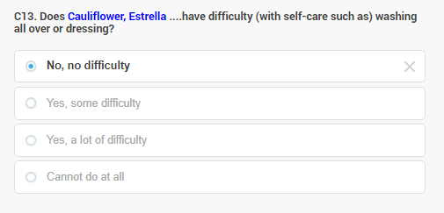

Washing all over refers to the process of cleaning one’s entire body (usually with soap and water)
in the usual manner for the culture. The washing activity includes cleaning hair and feet, as well
as gathering any necessary items for bathing such as soap or shampoo, a wash cloth, or water.
Dressing refers to all aspects of putting clothing or garments on the upper and lower body including the feet if culturally appropriate. Gathering clothing from storage areas (i.e. closet, dressers), securing buttons, tying knots, zipping, etc., should be considered part of the dressing activity.

C14. IN-PERSON COMMUNICATION - Does person on the household roster have difficulty with communicating (e.g. understanding or being understood by others) using his/her usual language? The purpose of this item is to identify persons who have some problems with talking, listening or understanding speech such that it contributes to difficulty in doing their daily activities. They may have a problem making themselves understood, or the problem may be that they can’t easily understand people who talk to them or try to communicate with them in other ways.

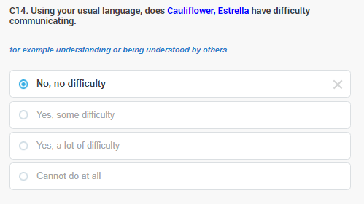

They may involve mechanical problems such those due to hearing impairment (which is a barrier for the person to understand others and will also be captured in D1) and/or speech impairment (which is a barrier for others to understand the person, including neurological speech or those associated with hearing impairment). It may also be sometimes related to the inability of the mind to interpret the sounds that one hears and to recognize the words that are being used.

BE MINDFUL: The intention is not to include communication problems due to non-native or unfamiliar language. Also, this item does not consider problems with written communication, for example not knowing how to read or write or other difficulties with reading (such as dyslexia, or vision impairment). Also, the functions of smaller children must be considered relative to their age.

7.6 D. Education and literacy

The information collected in this section will provide not only the updated education background
characteristics for the population but also provide useful information for developing education policy to support and improved education system and services in the country. The data is also relevant in developing the education planning such as planning on the number of schools, number of classrooms, number of teachers and so forth.

We will look at the questionnaire through the example of the daughter of the Cauliflower family, who is 13 years of age.

7.6.1 D1-D4. Education

The section on education is to be completed for all persons in the household roster aged 3 years and over.

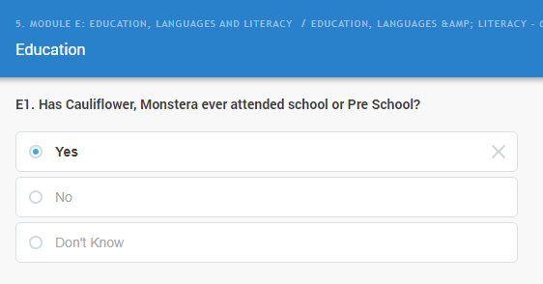
D1. EVER SCHOOLED Has the person on the household roster ever been attending school during his/her lifetime? This first question on education is important as it filters out the population into different categories; those who ever attended school in their life, the second group who never attended school at all in their life time and the last group for those who don’t know. Ask the question clearly and record one answer only.

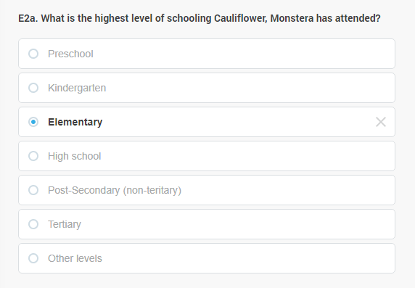
D2a. HIGHEST LEVEL ATTENDED What is person on the household roster’s highest level of schooling attended? The purpose of this question is to find out what the highest level of schooling the person has attended no matter whether the person completed all class/forms/years in that level or not. The intention in this question is to capture the highest level of schooling only.

For instance, Monstera is 13 years of age, and attends elementary school, however she did not finish it. Correspondingly, we code elementary school for attendance level.

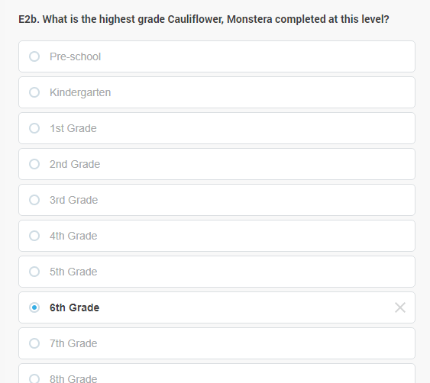
D2b. HIGHEST COMPLETED GRADE What is the highest grade/or level of schooling the person on the household roster completed? In the previous question, we find out the highest level of schooling that the person has attended whether it is primary, secondary or above. Now we are asking about the highest grade/form/class/year the person has completed in this level.

For instance, one may report that they attended tertiary education (college or university) in the previous question. But he or she may have left it before getting any diploma – in this case, you will have to select “some college, no degree”. But if they not just attended but also finished a university, then the completed level will be some kind of degree or diploma. In the example we follow, Monstera will have attending 7th grade, which means she finished the 6th grade. This is what needs to be indicated in E2b.

BE MINDFUL: The answer options provided for this question cover the whole range of one’s possible education career (see the full list at E4b that uses the same response categories). Sometimes it is not easy to decide the level the person is currently attending, especially in the more advanced stages of an educational career. In any case of doubt, rely on the person to decide which of the available response codes best describe the current type and level of education they are attending.

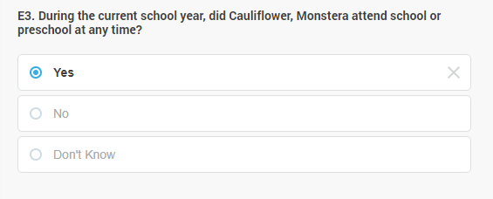
D3 to D4c: CURRENT SCHOOL ATTENDANCE: The questions in this sequence are concerned with recent school attendance. The term “attending school” refers to whether the person generally attends school; it does not measure how often a person actually goes to school but whether the person attends school at all at the time of the census. If a person goes to school occasionally, or usually goes to school but has been absent from school recently, record YES.

Record ‘NO’ only if the person did not attend at all in the current school year at all, and record ‘Don’t know’ if the person did not know. In these cases, the next questions till E4c will be skipped for the person.

BE MINDFUL: The school/academic year is typically counted from February to November. If person attended any school during the time since the start of the current school/academic year in August, he or she must be registered as currently attending school.

D4a. CURRENTLY ATTENDED LEVEL What level of schooling has person on the household roster attended in the current school/academic year? You will ask this question if the
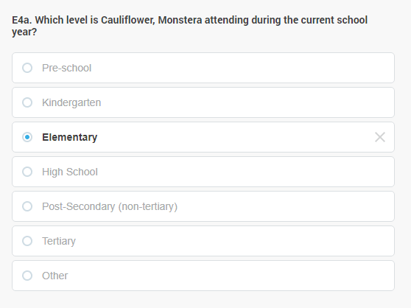
person has attended school during the ongoing school year to determine the level of schooling this person attended - whether it is primary, secondary or any other level. Make sure to get the right school level and record it accordingly.

In our example, Monstera has attended school, she went to the 7th grade of elementary school, hence we selected Elementary in D4a.

BE MINDFUL: If the school the person is currently attending does not fit to the levels provided, there is an option to select “Other” level. While it must be appreciated if one attends courses, training at work, spiritual development and other forms of learning and personal enrichment, for the purposes of this question, school is understood as a formal institution that provides training and education as its main profile. Attending education must be understood as participating in a training or education scheme that provides and accredited certificate of completion that either enables the person to move to a next level of education, or certifies the person – officially or informally, accepted by most employers – to apply for jobs that require some kind of specialised training or education level. Attending education may be in-person, or long distance (i.e. online), full time or part time.

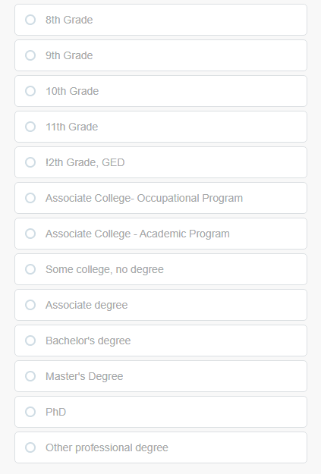
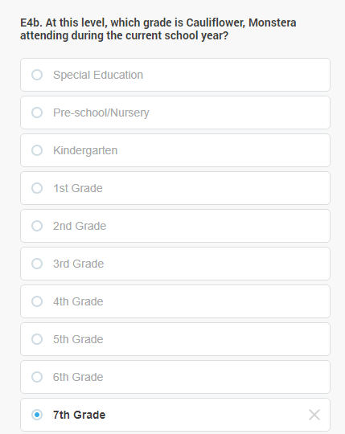
D4b. CURRENT GRADE What is the highest grade/level of education the person on the household roster is currently attending? The answer options cover the whole range of one’s possible education career. Sometimes it is not easy to decide the level the person is currently attending, especially in the more advanced stages of an educational career. In any case of doubt, rely on the person to decide which of the available response codes best describe the current type and level of education they are attending.

As we know, Monstera completed 6th grade, that we entered in E2b, and in the current school year she goes to 7th grade, this is what we record in this question.

7.6.2 D5-D8. Literacy & language

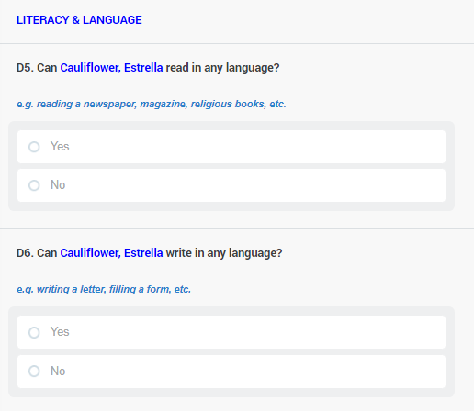
LITERACY - Literacy refers to whether or not persons on the household roster are able to read and write in any language, including languages developed for those with sensory difficulties (for example in Braille, for persons with severe vision impairment). A literate person is usually considered one who can both read and write a short sentence on his or her everyday life. An illiterate person is one who cannot, with understanding, both read and write such a statement. Hence, a person capable of reading and writing only figures and his or her own name should be considered illiterate, as should a person who can read but not write as well as one who can read and write only a ritual phrase that has been memorized. The census questions provide examples for literacy, use those in case of doubt – for those with vision impairment, the examples should be understood in Braille. Illiterate persons face a number of challenges in social life, that range for difficulties at the job market to their ability to interact with government services, or exercising their political rights, therefore the level of literacy is a very important social indicator to be captured by the Census.

Literacy question are not applicable, therefore skipped for all children below 5 years of age.

LANGUAGE – Persons who’s most often spoken tongue is not matching the official language(s) of their country could potentially face various challenges that others who are native in the official language are not facing. The census therefore clarifies the most spoken language at home by the person, in order to understand the scope of this problem and design policies that cope with it.

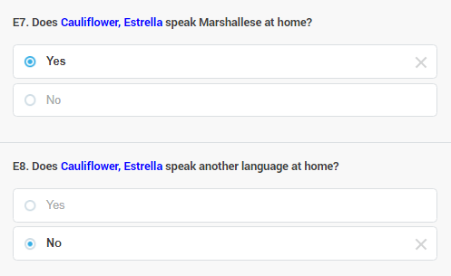
D7. OFFICAL LANGUAGE SPOKEN. Does person on the household roster speak the country’s official language at home? This refers to whether or not the person uses the official language for daily interaction within his or her family and household. The official language could be the second language used besides the mother tongue.

D8. ANY OTHER LANGUAGE SPOKEN Does person on the household roster speak any language other than the country’s official languages at home? This refers to whether or not the person uses any language besides the official language(s) of the country for his or her daily communication within the family or household.

7.6.3 D9-D11. Communications & Internet

This segment contains questions related to communication technology, internet accessibility and use. Having access to some type of communications services or devices provide a person with the opportunity to access information, places and increases the likelihood to be exposed to news and other relevant information. Also, possessing technologies of communication and accessibility may increase one’s chance on the job market. Therefore, information about this topic is crucially important for assessing possible inequalities in social participation. This segment will be asked of all persons on the household roster aged 5 or older.

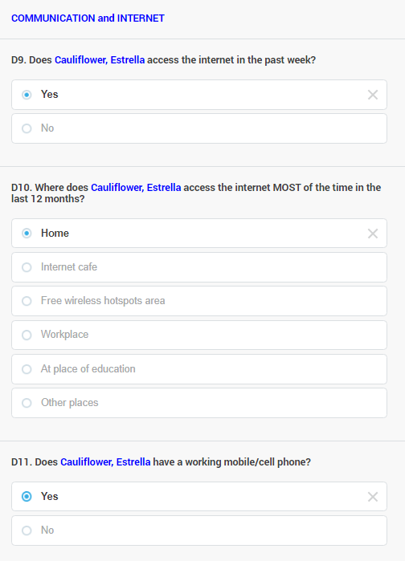
D9. INTERNET ACCESS – Did person on the household roster access the Internet in the last week? The purpose of this question is to find out if the respondent accessed the Internet in the last week for any reason at all. The question refers to deliberately accessing the internet whether for private or official use, for checking Whatsapp, for games or education or work, or for any other reason -- it does not matter as long as he/she accessed to Internet in the last week. Access to the Internet may have been through computers, phones or other devices (such as a television, a smart watch, or any other device that is able to display information retrieved from the Internet. When Internet-enabled devices were available for the person during the week, but the person never used those to actually access the internet, he or she should not be considered as having accessed the Internet even if the person theoretically has had the Internet available for her/him in the reference period. Record the correct answer.

D10. LOCATION OF THE INTERNET USE – If the respondent accessed the Internet, additional question appears asking where the person accessed the internet most of the time over the last 12 months. We are interested to find out the location or the place where the person typically accessed the internet from whether from the office, home, public places like internet café or another place. Ask the question and enter the right answer code in the space. If respondent is hesitant ask politely to make a judgement her- or himself, which of the listed locations were most dominant in her or his internet use. If the person mentions a location which cannot be characterised according to the responses listed (for example using it in someone else’s home, or “everywhere” via Internet enabled phone, or at a location abroad), tap Other (specify below) and type in the response in the text field appearing (D10a)

D11. MOBILE PHONE USE – Does person on the household roster have a working mobile/cell phone? The purpose of this question is to find out whether the person have or own a working mobile/cell phone. Having a mobile phone is a good indication of the person’s ability to communicate and reach out to other people as well as other places. Ask the question and record the answer properly. This ends this segment.

7.7 E. Economic activities last week

This section on Economic Activities should be completed for all persons aged 15 years and over. For those persons less than 15 years of age, the section is blank in the computer form, as shown.

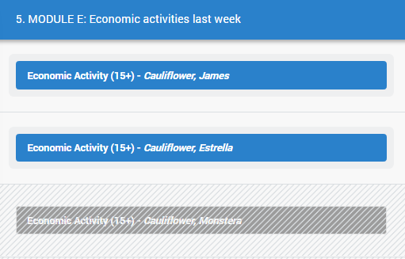

One of the main purposes of this section is to determine the size of the supply of labour (work force) in the country.

This refers to those people who are employed, unemployed people and those people who are categorised as not in the labour force. The data is very crucial to man power planning and other users who have interest in a summary picture of the country’s labour force as well as different activities undertaken in the country.

In order to obtain these data, the following questions in this section related to the person’s economic activities are been asked.

IMPORTANT: Economic activity refers to any activity that the person is involved with aiming at providing the necessities of his/her life, his/her family or household -- for example, bringing food to the table or getting money to pay for expenses. This may include various activities that we normally consider work, whether it is paid or not.

Any person who reported doing any such activities in the last week whether it was paid or not, will be categorised during the Census into one of the following categories, using several questions:

In labour force:
Paid Employment:
- Employer - An employer is any person for whom an individual performs or has performed any service, of whatever nature, as an employee. Also refers to someone producing goods or services for sale, running a business with paid employees.
- Self-employed - producing goods or services for sale, running a business without paid employees.
- Employee – working for wages/salary, in the public sector, NGOs and international agencies like the UN.
- Employee – working for wages/salary, in the private sector.

Unpaid Employment:
- Unpaid family worker (family business and plantation)
- Volunteer work (community, church, etc).
- Unpaid apprenticeship / traineeship

Job seekers:
- Unemployed persons (persons without paid employment who are able to work, and are seeking for employment or plan to start their own business)

Not in the labour force (categories for persons not in any paid or unpaid employment and not looking for employment):
- Studying
- Household duties, chores, including help with basic HH duties inside (washing, cleaning, cooking) outside (gardening, sweeping, cutting grass), and family/care work duties (caring for children and for elderly family members) – without the intention to get any type of paid or unpaid employment as detailed above.
- Retired or pensioner
- None – does not pursue any economic or labour activity (no work)
- Unable to work due to long-term illness, injury or disability

Anybody who falls into a category which is not in the labour force (the last group above), will skip to the next section of the questionnaire. For the others, depending on the type of activity they are doing, several other questions are asked.

BE MINDFUL: Most questions (unless specified differently) ask about the main economic activity of the person. One may do one or several of the above listed categories. A well-paid executive of a hotel may be an employee, but also an employer of a household-help. One may be working in a paid job and also attending courses at a university. Or one may plan to start their business while doing some voluntary work for an organisation. It must be up to the person to decide which of the multiple activities they consider their MAIN activity. The formulation of the questions also supports this concept: we ask how the person would characterise what they MAINLY do at present.

7.7.1 E1-E5. Labour force participation

E1. MAIN ACTIVITY – What was this person on the household roster’s main activity during last week? This refers to person’s main activity only in which the person spends most of his/her time doing in the last week. Remember that the person could involve in more than one activity. However, you are required in this question to record one main activity only. Record the correct main activity using the list of activities provided.

Working for someone else for pay: Person is an employee working as a salary/wage earner in a public or private sector (incl. NGO, International Agencies)
Working in own farming, raising animals or fishing: Person involved in agriculture, livestock or fishing activity for sale or own/family consumption
Working in any other kind of business activity: Persons who are self-employed or an employer who owns a business.
Household duties, chores: Persons who do not have any work and are mainly involved in household duties and chores, e.g. washing, cooking, cleaning, gardening, fetching firewood, cutting grass etc.
Studying: Students who are doing fulltime and part-time studies as their main activity
Doing an unpaid apprenticeship, internship: Person is an unpaid worker, working in a family business or another entity like a shop, office etc.
Doing unpaid voluntary, community, charity work: Person who is involved in unpaid voluntary or community work like in the church, community groups, school etc.
Looking for work: Person who have no work and looking for work most of their time
Retired or pensioner: Persons who have retired or pensioners (old-aged) and are not involved in any work mentioned above.
Long-term illness, injury or disability: Persons who are inactive and are not involved in any work mentioned above, due to an illness, injury or disability.

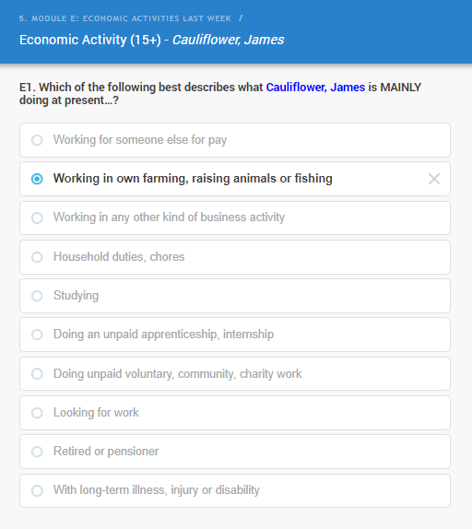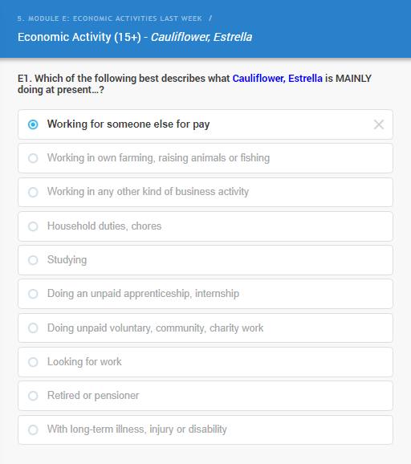

We are going to look at two examples; the one of James and the one of Estrella. James is working his fishing boat, mainly providing for the family, but sometimes also for the market. While he is in the labour force (see the definition above), several questions are needed to clarify how he participates and what economic activities he is involved with. His wife, Estrella, on the other hand, is a schoolteacher. She is teaching 1-6 graders at the municipal school. She is clearly part of the labour force, the questions asked in her case help to describe her occupation and employer and any other economic activities she may be involved with. We will also have an imaginary person in the family who is currently looking for a job. Let’s start with James:

E2. AGRICULTURAL WORK For those who, like James, are involved in agricultural production, the questionnaire establishes if they mainly produce for the market, or for own consumption. If they produce for the market, the question will be like in the case of any other type of employment or business activity: to describe their job (E6, see below), and so on.

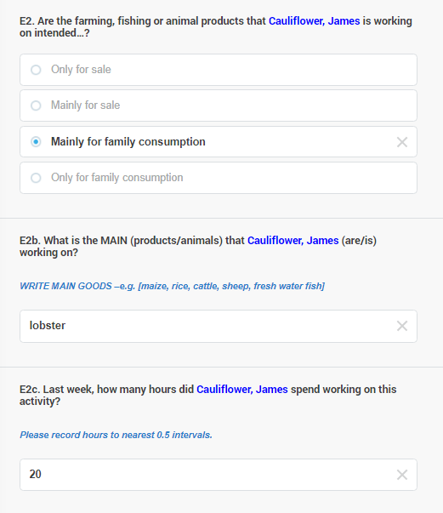

But if the person only or mainly produces for self-consumption (for the household), like James, you will have to ask the type of produce the person is dealing with (E2b) and the amount of time the person spent with this activity the last week, that is, in the 7 days before the day of the interview (E2c).

In E2b please enter the single most important types of produce or animals, according to the respondent’s opinion, even if there is a mixture of products they are involved in.

In E2c, you may enter half hours in decimal format (such as 12.5). If one worked less than one hour, but more than zero, use the code provided for that.

IMPORTANT: When the questionnaire asks about the last week, that is, the 7 days before the day of the interview, it is important to give the exact information that characterises those 7 days, even if they are not typical. For example, if a person was out sick the last week and only worked 2 hours, although he or she usually works 60 hours a week, you have to record those 2 hours. This is statistically very important to be rigorous and disciplined in this regard. Some respondents who do not have regular working hours will also need some reflection to recollect the number of hours they worked.

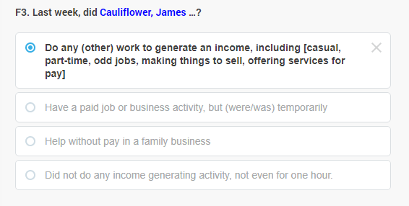
E3. IRREGULAR JOBS Those who are doing self-consumption agricultural activities or are looking for a job, or are in a category outside of the labour force (retired, studying, too sick to work, etc.) it is clarified if they have been involved, even for only as much as for an hour, in any economic activity. Question F3 should be answered in a way that the first response that applies to the person should be marked. For example, if James sold some of his lobster over the reference week, we mark that he did some job that generated an income, the first response category, even if he also helped -- without pay -- for his father-in-law’s family business during that week. The last category should only be selected in the case if someone did no paid or unpaid work that lasted at least one hour, over the 7 days preceding the day of the interview.

As above, it is important to give the exact information that characterises those 7 days, even if they are not typical and the person insists that this is not the information that should be recorded.

E4-E5 LOOKING FOR WORK Those who selected the last category in E3 (those not having a paying occupation and did not do any type of work over the reference week for at least 1 hour), the questionnaire clarifies if they were actively looking for work (either through a job or as a business they play to start) over the past 4 weeks (E4) or not. If not, E4a clarifies if they presently want to work or not. These two questions clarify the intent, to get some kind of paid employment or business. When asking these questions, indicating the precise start and end of the reference period in the question formulation can promote more consistent reporting (for example, providing the date that defines 4 weeks before).

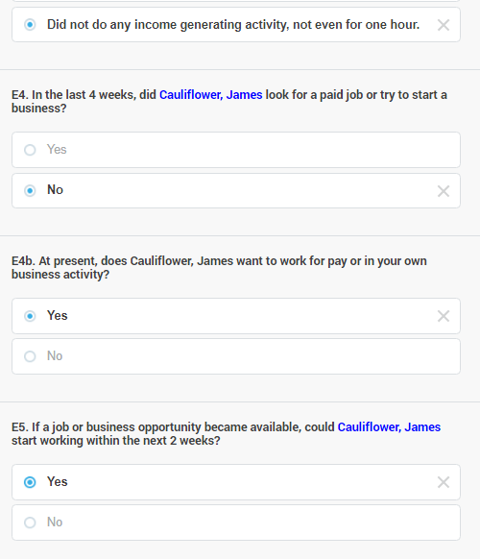

E5 then asks about the ability of the person to start with the new job or business within the next two weeks. This clarifies the ability of someone to enter a gainful employment or business. The respondent should not be required to consider any type of job or pay, but the type he or she is normally looking for anyway. He/she should reply in reference to their time availability and ability (for example being healthy enough, not busy with other duties such as caring for another person, etc.) and not on the basis of the characteristics of the job or business.

BE MINDFUL: Any activity to seek a paid job or to start a business should be considered and recorded as a YES, even if the activity was performed only for a few hours or if the job sought was a casual job. Seeking jobs or business opportunities my happen through formal or informal means. This includes applying to job postings; taking a test or job interview; applying directly to employers; posting or updating CVs in online job matching, registering and logging on to professional or social networking sites with the intent of finding jobs and business opportunities; checking for jobs at factories, work sites; seeking help from relatives, friends or others; registering with public or private employment centres etc. Activities to start a business would include applying for loans, looking for land, buildings or equipment or applying for a licence to start a business, or acquiring information about each of these with the intent of pursuing one’s own business.

7.7.2 E6. Occupation

E6. OCCUPATION – Let’s go back to Estrella, who said in E1 that she was “working for someone else for pay”, that is, in paid employment. She jumps to question E6 where you have to ask and describe her occupation. Each person who qualifies for this question will be asked what kind of work they do in their main job or business.

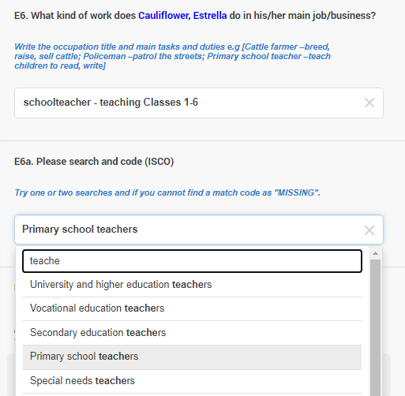

Occupation refers to the type of work done in a job by the person employed. Type of work is described by the main tasks and duties of the work. Ask the respondent to explain the type of work he/she usually carry out and record the description in the questionnaire. It is advisable to record more details than very few.

Then, in E6a, you should attempt to find a matching category for the occupation the person described. If you start typing the occupation of the person into the input box, it will give you a list of occupations with what you type. For Estrella, it was enough to start typing ‘teache’ and the list came up with Primary school teachers at the fourth place (see on the screen capture), which properly described her occupation. Sometimes more tries are necessary and some job titles (such as manager) will give longer lists. If you can’t code the occupation after a couple of tries, code it as ‘Missing’ by typing missing in the box and then selecting it from the dropdown list.

BE MINDFUL: You, as an interviewer, have to elicit and record a response that makes it possible to code the occupation according an international system (ISCO – International System of Coding Occupations) that has hundreds of categories. Especially if you can’t code the occupation yourself in F6a, someone at the Statistical Office will have to read the description in E6 and find a matching code for the occupation. Coding and the verification of the codes you give will only be possible, if you keep some important points in mind:
- always try to capture the job title, as it is on the visit card, or employment contract, or employee ID, or just how they refer to the job at the workplace. For example: Head of Department. This is necessary, but rarely enough.
- Always try to capture what the occupation is specifically about. It is not enough to capture that someone is for example a ‘driver’: in the ISCO system there are 8 different categories for drivers, depending on what they drive. So, you need to clarify what they are mostly driving and add that, for example that they are bus drivers. Or, the head of department example, it must be noted down what kind of department are we talking about, for example Head of the PR department at the Tax Authority.
- Always try to understand and record if the job involves supervision of others. One can be a plumber (coded as Plumbers and pipe fitters), but one can also call himself a plumber, but can lead a small team and organise their daily work. This is a different occupation, and he should be coded under Construction supervisors.
- Vague descriptions like ‘assistant’, ‘manager’, ‘worker’, ‘helper’, ’director’ will almost certainly will not yield in a usable code, these always need to be further precised.

7.7.3 E7-E9. Workplace characteristics

E7. INDUSTRY What is the main activity of the place where the person works? This question asks for a short free-text description of the type of work the organisation is doing the person is working with. If someone is a driver, he or she may be working in a number of industries depending on the context. The industry category will be different for a taxi driver (public transport) or ambulance driver (health industry); lorry driver (wholesale trade). By coding the industries where persons work, the country can develop an understanding about the contribution of various sectors in the total employment in the country.

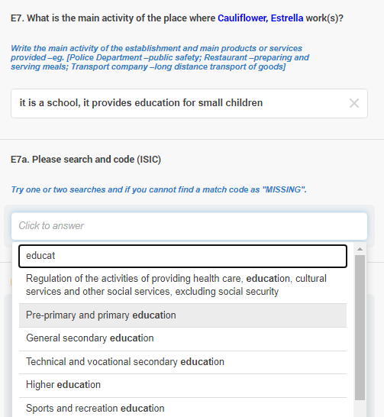

As you see, for Estrella, in E7. we could write something like “it is a school; it provides education for small children”. We could have added if it was a municipal or church school, or if it is a private school of some kind or if it is for example a French school. Interviewers will have to balance between the information required for industry coding and information that are less necessary. In this case, it could have been specified even further, because the description is in fact lacking the specific type of education the school provides: that this is a primary school. The description of the main activity of the establishment in which the work is carried out should preferably include all the relevant details that is necessary for coding.

E7b - PLACE OF WORK: In what kind of place does the person typically work? This question again refers to the main job, and expects one answer. If more than one answers could be chosen the person must select the one that characterises her or his job the best. The type of place where the respondent typically works in their main job enables analysis of working relationships and conditions in the country. It makes possible the identification of home-based workers, and, as additional supporting information, to identify domestic workers.

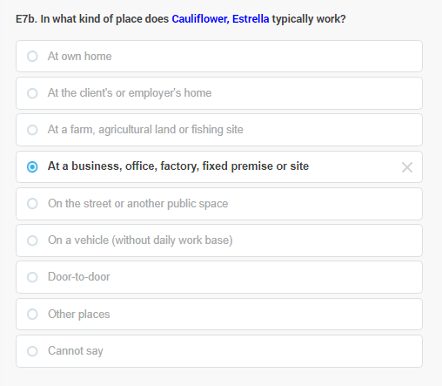

At own home includes cases where the respondent works in a space within the household premises. Teleworkers will have to indicate to be working from home.
At clients’ or employers’ home includes respondents who typically work at the clients’ or employer’s home, e.g. domestic workers, plumbers or gardeners who work at their clients’ houses, etc.
At a farm, agricultural land or fishing site refers to farmland, regardless of size or ownership status.
At a business, office, factory, fixed premises or site refers to cases where the respondent typically works at a fixed premise or site not used for residential purposes – this is Estrella’s case, as she works in a school that has its own building.
On the street, another public space includes cases where the respondent typically works on the street or another public space that enables interaction with potential clients (e.g. plaza, parking area, park, etc.) without a permanent structure. It includes street vendors, push-cart operators, operators of street stalls that are removed at the end of each day, etc.
On a vehicle (without daily work base) will include all cases where the work typically involves use of a motorized or non-motorized vehicle, including water, air or land-based vehicles.
Door-to-door refers to persons who work on an itinerant basis seeking potential clients at their residential premises without prior appointment, for example door to door sales agents

If a place of work can’t be categorised into any of the above, you may select “other places” or ‘cannot say”. Please do your best to elicit enough information that the workplace for the person could be categorised.

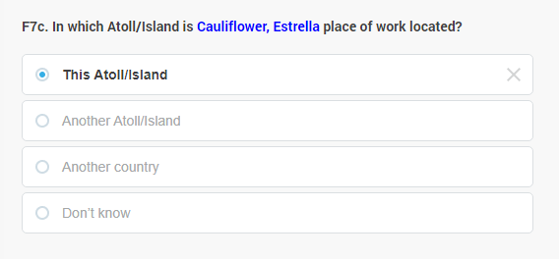
E7c - GEOGRAPHIC LOCATION OF WORKPLACE: In which District is person’s place of work located? This question supports analysis of commuting patterns. Please consider the usual location of the main activity, which may be different from the premises of the employer. Teleworkers will have to indicate to be working in their own District, even if their employer is based elsewhere.

E8. EMPLOYMENT RELATIONSHIP of the respondent in the main job/activity. The aim here is to distinguish between dependent and independent workers. Status in employment refers to the type of relationship, or employment arrangement, between the respondent and the unit they work for. The question is to capture the status in employment of the respondent as self-declared, meaning as the person reports it.

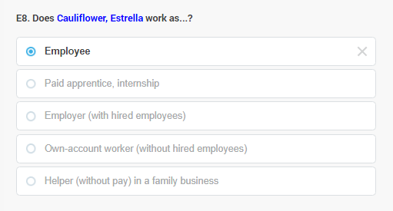

Employee: Refers to persons working for someone else for pay. This is typically a wage or salary, but may also be a commission from sales or in kind pay such as with products, housing and meals. It includes formal and informal employees with permanent, fixed-term, casual, temporary contracts or agreements, whether written or verbal.

Paid apprentice, internship: The respondent holds a paid job on a temporary basis to acquire workplace experience or skills. It includes formal and informal paid apprentices, interns, trainees, etc. It excludes employees on probation periods or on training assignments required by their job, which should be coded 1.

Employer (with hired employees): The respondent works in his/her own business activity and hires paid employees on a regular basis. Employers may hire employees on a formal or informal basis, for long or short durations, including casual employees. The distinguishing factor is that employers hire one or more employees on a frequent basis.

Own-account worker (without hired employees): The respondent works on his/her own account, without hiring employees on a regular basis. Persons working on their own-account may have business partners or family helpers, but do not hire employees.

Helper (without pay) in a family business: The respondent helps without receiving direct pay in business activity of a household member or a family member living elsewhere. It also includes cases of respondents helping a family member with their paid job.

E8a. INSTITUTIONAL SECTOR of employees. The question identifies the institutional sector of the main job/activity. The question helps in the classification of employed persons by institutional sector, including public/private sector employment. This is important for developing reliable estimates for use in the National Accounts (to calculate GDP). The question is also used in the identification of the informal sector.

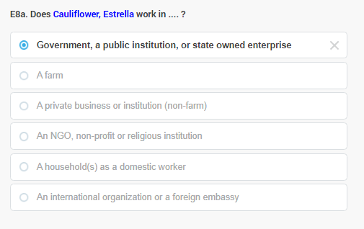

The question is asked only for respondents with a dependent employment relationship in their main job (employee, apprentice/intern, helping a family member who works for someone else). Estrella is such a person, being employed by the school, thus the question is asked for her.

It will not be asked of persons who work in their own business or in a business run by a family member. The institutional sector for all self-employed persons is by definition the private sector.

The institutional sector of employment refers to the type of institution that person works in, rather than their usual place of work. For example, a government doctor who works on call in different households works in government (first code) even though the usual place of work may be the clients’ households.

01 - Government, a public institution, or state-owned enterprise: Includes all the government institutions or state-owned enterprises (i.e. ownership of 50% or more by the state).
02 - A farm: Includes private farms or agricultural production sites, producing mainly for the market.
03 - A private business or institution (non-farm): Includes all other (i.e. non-farm) personal or private businesses, whether formal or informal, that are not publicly owned (or owned at less than 50% by the state).
04 - An NGO, non-profit or religious institution: Includes all non-profit institutions, such as NGO, charities, religious institutions, that provide their services or product to households or the community at large. It excludes NGOs controlled by the government (and to be included in code 01) or international organisations (such as the UN, to be coded as code 06).
05 - A household(s) as a domestic worker: Includes private households as employers of domestic workers only.
06 - An international organisation of a foreign embassy: Includes public institutions but owned by foreign or international institutions such as foreign embassies etc. International private companies should be under code 03.

E8b. JOB-RELATED SOCIAL CONTRIBUTIONS: Question is to clarify, according to the best knowledge of the person, whether the employer pays social contributions for the respondent. Question only asked from dependent workers. This question is part of the sequence of questions to identify persons in informal employment.

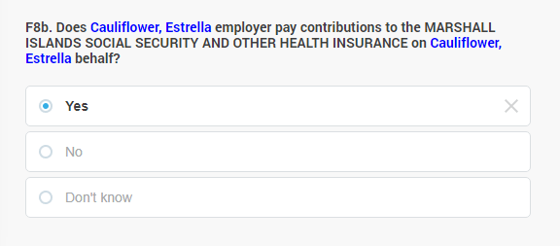
Non-job dependent social contribution schemes, such as means-tested and universal schemes, should not be considered in this question. It needs to be ensured that respondents understand that the question refers to the payment of social contributions by their employer, and not by themselves.

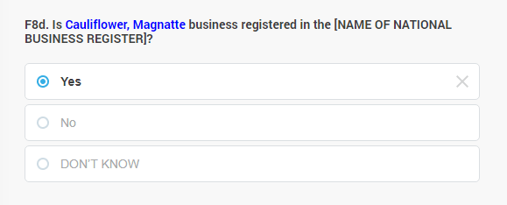
E8c-d REGISTRATION OF THE BUSINESS: Question asked from independent workers (business owners, farm owners, employers of other workers in the private sector, etc.) and it simply asks whether or not the person’s business is incorporated in the national business register or not. In other words, if their business legally exists or not. This question is one among those that help to estimate the informal sector in the country. The question has two variants with the same content, E8c for agricultural businesses (farms) and E8d for non-agricultural businesses.

E9. HOURS WORKED Question to capture the number of hours worked in the main job in the reference week. Information collected here supports the breakdowns of the employed population by bands of hours worked and compare the working hours across different segments of the society.

Hours worked refers to the actual time spent in the main job during the reference week for the performance of activities that contribute to the production of goods or services involved with the person’s main job. It includes direct hours carrying out the tasks, regardless of the location where they are performed; related hours spent maintaining or facilitating the work; down time due to interruptions; and resting time spent for short periods according to established norms or national circumstances. Exclude time spent travelling between the home and the place of work, as well as time spent on long breaks, for example, meal breaks. Also exclude any work activity that the person performed outside of her or his main job.

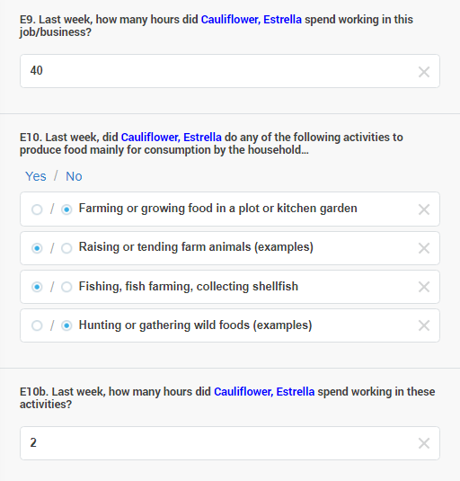

If the respondent cannot provide a total number of hours actually worked, interviewers are advised to assist with recall by asking about hours worked each day and adding up the days worked in reference week. Record hours in 0.5-hour intervals. Round up or down to the nearest 0.5 hours if necessary.

E10. ANY WORK IN AGRICULTURE/FISHING FOR OWN USE: Even among gainfully employed persons, some work in agriculture/fishing mainly for household consumption is not unusual. E10a-b ask if the person has engaged in such activities in the reference week and if yes, how many hours he or she spent with that. This question is part of the question-set aimed at identifying persons in own-use production or catching/collecting hunting of foodstuff.

E10b asks the number of hours the person worked in the reference week to produce goods from agriculture or fishing etc., for own consumption. The information is used to produce estimates of working time in own-use production of foodstuff as well as to estimate total time spent working among working age adults. Hours worked refers in this case to time spent directly on and in relation to farming/fishing work activities by the respondent to produce goods intended mainly for final consumption by the household or family. Record hours in 0.5-hour intervals. Exclude time spent travelling between the home and the land plot, lake, sea, etc. for example at the start and end of the work activity, as well as any time spent on long breaks, for example, meal breaks.

E11. WORK SUPPORTING THE HOUSEHOLD The question clarifies if person of working age regardless of their economic activity were involved, during the reference week, in various domestic work activities which are not strictly productive (in the sense that they are not paid for) but essential in upkeeping and ensuring the well-being of the household / family.

The questionnaire does not record time spent, only the involvement of the person in each of these activities, which you have to indicate by tapping on the appropriate button.

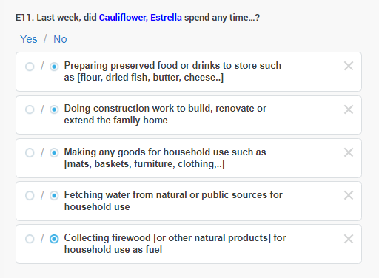

7.8 F. Fertility and Mortality

This section includes a series of questions related to fertility and mortality, the two major components of population change. The section starts with question regarding childbirth and childbearing (i.e. fertility, F1 to F8) which are asked of women aged 12 years and over. These include questions asking about whether the women ever given birth; asked about the total number of children ever born, also asked about children’s current living location. There is also a set of questions asked about the woman’s children that are no longer alive. And lastly, other questions asked about the last child born of the woman. The information collected in this section is very useful in determining and to estimate fertility and mortality in the country.

BE MINDFUL: You will encounter women who had their children passed away, either after birth, or later as a child or as an adult. Recollecting these memories may be a traumatic experience for these mothers, and they may show signs of distress. Allow them time to express their pain and sorrow and gently reassure them that you are mindful of their situation and you are sorry for their loss. Be compassionate, and politely explain that it is unfortunately necessary to understand these issues in order to probably avoid similar tragedies in the future. Do not, under any circumstance, blame a mother for her feelings about the loss of her child, for example, do not tell them not to cry or anything similar.

7.8.1 F1-F2 Any children

F1. ANY BIRTHS – Has person on the household roster ever given birth to a live child, even if the child died soon after birth? This question serves two purposes; to introduce the section and to learn whether the respondent has ever given birth or not. It is also a filtering questions to differentiate those women who had given birth and those who have had not given birth yet.

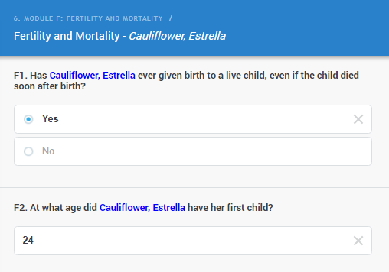

F2. AGE AT FIRST BIRTH records the age the women gave birth to her first live-born child. Record completed age: the age at the most recent birthday before the child was born. Make sure that the age of the woman refers to the age of the women when she had her first child and not her current age, at the time of the interview.

The age at which child bearing begins influences the number of children a woman may bear throughout her reproductive years. The information collected in this question will improve the level of understanding of the current and future levels of fertility and eventually the future population size.

7.8.2 F2a-F4c All children born

F2a and F2b. BOYS/GIRLS EVER BORN – How many boys and girls has the woman ever given birth to that were born alive? Information about the total number of living children the woman has ever given birth to by sex is very crucial in the calculation of fertility level. They are two important input data in the fertility analysis – the number of live-born girls and boys – which together produce the total number of live-births by the woman interviewed. Your duty is to accurately collect the right number of children the woman ever given birth to that were born alive. Record the right answers by inputting the number in the box, first the number of boys, then the number of girls.

Enter ‘0’ if the woman has no children of the specific sex.

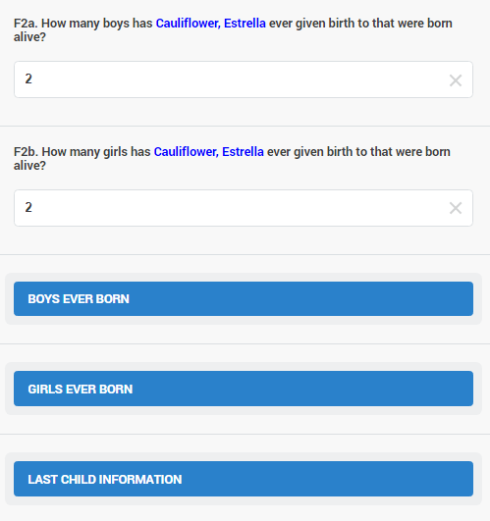

You will notice that if you enter a number higher than zero in any of these two fields, the buttons “BOYS EVER BORN” and “GIRLS EVER BORN” turn blue, and become active.
F3a-F4a BOYS/GIRLS ALIVE LIVING AT HOME – How many children, boys and girls, has the woman ever given birth to that were born alive and live in the household? These questions refer to the woman’s sons and daughters who are alive and living or staying with her in the same house. Remember that we are only interested in the respondent’s OWN natural (biological) children and not foster children, children of her husband by another woman, or children of a relative.

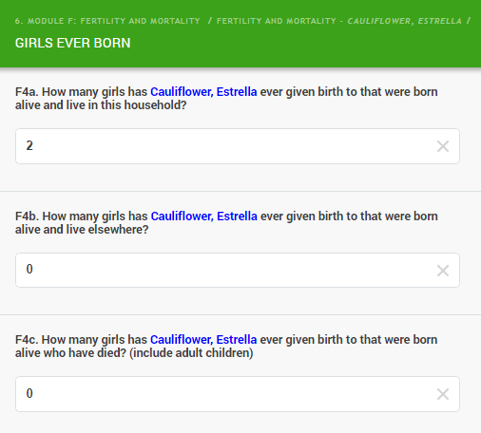

F3b-F4b BOYS/GIRLS ALIVE LIVING ELSEWHERE – How many children, boys and girls, has the woman ever given birth to that were born alive and live elsewhere? These questions refer to the woman’s sons and daughters who are alive but not living with her. For example, they may be living with a relative, may be staying in a boarding school, may have been given up for adoption, or may be grown-up children who have left home and are living separately. Make sure the woman is not reporting children who are not currently alive in this question. Explain the question clearly and record the right answers.

F3c-F4c. CHILDREN NOT ALIVE – How many children has person on the household roster ever given birth to that were born alive but have died?: These questions on children who were born alive, but later have died/not alive are extremely important for calculating mortality level. They are among the most difficult questions to administer on which to obtain accurate data. Some women/mothers may fail to mention children who died very young, so if a woman answers NO, it is important to probe by asking, “Any baby who cried or showed signs of life but survived only a few hours or days?” Some women/mothers may be reluctant to talk about this subject and may become sad or upset that you are asking such questions. Be sympathetic and tactful in such situations. Ask the question politely and record the answers correctly. Never, under any circumstance criticise the behaviour, either with words or by gestures (like rolling your eye, etc.) of a mother that shows distress when recalling the loss of a child. This would be extremely rude, unprofessional and may lead to disciplinary action.

BE MINDFUL: The total of the boys and girls living at home, living elsewhere and deceased must equal to the total number of boys and girls given birth to. This is checked by the computer and an error message will display if the two numbers do not match.

7.8.3 F5-F8 Last child

F5 LAST CHILD BIRTHDATE AND F6. LAST CHILD SEX Information on date of birth (month and year) of the last child born alive and on the sex of the child is used for estimating current fertility. F5a asks the MONTH an F5b the YEAR when the last live birth was given by the woman. Then, the sex of this last child who was born alive has to be recorded, in F6.

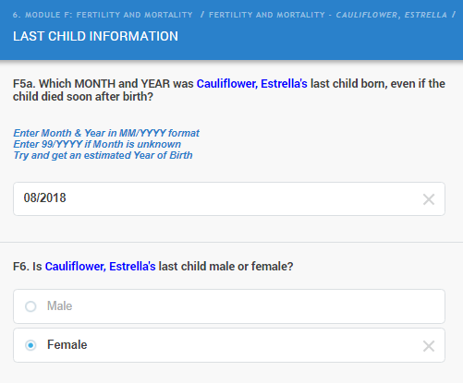

Ask both questions separately and record the right answers accordingly.

F7. LAST CHILD STILL ALIVE? – Is the woman’s last child still alive? Remember that this question refers to the last child of the woman, the one who’s sex and birth year and month you registered in the previous questions. Ask if this last child of the woman is still alive or not. The information collected in this question is useful for the analysis and estimate of mortality (infant, child and adult mortality). Record the answer correctly.

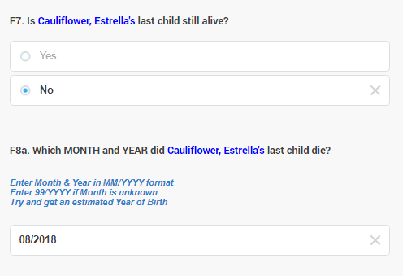

F8. LAST CHILD DATE OF DEATH – If the child born last is not alive anymore, you will need to ask the date of his or her death. The computer will not accept a date for the death that is before the date of birth.

The information collected in this question is of most important to provide accurate estimate of mortality. As an interviewer, you should try to obtain the most accurate date of death of the last child of the woman. Misreporting the date could have a great impact on the computed level of mortality in the country. As usual, ask the question politely and compassionately, and record the date of death in the spaces provided.

7.9 G. Housing and household information

7.9.1 Completing the ‘Housing and households’ section

To complete the housing section, you will need to find a suitable respondent. The best person to interview is the head of the house or his or her spouse. In case that the head or spouse is not available, we recommend to schedule a visit when any of those two persons will be available to be interviewed. Alternatively, you may be able to find another adult member of the house who is sufficiently informed about the housing arrangements and other characteristics of the building used as a dwelling.

Some questions in this section are for observation only such as questions related to the building and structure. With these questions, you do not need to ask the respondent since you will usually be able to see the answer for yourself. However, you ALWAYS should ask if you are in any doubt.

The following are the common key terms used in this section. You should study and understand them clearly as they will assist you in understanding the questions and answers provided:

Structure – is a free-standing building or other construction that can have one or more dwelling units for residential or commercial use. Residential structures can have one or more dwelling units (for example: single house, apartment structure)

Living quarters – A structure with one or more dwelling unit. Any structure where at least one person is living permanently, counts as a living quarter.

Dwelling unit – is a room or a group of rooms normally intended as a residence for one household. Note that some dwelling units may not be designed to be residential units. In any case, if a structure or a section of a structure is occupied by people for residential purposes (they live and cook there) it must be considered a dwelling.

This Housing section is designed with five sub-sections for easy reference while using the tablet for data entry, see on the screenshot:

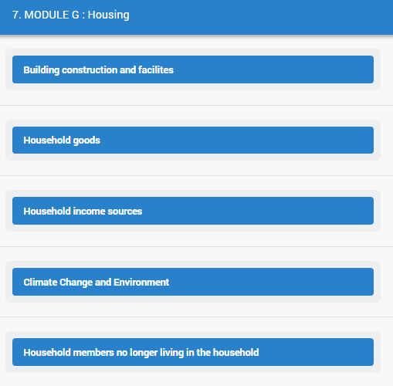

7.9.2 G1-G5 Type of housing

G1. BUILDING TYPE Which types of living quarters does this household live in? The purpose of this question is to obtain the information about the building that the household is living in. You will come across different types of buildings or housings arrangement that the household is residing in during your work. For example, some households may live in a single building with several rooms. In some cases, there might be two other buildings detached from the main house, which the household uses for other activities. Other households might be staying in a dwelling with several rooms attached to a commercial institution.

The information on the description of the building in which the household is living in provides a better understanding of other related health, social and economic background of the members of the household. Make sure to observe the building or the house that the household resides in and ask the qualified respondent to confirm if there are other houses close by which could also belong to the same household. Select one response for this question, which best describes the situation you observe. If the building description is not among the answer categories, then simply tap “Other (specify)” and write the description of the building in the space that opens up (G1a).

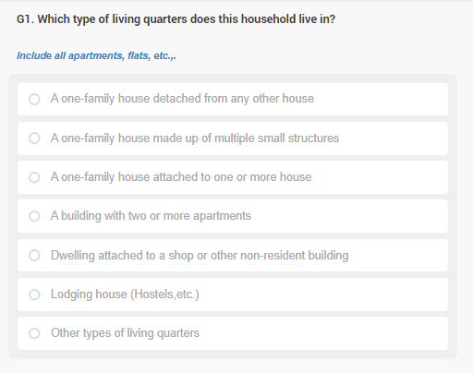

Below is the list of answer categories with some clarifications:

One-family house detached from any other house: refers to one single house/dwelling that is not joined to other dwellings by one or more walls and is not also in the building used for a shop or other commercial related activities.

One-family house made up of multiple small structures: refers to a living quarter which has several houses or dwellings.

One-family house attached to one or more house: refers to a living quarter that is part of a section of rowhouses or of a twin-house.

A building with two or more apartments: refers to block or flats, an apartment or town houses.

Dwelling attached to a shop or other non-resident building: refers to a dwelling that shared a common wall to shops or other commercial related activities.

Lodging house: is like a hostel where people either share rooms or have separate rooms but share either cooking or washing facilities.

Other (Specify): You will select this option if the building does not fall in any of the above description.

G2. HOME OWNERSHIP STATUS: This question collects information about the house ownership and whether the household is paying rent or not while occupying this building.

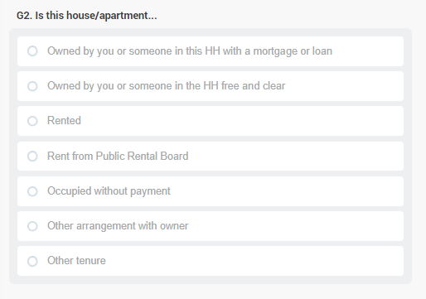

Select one right answer only according to the answer provided by the respondent and enter the code in the space provided from the list of answer categories:

Owned by you or someone in this HH with a mortgage or loan: The head of household or any other member(s) of this household own(s) the house through mortgage or loan that the household still continues to pay off for getting the house.

Owned by you or someone in this HH free and clear: The house is owned by the head of the household or other members of the household without any outstanding loan or payment.

Rented: The house is rented from private entities with payment arrangement are done on a regular basis either at a weekly, monthly or annually.

Rent from the Public Rental Board: The house is rented from a public body designated to provide housing (Public Rental Board) with payment arrangement are done on a regular basis either at a weekly, monthly or annually.

Occupied without payment refers to arrangements sometimes made between an employer or owner of the house/dwelling and the household to occupy the dwelling or house without any payment.

Other arrangement with the owner: may mean that the house/dwelling is provided for the household maybe in exchange for other services or for work to be performed in exchange (serving the owner’s guests, mowing the lawn, etc.)

G2b. AGE OF THE DWELLING Ask the person the year when the dwelling was initially built and enter in the field provided. If the dwelling was completely reconstructed or rebuilt during its lifetime, please indicate the year of the last major reconstruction when most of the structure was built fresh. If the person does not know the precise year when the dwelling was constructed, make sure you elicit an informed estimate.

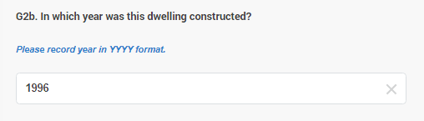

G3. MATERIAL OF THE FLOOR: This question asks about the main material used to construct the floor of the main building (if there are several). The main building refers to the building that the household uses mostly for their daily activities. Households may use more than one material for constructing the floor. Look for the most common one and record it accordingly.

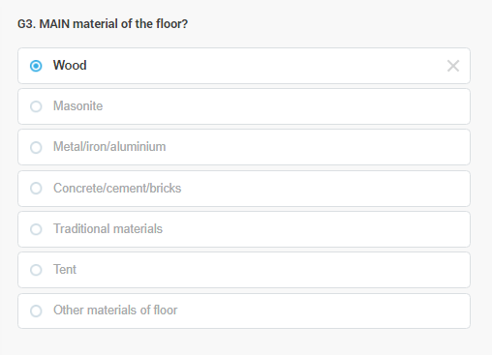

You should normally be able to identify the answer by observing the dwelling, given that you were allowed into the main building the household uses. If not, this and the next questions need to be asked from the reference person.

Most answer categories are self-explanatory. By traditional materials we mean that the floor is mainly made of any local or traditional type of material such as coconut midribs, etc. Materials that are named specifically in other categories are not to be considered here.

An option “Tent” is provided for tent-like living quarters where there may be no specific floor material.

Category Other (specify) should be used for any other type of material used for the floor that does not fall in one of the above categories. If selected a text box gets enabled where the response needs to be typed in (G3a)

G4. MATERIAL OF THE ROOF: This question asks about the main material used to construct the roof of the main building. Use your observation and enter one right answer only from the list of answer categories provided. As in the previous question, you may select the other option for materials not included (type in to G4a).

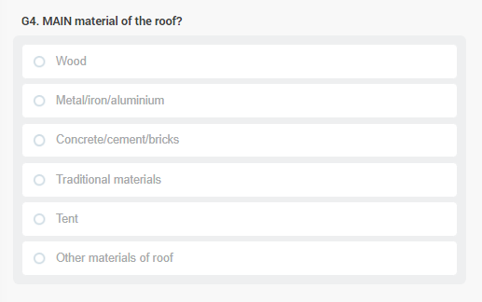

G5. MATERIAL OF THE OUTER WALL: This question refers to the main material used to construct the outer wall of the main building. Use similar approach as details in the G3 and G4 to confirm the material type and record the right answer using the answer categories in G3.

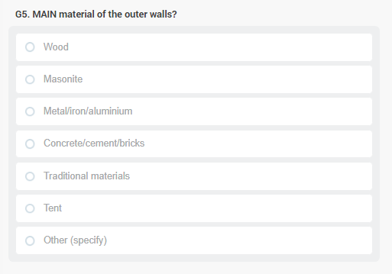

7.9.3 G6-G12 Facilities

G6-G7. WATER SUPPLY The purpose of these questions is to assess the how healthy is the source of the household’s water by asking about the household’s main source of water, separately for drinking water (G6) and water used for cooking and personal hygiene (G7). From this question, the proportion of the total households in the country with good access or very poor access to safe drinking water is determined. Increased access to improved drinking water source results in improved health outcomes in the form of reduced cases of water-borne diseases and sickness like dysentery and cholera.

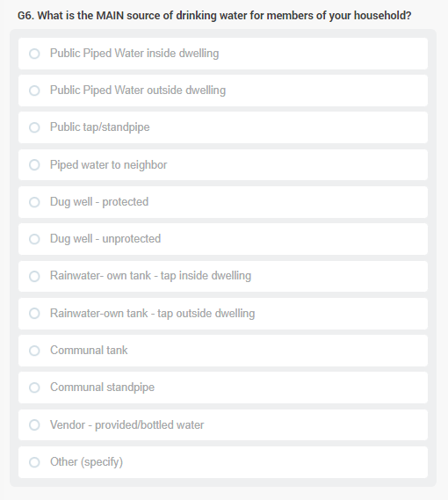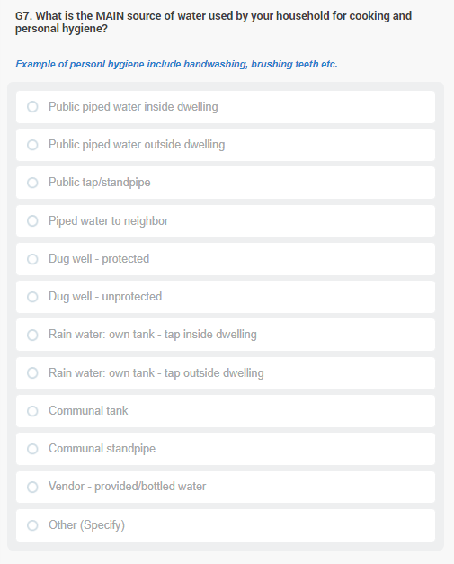
The intention of question G7 is to find out about the source of water the household used for cooking and other personal hygiene related activities. Ask both question as they are written and use the list of answer categories provided. In both question you may select “other” and a space will open to write in the type of water source not included in the code list.
BE MINDFUL: If the household uses more than one source, you can mark each on the response list, by marking in the check boxes. Please only mark typical sources of water, so for example if someone drinks bottled water very infrequently (i.e. less than on a weekly basis) that does not need to be marked. Focus on the usual types that are part of the family’s daily routine.

G8. TOILET FACILITIES The main purpose of this question is to obtain a measure of the sanitation level of the household, since toilet facilities are important for disease control and health improvement.

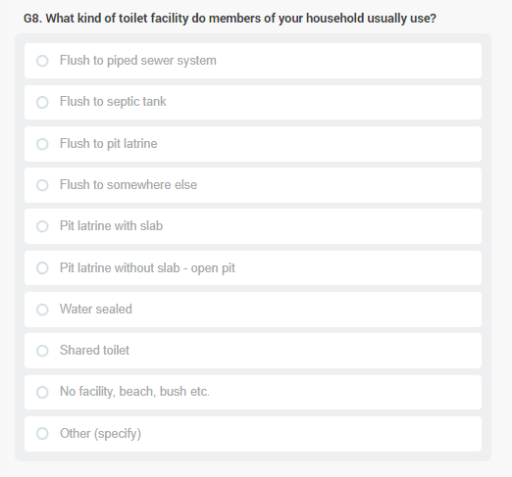

Below are some definitions for the terms used in the codes for this question:

Definitions of Toilet Facility Codes in G8
Flush/pour flush toilet | A flush toilet uses a cistern or holding tank for flushing water and has a water seal, which is a U-shaped pipe, below the seat or squatting pan that prevents the passage of flies and odours.  A pour flush toilet uses a water seal, but unlike a flush toilet, a pour flush toilet uses water poured by hand for flushing (no cistern is used).
- to piped sewer system | A system of sewer pipes (also called sewerage) that is designed to collect human excreta (faeces and urine) and wastewater and remove them from the household environment. Sewerage systems consist of facilities for collection, pumping, treating and disposing of human excreta and wastewater.
- to septic tank | An excreta collection device consisting of a water-tight settling tank normally located underground, away from the house or toilet.
- to pit latrine | A system that flushes excreta to a hole in the ground.
- to somewhere else | A system in which the excreta is deposited in or nearby the household environment in a location other than a sewer, septic tank, or pit, e.g., excreta may be flushed to the street, yard/plot, drainage ditch or other location.
Pit latrine | Excreta are deposited without flushing directly into a hole in the ground.
- pit latrine with slab | A latrine with a squatting slab, platform or seat firmly supported on all sides which is raised above the surrounding ground level to prevent surface water from entering the pit and for ease of cleaning.
- pit latrine without slab/open pit | A latrine without a squatting slab, platform or seat. An open pit is a rudimentary hole in the ground where excreta is collected.
- water sealed | A latrine with water sealing
Public shared toilet | A public toilet used by the public with the system in which excreta is deposited either to piped sewer system, septic tank or other types of system.

G8b-c. SHARED TOILETS: Do you share this toilet facility with others who are not members of your HH? The purpose of this question is to establish whether the toilet facilities used by this household are shared with one or more other households. The number of households that share toilet facilities is an important measure of the level of hygiene in the household.

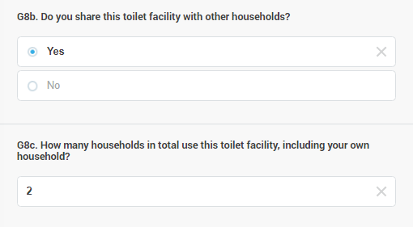

G8c. How many HHs in total use this toilet facility? This is a follow up question from question I8a if the household shared the toilet facility with one or more households. You will ask this question only if the answer in question I8a “Yes”. At this stage, we want to find out exactly (or at least approximately, if it is not easy to tell) how many households including the respondent’s household that use the same facility. Record the total number of households in the field provided.

G9. COOKING FUEL What type of fuel does your HH mainly use for cooking? Information on the type of fuel used for cooking is collected as another measure of the socioeconomic status of the household. The use of some cooking fuels can also have adverse health consequences. Remember that this question asks about fuel for cooking only, not fuel for heating or lighting.

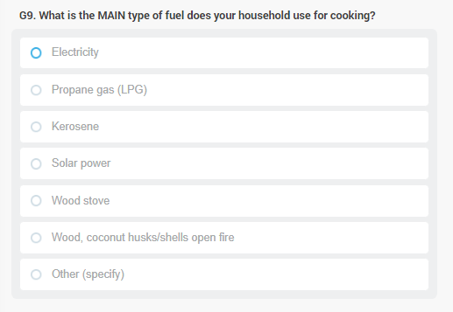
The question allows for a single response, please mark the type of fuel the household is usually using for cooking. If any fuel other than the pre-coded ones is reported as used for cooking, enter code ‘Other’ and specify the type of fuel in the space provided.

G10. SOURCE OF ELECTRICITY This question clarifies the household’s main source of electricity whether it is from the public grid, from own generator, solar and others. Similar to the above questions, this information is collected as another measure of the household’s socioeconomic and environmental status. You may record one answer describing the type of electricity the household has access to and usually use.

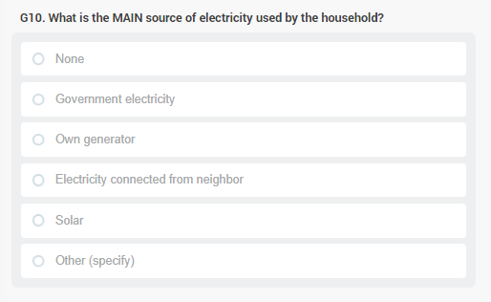

G11. SOURCE OF LIGHTING This question asks about the household’s main source(s) of lighting whether electricity, solar, kerosene and others. Similar to the above questions, this information is collected as another measure of the household’s socioeconomic and environmental status. You should record multiple answers describing the source(s) of lighting the household mostly used.

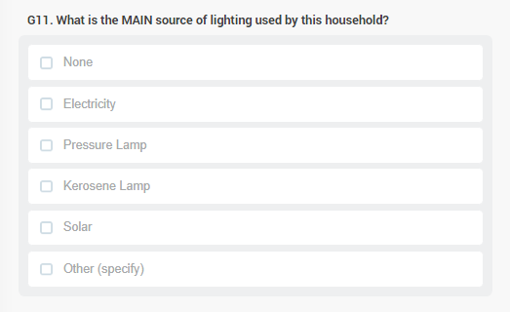

G12. WASTE DISPOSAL Poor waste management and household’s improper waste disposal can be an environmental hazard as well as a cause of diseases breakout such as dysentery and cholera. This question collects information on where the household’s dispose its waste which is a good measure of household’s environmental impact. You may record one reply, indicating the typical forms of waste disposal.

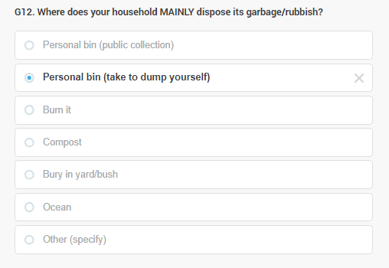

7.9.4 G13. Household goods

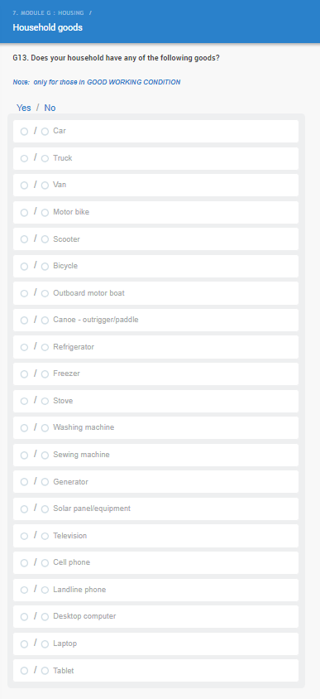
The answers to these questions will be used as a rough measure of the socioeconomic status of the household.

Please note that, this is a multi-select question and you will have to tap into the items that are only owned by the household. Select the ones that are available in the house.

Select ‘None’ if the house owns nothing of the listed items.

BE MINDFUL: One item should only be recorded once. Please make sure if the household reports they have a car and they also have a truck – they actually refer to different vehicles or not. If not, ask them to decide where to record that vehicle. Similarly, motorbike and scooter should be two different vehicles. A portable computer should be categorised either as a laptop or a tablet (sometimes modern devices could be somewhere in between), and it also has to be decided by the respondent that a large-screen smart device is categorised as a cell phone or a tablet, but should not be both. The purpose is to record each item the household owns only once.

Fields I13a-I13u will open if a category of household goods is confirmed to be present in the household. For each confirmed type, you have to clarify how many they have in the household. The computer will allow any number above 1 but will ask you to double-check in case of suspiciously high numbers.

G13g INTERNET AT HOME The section ends with a simple question whether or not the household has Internet access at home. This may be any technology (mobile, wired, fibreoptic, etc.). By Internet we mean some kind of access that allows for a stable connection that is usually available for the household.

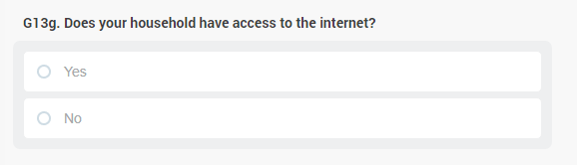

7.9.5 G15-G16 Source of household income

G15a. SOURCES OF INCOME What is are the sources of income your household received in the last 12 months? Income is one important component of any measure of socioeconomic status and financial well-being, influencing families’ access to social and economic resources such as education, health, good housing facilities and so forth. Therefore, the information collected from this question would provide further understanding of the status of the households and its members.

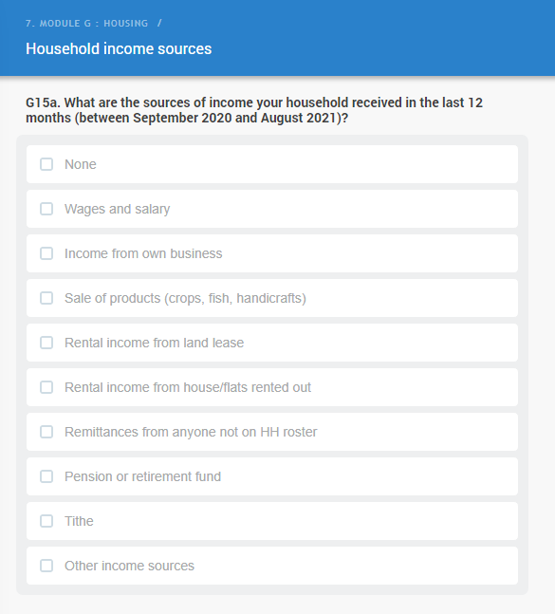

BE MINDFUL: The time reference in this question is the last 12 months. If a household receives income from various sources, mark them all.

7.9.6 G16-G21 Climate Change and Environment

EXPERIENCE OF DETERIORATING NATURAL ENVIRONMENT: The section on environmental problems and hazards aims at shedding light on the possible adverse consequences of the changing global – and local – climate-related and other man-caused damages of the environment.

The section begins with a list of environmental problems, asking if each of these affected the household or their village (G16). This may be their current village or any previous one where the household resided.
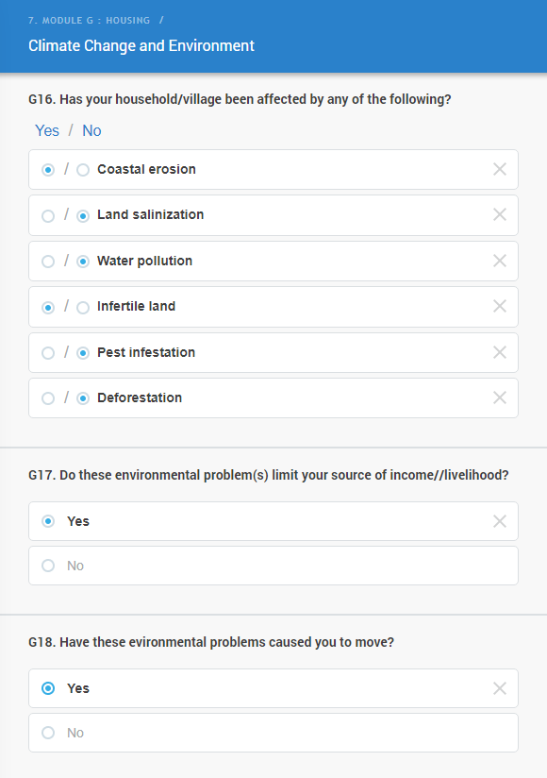

If any of the environmental problems are confirmed, G17 will ask if these problems currently limit the household’s source of income and livelihood and G18 if the household has ever had to move due to (some of) these environmental problems.

ENVIRONMENTAL HAZARDS: The section continues with a list of environmental hazards, asking if each of these affected the household or their community (G19) over the past 10 years. This may be their current community or any previous one where the household resided.

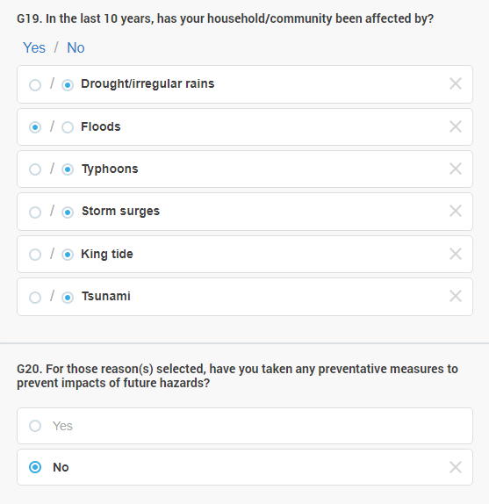

If any of the environmental hazards are confirmed, G20 will ask if the family was able to take any preventive measures to decrease their exposure to the risk these hazards mean for them. Please take a Yes answer only if the person felt that they were able to take some measures – effective or not – against ALL the hazards mentioned as relevant. For the definition of “preventive measure”, we defer to the respondent – whatever they feel like a preventive measure needs to be accepted as such in this reply. While it is not specified in the question, we are still considering the past 10 years timeframe for these possible actions.

For those said they did not take any precautions or “preventive measures” G21 will ask the reason why they did not take any preventive measures in the past 10 years. The question includes several options that will cover most of the typical responses given to this question, please select all that apply to the household.

BE MINDFUL: For most people it is hard to remember what happened 10 years ago. Please help them with finding an event relevant either in the country of in the family that helps to relate them to this time period.

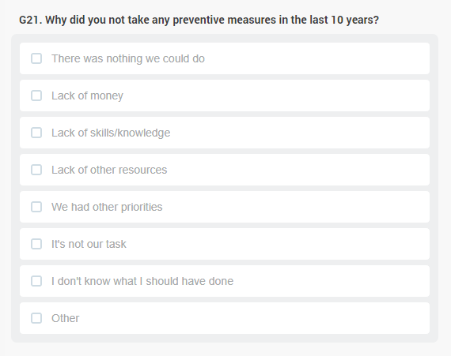

7.9.7 G22-G23 Household members no longer living in the household

This section asks for those previous household members who are no longer living in the household. The question asks for the last 10 years, meaning that the enumerator has to list all persons who lived in the household over the past 10 years but not anymore, because they moved out, or passed away. Having lived in the household means to having had the dwelling of the interviewed household as one’s usual residence, that is, to have lived in the household for at least over six months. Information collected from this section is important as we could determine the mortality indicators for those who have died as well those who have migrated to other places for various reasons.

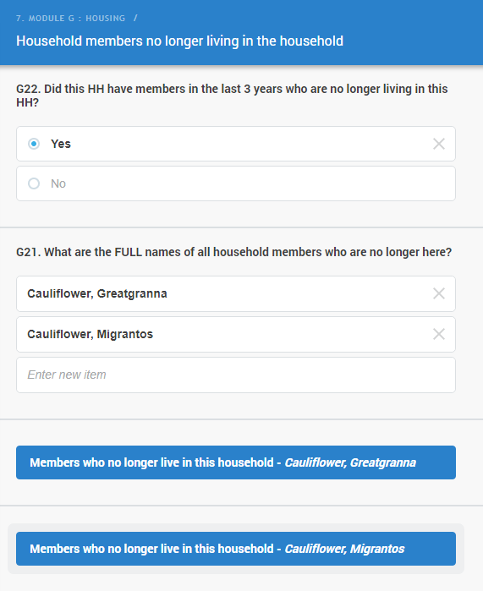

BE MINDFUL: For most people it is hard to remember what happened 10 years ago. Please help them with finding an event relevant either in the country of in the family that helps to relate them to this time period. If a departure or passing away is recalled that was 10 years ago, try to ascertain that it was indeed within the past 10 years compared to the day of the interview, or earlier 10 years ago. Only include departures/deaths that strictly occurred within the past 10 period (this may be more difficult with migration as it may be a more gradual process, in those cases rely on respondent judgement).
ALSO BE MINDFUL: The household you are interviewing may not have existed 10 years ago. In this case, the period since the household exists should be considered. It may be that the current household took over their current dwelling from a previous household with whom part of the current household lived together before (for example in the house/household of the current Head of Household’s parents, who in the meantime retired or one or both of whom may be deceased), in that case we consider the current household being the continuation of the previous and the full 10-year period counts, even if the current household setup was established later.

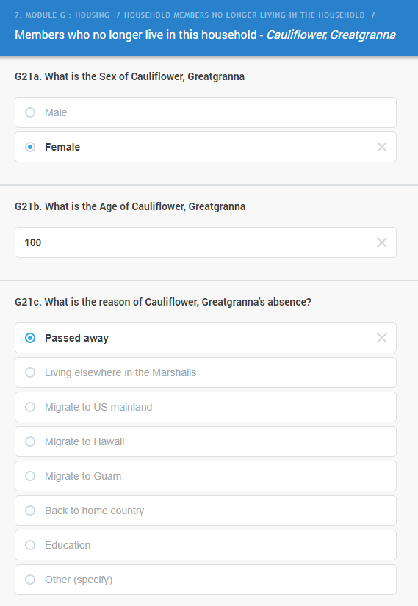

THE ISSUE OF MOVING: Households may have changed their dwelling during the course of the past 10 years. Anybody, who lived with the household over the past 10 years in any of the dwellings the current household used over this period, counts and may be listed, if the person is not with the household anymore.

Similar to the Household Roster, the same procedure applies where a list of names has to be entered for those who lived in the household in the past 10 years but are no longer living in the household. Once the list is complete, a number of questions are asked about each individual in the list.

For each person, who are not with the household anymore, a number of questions are asked. It starts with the sex of the person, then the age. You also need to select the reason why the person is not with the household anymore. Please register the immediate reason when they left the household in the first place; for example, if a person left a household to live somewhere else, and died after that, the reason recorded should be the person left to live somewhere else.

BE MINDFUL: If you are registering a person who no longer live with the household because they have deceased, their age at the time of their death should be recorded.

If a previous member of the household left because (s)he passed away, a question is added to clarify in which country the person died. The list only includes the most typical options, without the need of specifying if the person dies somewhere else.

For all past members of the household, the exact date of departure (when they left to somewhere else or when they deceased) is to be recorded as precisely as possible, although the question will allow for ‘99’ codes when exact dates are not known.

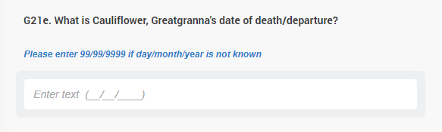

7.10 H. Agriculture and Fishing

H1. Has any member of this household conducted any of the below activities in the last 12 months? Note carefully that this question has several parts to be completed correctly and accordingly. You would need to ask this question in related to all activities as listed in the table and considering all members of the household and record the right answer correctly in the right place. For instance, if the household grew food crops in the last 12 months, you should mark the button in the first column that say ‘Yes’, in that row. If they did not raise livestock, you need to tap the button in the second column that says “No”.

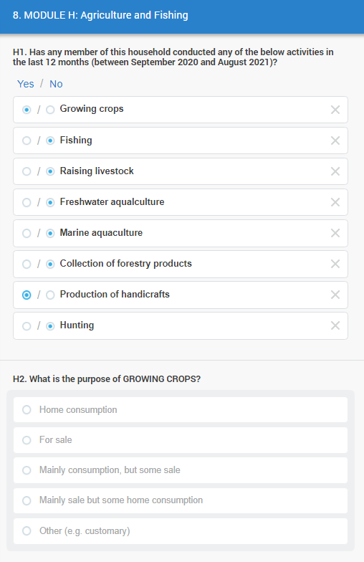
Ask the second part regarding the purpose of this activity and enter the right code whether the purpose of the activity is for home consumption, for sale or others. All the activities confirmed above will have all the answers required in the follow up, here we only show the first one, GROWING CROPS.

H2-H9. What is the purpose of each activity? The main purpose of this question is to find out the purpose of being involved in each activity for the past 12 months.

NOTICE: in H8. For handicrafts, instead of “Home consumption” you’ll find “Gift to family, friends”, this should also include when people produce artisanal tools or appliances for themselves, for their own use.

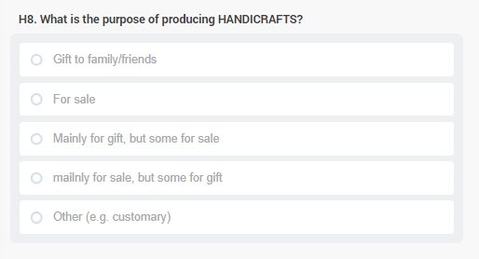

7.11 I. Food Insecurity Experience Scale

FOOD INSECURITY – Section K lists eight different statements, all related to potential problems with having enough for everyone in the household to eat. This is an international instrument that is widely used to estimate the risk of food insecurity in societies.

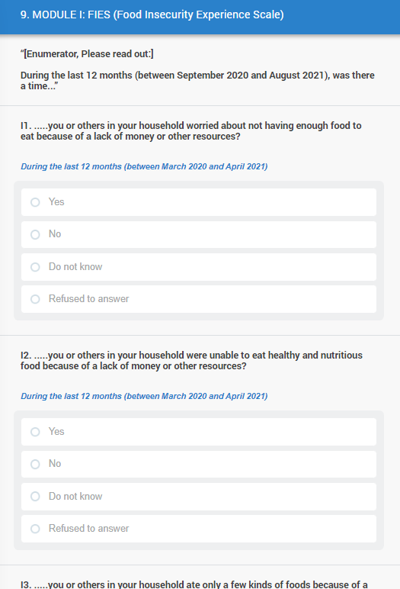

The question starts with a lead that you need to read out which defines that the timeframe to be considered is the past one year: During the last 12 months (between September 2020 and August 2021), was there a time...”

Than it continues with eight yes/no questions, as follows:

I1. .....you or others in your household worried about not having enough food to eat because of a lack of money or other resources?
I2. .....you or others in your household were unable to eat healthy and nutritious food because of a lack of money or other resources?
I3. .....you or others in your household ate only a few kinds of foods because of a lack of money or other resources?
I4. .....you or others in your household had to skip a meal because there was not enough money or other resources to get food?
I5. .....you or others in your household ate less than you thought you should because of a lack of money or other resources?
I6. .....your household ran out of food because of a lack of money or other resources?
I7. .....you or others in your household were hungry but did not eat because there was not enough money or other resources for food?
I8. .....you or others in your household went without eating for a whole day because of a lack of money or other resources?

Please read these out to the respondent and record their reply. If they are hesitant, probe by reading the item again. If they still can’t determine an answer, you may take a Do not know as a reply. Some people may be embarrassed about problems with hunger and food stability in their household, they may have a tendency not to answer these questions. Please reassure these respondents that the answers they give will remain confidential and it is very important that the census collects everyone’s experience. If they insist not to answer (some of) these questions, you may code ‘Refused to answer’.

7.12 Manual Household location + Photo

Finally, before fully closing the enumeration of a household, you will be required to manually confirm the location of the interview, by pointing at it, as precisely as you can, on the map displayed on your tablet.

Once the location has been stored, you need to take a photo of the dwelling, from the outside, from the direction of the street, or if this is not applicable, showing the main entrance.



