Supervisor Manual
for the Population and Housing Census, 2021

Nauru, Bureau of Statistics Office
Ministry of Finance
Yaren District, Nauru
Telephone: (674) 444 3133 (ext 255)

Table of contents

Table of contents 2
GLOSARY OF ABBREVIATIONS 4
CHAPTER 1: WELCOME TO THE TEAM 9
1.1 How to use this Manual 10
2. THE CENSUS 11
2.1 What is a Population and Housing Census? 11
2.2 Why take a Census? 12
2.3 How do we take the Census? 12
2.4 Who provides Census information? 12
2.5 Confidentiality 12
2.6 How is people’s information kept confidential? 13
CHAPTER 3: ORGANISATIONAL AND ADMINISTRATIVE MATTERS 14
3.1 Calendar of major field operation 14
3.2 Line of supervision and flow of communication 15
CHAPTER 4: TRAINING AND ENUMERATION AREA ASSIGNMENTS 16
4.1 Training of Census Field Supervisors 16
4.2 Training of field staff 16
4.3 Training curriculum 17
4.4 Assigning work to Enumerators 18
CHAPTER 5: FIELD SUPERVISION AND CONTROL 19
5.1 You as a leader 19
5.2 Managing fieldwork 19
5.2.1. Meetings between Supervisor and Enumerators 20
5.2.2. Verification of the Enumeration Area 20
5.2.3. Verify the list of institutions prior to Census Day 20
5.2.4. Communicating effectively with Enumerator 21
5.2.5. Observing the conduct of enumeration 21
5.2.6. Correcting errors as early as possible 22
5.2.7. Conducting spot checks and re-interviews 22
5.3 Handling enumeration and other field problems 23
5.3.1. Refusals 23
5.3.2. Call-backs 24
5.3.3. Other Field Problems. 25
5.3.4. Report of calamity, disaster or abnormal conditions 25
5.3.5. Report of accidents 25
5.3.6. Report of problem areas 25
5.3.7. Report of loss or damage to Census equipment, documents or materials 25
5.4 Resolving problems with Enumerators 25
CHAPTER 6: SUPERVISOR ROLE TECHNICAL OPERATIONS 27
6.1 Supervisor Login to Survey Solutions 32
6.2 How to review approve/reject a questionnaire 35
6.3 How to check status and overall progress of data collection during fieldwork 36
6.4 Supervisor’s role: Monitoring of interviews 37

GLOSARY OF ABBREVIATIONS

EA Enumeration Area
SA Supervisory Area
PHC Population and Housing Census
NBS Nauru Bureau of Statistics

Table of Contents
Table of contents 2
GLOSARY OF ABBREVIATIONS 4
CHAPTER 1: WELCOME TO THE TEAM 9
1.1 How to use this Manual 10
2. THE CENSUS 11
2.1 What is a Population and Housing Census? 11
2.2 Why take a Census? 12
2.3 How do we take the Census? 12
2.4 Who provides Census information? 12
2.5 Confidentiality 12
2.6 How is people’s information kept confidential? 13
CHAPTER 3: ORGANISATIONAL AND ADMINISTRATIVE MATTERS 14
3.1 Calendar of major field operation 14
3.2 Line of supervision and flow of communication 15
CHAPTER 4: TRAINING AND ENUMERATION AREA ASSIGNMENTS 16
4.1 Training of Census Field Supervisors 16
4.2 Training of field staff 16
4.3 Training staff 17
4.4 Assigning work to Enumerators 17
CHAPTER 5: FIELD SUPERVISION AND CONTROL 20
5.1 Quality control 20
5.2 Handling enumeration and other field problems 22
CHAPTER 6: SUPERVISOR ROLE TECHNICAL OPERATIONS 23
6.1 SUPERVISOR LOGIN (Using Survey Solutions server) 27
6.2 Supervisors Role: Review approve/reject by Supervisor and checking status and overall progress of data collection during fieldwork 29
6.3 Supervisor’s role: Monitoring of interviews 30
CHAPTER 2. LEADERSHIP OF THE FIELD SUPERVISOR 32
1.1 Your Status in the Census Field Organization 32
1.2 What is your Main Task in the Census? 33
1.3 You must Master the Enumerator’s Manual 33
1.4 You must Command the Confidence of your Enumerators 33
1.5 Whom to Contact in Case Of Difficulties 33
1.6 Do not Give Wrong Directives to the Enumerator 33
1.7 Your Behaviour Matters a lot 34
1.8 You Must Co-operate with them 34
1.9 Enumeration Period and Working Hours 34
1.10 Replacement of Enumerators when they fall sick 34
1.11 Replacement of Inefficient Enumerators 34
CHAPTER 2. YOUR DUTIES BEFORE THE ENUMERATION PERIOD 35
2.1 Training of Enumerators 35
2.2 List of Historical Events to Estimate the Age of Respondents 35
2.3 Help in Publicizing the Census 36
2.4 You Must Ensure that your Enumerators Check the Boundaries of their EAs 37
2.5 How to Allocate Two EAs to One Enumerator 37
2.6 How to Allocate One EA to Two or more Enumerators 37
2.7 Preparation of Itinerary 39
2.8 Ensure that Each Enumerator has a Complete List of Institutions and Locations of Out-Door Sleepers in their Area 40
2.9 Listing of structures 40
2.10 Distribution of Kit 41
2.11 Field Supervisors Materials Record Form 41
CHAPTER 3. WHAT TO DO DURING ENUMERATION 42
3.1 Always Keep in Touch with your Enumerators 42
3.2 Maintain effective control over Enumeration 42
3.3 What to Check During Field Visits 42
3.4 How to deal with difficult cases 43
3.5 New localities discovered by Enumerators 44
3.6 Action to be taken after Enumerator’s third unsuccessful visit 45
3.7 Provision of Interpreters 45
3.8 You will hold a stock of materials 47
CHAPTER 4. WHAT TO DO AFTER ENUMERATION 48
4.1 EA Enumeration Result Sheet (PHC 3) 48
4.2 PHC 2 (Enumeration Area Boundary Description) 48
4.3 PHC 4 (Final Summary Sheet) 48
4.4 Taking over Census Documents and Materials from each Enumerator 49
4.5 Coding of Occupation (P14) and Main Product or Service of Establishment (P15a) 50
4.6 Editing the Completed Questionnaires 50
4.7 How to Deal with Omissions and Errors 51
4.8 Completing the Field Supervisor’s Scrutiny Report after the final check 51
4.9 Need for careful handling of documents 52
4.10 Handing over of documents to DCO/SFS 52

CHAPTER 1: WELCOME TO THE TEAM
Congratulations, you have been appointed Field Supervisor in the Nauru Population and Housing Census Field Operations. Your main task will be the supervision of a number of Enumerators, who will work directly under you during the Census. Enumerators’ main assignment is to enumerate, during the Census period, all persons alive on Census Night in their EAs. It is your task to see that they carry out this assignment efficiently. You will also assist the trainers in the training of the Enumerators.

The Census is the main source of nationwide statistics, not only at the national level, but also at sub-national levels, down to the smallest geographical unit. Your work will be essential to make the 2021 PHC a success in the Republic of Nauru and we appreciate the time you spend with preparing for your tasks.

A population and housing Census is the single most extensive and expensive statistical operation that will ever be undertaken by Nauru. It is a snapshot and portrait of a country’s population at a particular point in time. For operational, financial and other reasons, Censuses have limitations to the amount and level of sophistication of information that can be collected on a full-coverage basis – asking everyone in the country. Censuses do not usually collect complicated, detailed, and specialised information; instead, follow-on surveys usually collect these data on a sample basis. Nevertheless, as you may already be familiar with, the Census forms cover a range of fundamental indicators that contribute to a better understanding the structure of the population in Nauru and their living conditions.

Coverage and quality are the two key words that should be at the back of your mind during the entire Census operation. The success of a Census depends on many factors. However, in the final assessment, the most important criteria of success are:
- The level of completeness and accuracy of enumeration (coverage) achieved with respect to:
  - All structures that permanently or temporarily house people to be enlisted, from private homes to institutions such as hospitals, from villas to shanty homes, from concrete buildings to boats that may serve a residence for their owners or workers. Every structure that potentially sleeps a person must be accounted for and enumerated.
  - Each and every person alive who spent Census Night in Nauru must be enumerated, without any exceptions.
  - Very importantly, everyone must be counted only once. The Census protocols, if followed closely, will ensure that this won’t happen.
  - Erroneous enumeration of persons who were not spending Census Night in the country must be avoided to avoid errors in the Census coverage.
- The quality (the content) of the collected information in terms of
  - Avoid nonresponse in the PHC forms and questionnaires
  - Elicit honest and truthful responses from enumerated individuals
  - Avoid imputation errors or coding mistakes when noting down the responses
  - As much as possible and practical: obtain information from individuals directly, not only through heads of households
  - Documentation that enables parallel and retrospective quality monitoring of the processes, enabling corrective actions where necessary

A good Census requires not only good enumeration but also good field supervision. As a Supervisor, you will be a manager but also a trusted partner of your Enumerators, whom you have to enable and encourage to do their jobs perfectly and whose work you will be mandated to monitor.

This Supervisor’s Manual is a comprehensive guide to the field supervision aspects of the Census activity. It provides you with clear descriptions of their roles and responsibilities, including guidelines for supervising and managing Enumerators. It is intended for use as a training and reference guide during the course of your work in your Supervisory Area. All Supervisors should be thoroughly familiar with its contents and instructions. It is your responsibility as a Supervisor to read, understand and learn its contents.

As a Supervisor you are expected to be perfectly familiar with the contents of the Enumerator’s Manual, too. That Manual is a comprehensive guide to the fieldwork and data collection aspects of the Census. It details the roles and responsibilities of Enumerators in terms of the procedures involved in the enumeration of the dwelling unit members and the housing conditions. The Enumerator’s Manual also gives specific instructions in the form of notes to Enumerators with respect to specific questions on the PHC questionnaires.

1.1 How to use this Manual
This handbook contains a description of your job as a Supervisor, along with explanations and definitions that you must fully understand before you begin the process of supervising Enumerator work and their interviews. If anything in this Manual is unclear, please contact your superiors and request clarifications.

This manual is intended to be used by supervisors working on the 2021 Nauru Population and Housing Census (PHC). The main purpose of the manual is to assist both supervisors in ensuring the timely and accurate completion of the census questionnaires. It contains guidelines and procedures for the conduct of the PHC and specific instructions for filling out the questionnaires. All persons involved in this survey, other than the respondents, are required to study and understand fully the instructions and procedures that are contained in this manual.

It is important that the instructions in this manual are followed so that all interviews around Nauru consistently follow the same procedures. The success of this survey depends largely on the manner in which the staff conduct themselves during both the training and fieldwork.

You must become familiar with your manual to learn how to find the answers you need. There will always be a lot of “what if’s. Dealing with these in a nationally consistent way is essential to the collection of accurate statistics. If you are unsure about anything, ask during Supervisor training or contact the responsible officials at the NBS. In case Enumerators come to you with questions you are not certain about, you should always escalate the question to the persons you are reporting to. Whenever you are in doubt, explain to them that you are not sure yourself, and that you will obtain the necessary explanation from your superiors. It is always better to admit your uncertainty rather than to offer wrong answers to Enumerators.

2. THE CENSUS

2.1 What is a Population and Housing Census?
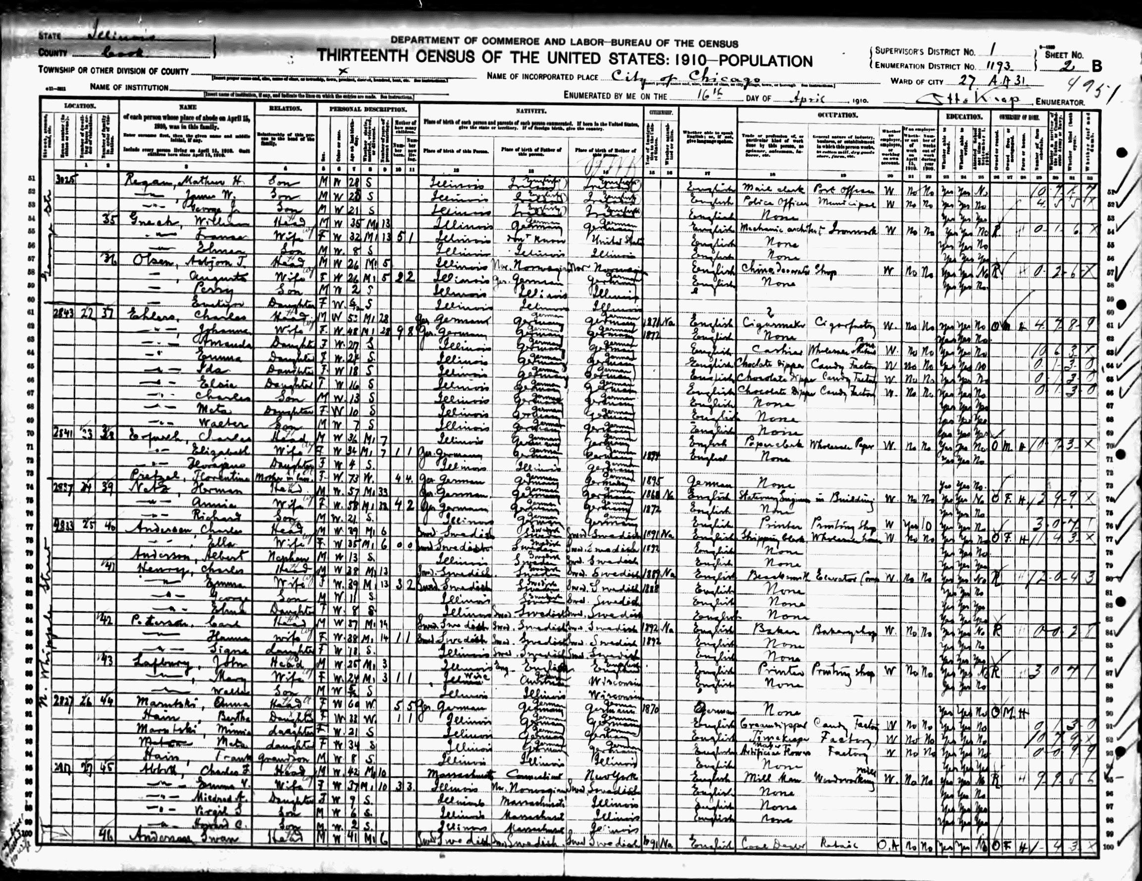
The term “Census” originates from early 17th century (denoting a poll tax): from Latin, applied to the registration of citizens and property in ancient Rome, usually for taxation and military purposes, from censere ‘assess’. The current sense dates from the mid-18th century. In the modern age, the Census is, above all, an official count of how many people and dwellings there are in a geographic area, for example in Nauru. It counts everyone present in the territory of the country on Census Night, including babies and visitors and provides a snapshot of the people of Nauru and the places they live.
Census Sheet from 1910, Chicago

Besides providing a simple headcount of the population, a modern population and housing Census is the process of collecting, compiling, analysing, and publishing demographic, socio-economic, and other data pertaining to all persons in a country and the national housing stock and characteristics at a specified time.

A Census is a form of national stocktaking. Since the Census is a complete count of the population and living quarters/dwelling unit, it provides detailed benchmark data on the size of the population, age structure, educational attainment, economic activity, disability, housing, and household amenities as well as other major socio-economic characteristics.

2.2 Why take a Census?
Most countries conduct Censuses every 10 years. Many changes in the social fabric of a country take place over a decade. These changes include fluctuating rates of population growth, changes in employment and unemployment, changes in the annual births and death, immigration and emigration, and internal migration.

All of these changes affect the demand for services including hospitals and health clinics, schools and classrooms, basketball courts and other recreational facilities, and infrastructure (including water, electricity, and transportation systems). Census data are useful both to public and private sectors, including government policy makers, private industry, the media, academia, researchers, labour organizations, small and large businesses, and the general public itself. Finally, Census results usually contribute to electoral districting that ensure a fair and proportional representation of the people in Nauru’s democratic processes.

2.3 How do we take the Census?
The Census generally means counting the country’s population as well as recording their characteristics as a snapshot in time. We must complete several distinct and inter-related operations before a picture of the population can be presented. With the proliferation of digital records of people and their condition in modern societies, the significance of the census is still paramount to establish a baseline, generated by physically visiting all the dwellings and their inhabitants, and directly asking questions from the population. Censuses are always carried out in-person.

2.4 Who provides Census information?
Ideally, the Census enumerates every individual in the household directly, but this is not always possible (some people may not be available in the data collection period, children can’t capably respond to questions that are designed to be understood by adults, etc. Therefore, responsible adults -- usually the head of household can act as a proxy -- to provide the information about other persons in that household, if these adults know the required answers.

2.5 Confidentiality
You must not reveal Census data to anyone who is not working with the Census Office. Never reveal any information about a particular person or household except to your Census Commissioner. The Statistics Act (No.10 of 1992) requires respondents to answer Census questions to the best of their knowledge, but it also protects their right to confidentiality. Under this Act/Law you can be severely penalized if you reveal any information about individuals, or their households or places of residence, to any unauthorized person. This legislation encourages the public to participate in the Census because they understand that their personal information will remain confidential.
All information furnished will be kept confidential. The Nauru National Statistics Office currently operates under the guidance of the Statistics Act. The relevant sections of this Act, relating to the confidentiality issues of the survey are:

12. Every person employed in the execution of any duty under this Ordinance shall, before entering on his duties, make and subscribe before a magistrate, or other person authorized by law to administer oaths, an oath or affirmation in the form set out in Schedule 2.

13. (1) Any person, being employed in the execution of any duty under this Ordinance, who-
(a) by virtue of such employment or duty becomes possessed of any information which might influence or affect the market value of any share, interest or other security, product or article, and who, before such information is made public, directly or indirectly uses it for personal gain; or
(b) without lawful authority publishes or communicates to any person otherwise than in the ordinary course of his employment any information acquired by him in the course of such employment; or
(c) knowingly compiles for issue any false statistics or information,
Shall be guilty of an offence and shall be liable to imprisonment for 2 years and to a fine of $800.

(2) Any person , being in possession of any information which to his knowledge has been disclosed in contravention of this Ordinance, who publishes or communicates such information to any person shall be guilty of an offence and shall be liable to imprisonment for 2 years and to a fine of $800.
(3) Any person who-
(a) hinders or obstructs an authorized officer in the lawful performance of any duties or in the lawful exercises of any powers imposed or conferred upon him under this Ordinance; or
(b) refuses or neglects-
(i) to complete and supply, within such time as may be specified in that behalf, the particulars required in any return, form or other document left with or sent to him; or
(ii) to answer any question or inquiries put to or made of him,
under this Ordinance; or
(c) knowingly or recklessly makes in any return, form or other document completed by him under this Ordinance, or in any answer to any question or inquiry put to or made of him under this Ordinance, any statement which is untrue in any material particular; or
(d) without lawful authority or excuse, destroys, defaces or mutilates any return, form or other document containing particulars collected under this Ordinance; or
(e) refuses without reasonable cause to grant access to records and documents in accordance with the provisions of section 9,
shall be guilty of an offence and shall be liable to imprisonment for 1 year and to a fine of $400.

Breaches of this contract can have significant impacts on the successful conduct of not only this survey but future surveys undertaken by the Government of the Nauru.

Breaches of the contract will also have an impact on the individual/s concerned in the sense that their pay can be docked and any other employment opportunities of this nature in the future will be lost.

2.6 How is people’s information kept confidential?
NBS are committed to protecting the confidentiality of the information being collected. The information provided is protected by the and the Nauru Statistics Act (No.10 of 1992)and must be always kept confidential and secure. When Census information is published, it must be in a way that cannot identify a person through their private details.

The only people who have access to personal identifiable information are those authorised. You are one of these people as you have signed a declaration of confidentiality. This means you cannot reveal to anyone else the personal information you have access to.

CHAPTER 3: ORGANISATIONAL AND ADMINISTRATIVE MATTERS
This chapter aims to familiarise the Supervisors with the calendar of major field activities and information concerning organizational and administrative matters.

3.1 Calendar of major field operation
The conduct of a Census involves several distinct but interrelated activities. Some of these activities cannot be undertaken unless related prior activities are accomplished. Moreover, all these activities are meant to be undertaken throughout the entire country simultaneously. They must be coordinated and synchronized in order that the goals of the 2021 PHC can be achieved. For this reason, it is imperative upon each person involved in Census taking to be aware of and to adhere strictly to the timetable of activities.

As Supervisor you will be deeply involved in all aspects of the operations. It is your responsibility to see to it that the timetable of operations in the 2021 Census of Population and Housing for your assigned area is followed in your areas of responsibility:

CENSUS CALENDAR
Supervisor Training 25-29th October (1 week)
Enumerator Training 18-22nd October (1 week)
EA Boundaries verification 18th October
Census Day Saturday 30th October (midnight)
Enumeration and supervision: [DATE] to [DATE]

You should work as hard as you can to complete your assignment during the Census Enumeration Period. You and your Enumerators will have to work outside the normal office hours during the enumeration. If you cannot finish on time, report the matter as soon as possible to the Census management team. But under no circumstance should you stop before completing enumeration in the whole Supervision Area. Working hours will have to remain flexible to adapt to the availability of the inhabitants of the Enumeration Area.

3.2 Line of supervision and flow of communication

The Nauru Bureau of Statistics (NBS) is the agency mandated to formulate and execute plans to undertake Censuses in Nauru including the 2021 PHC. The tasks involved in undertaking the Census are delegated to the Supervisor through a chain of command which is shown on the organisational schematic below:

From the above diagram, it is clear that – personally and through his/her team – the Census Commissioner exercises authority over all Supervisors in their respective areas of jurisdiction. The Supervisor’s are expected to work very closely with the representatives of the NBS. The Supervisor receives instructions and all communication directly from the NBS. If such instructions concern the Enumerators, it is the responsibility of the Supervisor to pass these on to all Enumerators under his/her supervision in the manner and at the time required by the NBS team.

Reports and other information intended for higher levels of authority must likewise follow the same channels. Thus, the Supervisor submits all his/her reports and sends his/her communication to NBS. The materials, data and any questions of Enumerators are to be channelled through the Supervisor to the national Census management team – Enumerators are not expected to communicate directly, at their own initiative, with the NBS.

Observance of this line of supervision and channels of communication is essential to ensure the smooth conduct of the Census as well as the efficient flow of information through all those involved in Census taking.

CHAPTER 4: TRAINING AND ENUMERATION AREA ASSIGNMENTS

Training of personnel to be involved in the actual collection of data is one of the crucial aspects in the nationwide Census activity. This chapter describes the type of training which the Supervisors and Enumerators will have to undergo. Included in this chapter is a discussion of the guidelines for the assignment of Enumeration Areas (EAs) to Enumerator’s)

4.1 Training of Census Field Supervisors
Training of personnel performing the Census data collection is one crucial activity in the nationwide Census effort. As Supervisor, you will be thoroughly trained for Census work at a designated site, with the Pacific Community (SPC) and NBS staff as your trainers.

How you perform on these trainings and how well you learn the protocols, procedures, methods and explanations to be used during the fieldwork implementation is crucial to the success of the Census operation. Besides developing perfect familiarity with enumeration procedures and the technology and other materials to be used during data collection (attending the same training as Enumerators receive), part of your training will be devoted to your Supervisory duties, where you will be briefed what is expected of you in this capacity.

You will be taught systematic procedures for checking on various aspects of the fieldwork performed by the Enumerators, verifying the accuracy of data they collect and assisting them in enumeration difficulties they may encounter. During this training, you will be briefed in detail about your organizational and administrative tasks, and you will learn how to prepare reports and other administrative forms as required by the national Census management team. You will also receive assistance and advise how to handle difficult situations which may arise, which the Enumerator alone may not be able to resolve.

4.2 Training of field staff
Note that supervisors will be trained two weeks before Census day, one week before Enumerator Training that you are also required to attend. You can supervise these Enumerators and help them conduct the Census well, only if you yourself understand very clearly what the Enumerators are being asked to do. This means that you have to read and master the Enumerator Manual before starting your supervisory work. It is only when you know the functions being performed by the Enumerators very well that you will be able to help them when they approach you with their problems.

Both Supervisor and Enumerator Training will cover a period of 5 days. The focus of the training will to provide Enumerators and Supervisors with background information on the Census; work organisation using the control listing; how to conduct the interview; and all aspects of the questionnaire and how to use CAPI technology used for interviewing such as the use of tablets and Survey Solutions software.

As Supervisor, you are expected to be attentive during the training, to actively participate in the discussions and to intelligently ask questions whenever any topic, concept, or instruction is vague or ambiguous to you and when you feel that further explanation is necessary. You must also encourage participation the Enumerators assigned to you and make sure they attend every session, participate in exercises and ask their questions openly.

4.3 Training curriculum

The training for Supervisor’s will cover the following areas:

1. Work Organisation and Supervision of Enumerators
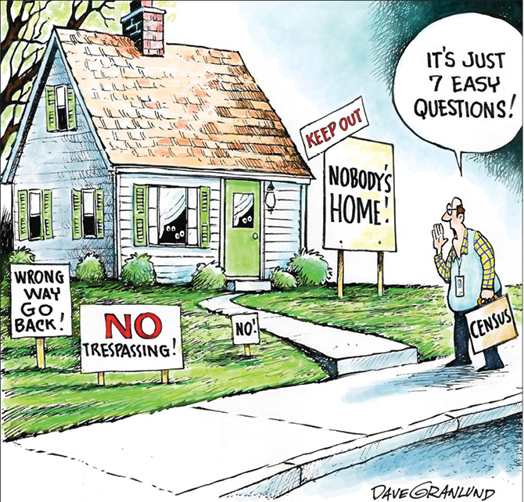
Supervisors will receive specialised training on organising and overseeing the work of the Enumerators assigned to them. You will be taught the standards and how to go about monitoring interviewing quality of Enumerators and subsequent quality checking of accomplished questionnaires. The training will also cover leadership and motivation of your team, together with details on how your team can achieve its work assignment and daily reporting requirements to management on work completed. Guidance will also be given on how to deal with difficult respondents and particular situations. Enumerators will spend one day of their training with Supervisor’s on administrative matters such as work contracts, photos for ID cards and other matters.

2. Background to the Census
You will be provided with information on why we have a Census, its purpose and who benefits from the data collected. Also covered are, the concepts and definitions for who is included in the Census and who is not (“population present”). Sessions this day will outline Enumerator responsibilities, confidentiality and conduct. Instruction will include interviewing techniques, use of CAPI and Mapping to finish off the day.

3. Census Questionnaire
Extensive instruction will be given on every question in the Population and Housing questionnaire using PowerPoint visual presentations and training manual. Each section of the questionnaire will be covered. Supervisors as well as Enumerator’s must be confident that they can collect the correct information on each of the questions, especially in the Education, Labour Force and Fertility sections which are relatively more complicated and adequate coding sometimes requires careful assessment. Training will include simulated or mock interviews with each other and a field presentation to give more confidence and practise for the work ahead of them.

4. Use of the Enumerator’s Manual
The Enumerators Manual will also a good resource. You should remind the Enumerators that during the actual enumeration, you may not always be at their side to resolve the problems that may encounter. You should encourage Enumerators to read their Enumerator’s manual attentively to find solutions to problems they encounter. But do not use the Manual as an excuse: if Enumerators need explanations, provide them with those and also refer to the Manual for their further reference.

4.4 Assigning work to Enumerators
NBS will assign each Enumerator to Enumeration Areas. The size of these EAs may vary from as little as 20 households through to 50 households in more densely inhabited locations. Accordingly, Enumerators may work independently taking full responsibility for the EA or work with several other Enumerators as a team under the direction of you, as their Supervisor. You are responsible for overseeing the work of your Enumerator’s. If some Enumerators have difficulty completing their work allocation on time or suffer from illness during the enumeration, you may have to reallocate some of their workload. That is your responsibility but you must keep the Census Commissioner informed if that is the case.

Discussed below are guidelines and pointers, upon which the allocation of work assignments to your Enumerators is based.

An Enumeration Area (EA) may range from 30 through 50 households. An EA may be an entire village, or small settlement. Localities with larger population or surface area are divided to several EAs, to be split between several Enumerators. The idea of an EA is that it is a delineated physical area large enough for one Enumerator or a small team of Enumerators to completely cover within the duration of Census.

Enumerators and Supervisors will be provided with a map of their designated EA(s) clearly showing the boundaries and possible structures (buildings) to enumerate and interview. Supervisors are expected to verify the EA boundaries where this seems necessary (boundaries may be ambiguous) and the structures within, jointly with the Enumerators, before Census Day.

Ideally, an Enumerator should have been assigned to the EA in which he/she lives or is familiar with. If this was not possible, he/she may have been assigned to another EA. The NBS attempts to assign all Enumerators as close as possible to their home to minimise travel and because of their familiarity with their area. In planning the assignment of Enumerators, the followings are taken into account:
population of the area, the dispersion of houses, the terrain, means of transportation, and proximity and accessibility of the EA to Enumerators. For instance, the number of interviews completed per day in a sparsely populated area where that Enumerator may have to walk long distances between houses would be lower than in a dense urban area.

The ideal ratio of Enumerator per Supervisor is based on the expected workload of Field Supervisor overseeing fieldwork activities, checking the completed questionnaires, facilitating contacting and converting refusals. In Nauru one Supervisor is assigned to four or five Enumerators, on average.
Take note that enumeration for the whole country is set to be completed in 20 calendar days starting on 1st of November. Thus, you should constantly monitor work assignments under your supervision so that all Enumerators can be expected to finish in more or less 15 days, and if you see this objective to be in jeopardy, escalate the problem to the NBS management team without delay, to jointly find an appropriate solution for the problem faced.

CHAPTER 5: FIELD SUPERVISION AND CONTROL

This chapter discusses the general instructions to the Supervisor on field supervision. The purpose and frequency of field observations, procedures for review of Enumerator’s) - work, and for ensuring high quality of data to be collected are discussed in detail in this chapter. Guidelines for Supervisors on how to handle enumeration and related problems are provided so that they will be better prepared to cope with common problems that they may encounter in the course of their work.

5.1 You as a leader
You must always try to command the confidence of the Enumerators who are working under you. Remember that you are their leader to whom they will turn whenever they come across any difficulties. If they have no confidence in your ability, they will always be reluctant to approach you with their problems. Your appointment as a Field Supervisor will be fulfilled if Enumerators find that you can indeed help them to solve their problems. Whenever you are in any doubt concerning any part of your assignment, you must consult the Census management team, they are in the position to help you overcome your difficulties.

You are leading a group of about less than 10 Enumerators into the field to conduct an operation which is of vital national importance. You must always try to kindly explain problems by giving good examples to your Enumerators. In particular, you have to maintain your approachability throughout the fieldwork, even with more difficult Enumerators. If you are too hard on them, that will discourage them to approach you with their problems. Remember, that some of the Enumerators may be of the same educational level as you and you all are part of the same team trying to achieve the same purpose, so do not give them any cause to be disaffected due to your leadership style or methods. Remember: if they fail, it means that you yourself have failed, but if they succeed you will share the honours of success equally with them.

5.2 Managing fieldwork
The best method of ensuring good output is to ensure good input. It means that statistics, which are the final product of this Census, are accurate only if the data that are collected from the field are of good quality. No matter how efficient the processing and handling of the collected information will be, the final statistics may be worthless if no adequate controls are instituted at the source to ensure that only accurate information are obtained and recorded correctly in the forms used for the data collection.

Close supervision of the Enumerators is a fundamental requirement that can assure of good quality Census data. In the 2021 PHC, the quality of the field enumeration shall be controlled at various levels, through the following procedures:

- As Supervisors, you shall observe the Enumerators as they conduct their enumeration, and review (accept/reject) of the submitted questionnaires digitally, in Survey Solutions (see Chapter 6;
- You shall regularly check on the performance and the conduct of the Enumerator, preferably on-location; and
- You shall report to NBS problems that you may encounter and unexpected event that may affect the Census operation.

To properly monitor the progress of enumeration and detect the potential problems of data collection early enough so that appropriate measures can be taken, the following Supervisor activities are prescribed:

5.2.1. Meetings between Supervisor and Enumerators
Before the start of the enumeration, you must call a meeting with your Enumerators to discuss strategies to facilitate enumeration of the assigned areas and, if applicable, to walk/drive the area to determine EA boundaries and verify if all structures are marked on the map/listing.

During the fieldwork, you are expected to meet one or two of your Enumerators every day. You will be entitled to request your Enumerators for a meeting at any day as you deem necessary, to check on the progress of their enumeration. These meetings provide an opportunity for Enumerators to share the difficulties they are facing and tell about any doubts they had with any aspect of their work. Also, during these meetings, the results of the observations/spot-checks conducted by you during the enumeration shall be discussed. Specifically, you are required to discuss and correct any errors committed by each of your Enumerators and must give them suggestions on how to improve the conduct of enumeration.

5.2.2. Verification of the Enumeration Area
Before starting any data collection – that is, before Census Day – Supervisors and Enumerators should jointly check their Enumeration Areas boundaries and localities within each EA. You should show them how to read their maps and how to find the boundaries of their EAs on the ground. You must accompany all the Enumerators during this checking of boundaries. Try to go in groups of two or three, so that neighbouring Enumerators know their common boundaries and agree on them.

If during the field check of the boundaries, you come across any discrepancies or errors, which you cannot resolve yourself, seek the advice of the Census management team. This boundary checking will reveal any short-comings of the EA maps, for example by revealing new houses/structures not shown on the EA Map. On the other hand, some of the localities or structures, which are on the Map, might be extinct at the time of the checking. You must ensure that this checking is carried out thoroughly. If necessary, more than one visit should be arranged. It is important to do all you can to ensure that Enumerators have a thorough knowledge of the location of boundaries as well as the areas in which they will be working, this is one of the key strategies to avoid double-counting resulting from overlapping enumeration by different Enumerators.

5.2.3. Verify the list of institutions prior to Census Day
A list of institutions e.g. boarding schools, hospitals prisons hotels etc. in each EA is prepared and will be handed out to Supervisors by the Census management team. It is possible that the list will not be complete or up to date. Go over the list with each Enumerator and make inquiries from people in these areas, to verify whether the list is complete and accurate at the time of the Census. If you established that the list is complete, discuss with each Enumerator arrangements for enumerating residents of each of these institutions and go over the instructions carefully with each of them. By DATE, you should have completed all arrangements for the complete coverage of persons living in group quarters. Enumeration of group quarters population including enumeration of persons in boarding schools, hotels, guest houses, hospital patients, etc. will take place before Census Night. Details of enumeration procedures for these persons are described in the Enumerator’s Manual.

5.2.4. Communicating effectively with Enumerator
As Supervisor, you should maintain contact with your Enumerators and monitor their progress every day of the enumeration. You should also maintain open communication with your Enumerators in order for you to supervise them effectively. Open communication involves listening to their problems and letting them know that you are willing and capable to handle their problems. As Supervisor, you should know how to resolve the most common problems of your Enumerators by having the Enumerator’s and Supervisor’s Manual as your reference.

5.2.5. Observing the conduct of enumeration
It is expected that you spend most of the time in the field observing the conduct of enumeration. This is to guarantee that the procedures for canvassing, mapping, listing and interviewing are being followed correctly. When observing an Enumerator do an interview, you should never interfere with the interview while it is being conducted. You should simply note down your observations and comments while the interview is in progress.

You need to check or observe the following:

- Has Enumerator correctly located the house from the map?
- Properly ascertained the number of households within the dwelling?
- Given proper introduction and explain the Census?
- Tried to interview each member individually and where this was not possible, did they interview a responsible adult member of the household?
- Ascertain if each enumerated person is eligible under Census definition?
- Ask questions as worded or correctly interpret wording if was requested to reframe/explain question?
- Correctly filled out questionnaire on the tablet using (Survey Solutions)
- Check/review questionnaire after interview?
- Close interview properly and thank respondent?

During the first two days of enumeration, you should spend about half a day with each Enumerator to observe how he/she conducts an interview. This is to check early on if the Enumerators are doing their task properly and to ensure that the errors are corrected early enough. You should immediately inform the Enumerator of his/her errors and suggest improvements for the next interviews.

5.2.6. Correcting errors as early as possible
Early detection of errors will lead to early correction of such errors. Errors are best corrected on the spot and early enough so that occurrence of similar errors with other households can be avoided. As Supervisor, you should be aware of some of the common problems of enumeration so that you can anticipate the kind of errors to be expected and be ready to deal with them. These common problems include:
- failure to include babies born on or before midnight of Census Day as members of the household (unless they spent the night in a hospital, so they are enumerated there);
- inaccurate coverage of households located near EA boundaries
- omission of household residing in isolated parts of the EA
- omission of households not listed / marked on the EA map
- omission of households / individuals who live in irregular living arrangements (boats, shanties, RVs, or non-residential buildings, including also homeless persons, if applicable in the country or enumeration area.
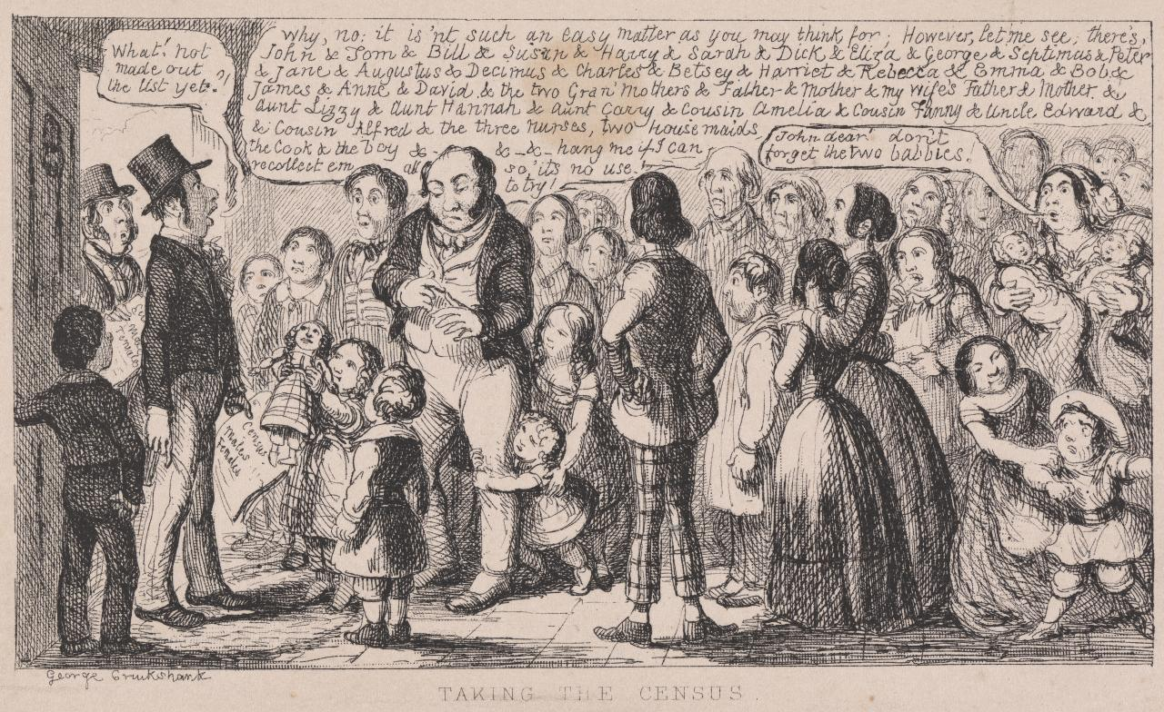
The Supervisors should explain these potential mistakes during the kick-off meeting already, and call the attention of those concerned if such errors are detected later. In these cases, Enumerators should go back and enumerate missed households or individuals.

5.2.7. Conducting spot checks and re-interviews
One of the main tasks of the Supervisor is to see to it that the Enumerators are at work and that they are doing the work themselves (“subcontracting” Census enumeration work is strictly prohibited and will lead to immediate termination). Moreover, you must see to it that the listing and enumeration of households in an EA are done systematically to ensure complete coverage of that EA. One way to check that an Enumerator is doing his/her job correctly and up to the standards required by the Census is to conduct spot-checks and review what he/she has accomplished. In spot-checking, you should check, among others, the following:

- That no dwelling has been missed by the Enumerator;
- That no household within the enumerated dwellings has been missed by the Enumerator;
- That in cases of reported refusals, these should have been revisited by the Enumerator.
- That all questionnaires should be complete and accurate, and cover all individuals in each household, who were present at Census Night.

5.3 Handling enumeration and other field problems
As Supervisor, you are expected to provide advice and help in resolving problems related to Census enumeration. Experience has shown that a solution to a specific problem may be feasible in one area but may not be so in another. The solutions given below are only suggestive. Nevertheless, you should exercise your best judgment in coming up with ways to overcome problems in the field. As always, if in doubt, please contact your contact person in the Census management team at the NBS. Remember, the standard application of protocols is the key to a quality data collection, so you must be absolutely certain that your actions and recommendations are in line with the protocols laid out in any of the Manuals, and if that is unclear, the best is to ask advice from your own supervisors.

5.3.1. Refusals
The first rule and primary objective of the Census is to enumerate all persons who spent Census Night 30th October in Nauru. Much will depend on how the people co-operate with the Enumerators.
Every effort has been made to ensure that everybody understands the nature of the Census and it is hoped that by the time Enumerators start enumeration, most people would have heard about the Census. In spite of the publicity campaign, an Enumerator may occasionally encounter a respondent who refuses to give the required information, or who refuses to be interviewed at all. Whether or not a respondent is willing to cooperate in the Census depends very much on the initial impression that the Enumerator makes on the respondent. The Enumerator should introduce himself/herself properly to the respondent, explain the purpose of the visit and assure the respondent of the confidentiality of the information that the respondent is going to provide. Still, even with the best Enumerators, there are likely to be a few difficult cases. It will be your duty to try and solve these difficulties. The main difficulty arises when persons refuse to be enumerated by Enumerators. They may give many reasons and excuses with the result that they will not give the Enumerators the information that is required. Or, what is even worse, people might give evidently wrong responses.

Enumerators are instructed to explain to such persons the beneficial nature of the Census and also to seek help from neighbouring houses to maybe convince the resisting person through their own example that they participated the Census. If this also fails, it will become your duty to do everything you can to ensure that the difficulties are overcome. Even if the process can tolerate some level of non-response in some of the questionnaires a household and its members have to fill in, we cannot totally miss any household or person from the Census. This means that all these difficult cases must be resolved somehow.

As Supervisor, you will have to investigate these cases in person and do everything within your power to persuade such persons, to cooperate and be interviewed. In some instances where the respondents stubbornly refuse to respond to the designated Enumerator and even the Supervisor, as a fall-back, information may be obtained from neighbours or friends about this non-responding household. The names and addresses of such cases should be specifically reported to the NBS. Cases like these are expected to be rare, most people acknowledge the benefit of the Census and will find the time to respond, even if not immediately.

5.3.2. Call-backs
A call-back means an actual revisit to the household with a view of contacting a respondent who was not at home or was not available at the time of listing or to continue a disrupted or incomplete interview.

Making call-backs is time consuming and one would have to fit them into his/her regular schedule for the day. As Supervisor, you should advise the Enumerator to plan his/her call-backs efficiently so that his/her schedule will not be disrupted. It is more advisable to make call-backs on the time when most people are most likely to be home (for example evenings, or maybe on the weekend). Enumerators are instructed that whenever they visit a house and do not meet anybody, they must leave a Call-Back Card on which is stated the time they will call again and a telephone number how they can be reached. They have been asked to make at least X call-backs. If on the Xth visit no enumeration takes place they must make a note of the dwelling and report it to you.

Whenever you call on an Enumerator, obtain from him all the houses which he has not been able to enumerate (because of refusals or unavailability of respondents) after making the X visits. Try to help by contacting neighbouring houses to find out whether people are staying in the house and if they are, obtain some indication about their movements. Pass every piece of information, which you obtain to the Enumerator, and give him specific instructions as to how she/he should conduct a next visit. Never allow the Enumerator to “write-off” some houses simply because he did not meet anybody to interview on any of the X visits he/she made.

Last resort information (i.e. asking neighbours or acquaintances about a household that is impossible to contact) must be obtained after X call-backs have been made and still the Enumerator fails to interview a target household and there is no hope that the enumeration could still take place in the designated enumeration period.

While it is recommended that the Individual Census form is filled with each respective person directly, it may be that some household members are never available during the enumeration period, in these cases, other responsible adults may be interviewed to provide information not just for minors, but also for absent members.

5.3.3. Other Field Problems.
There may be some problems during the field enumeration that require the personal attention or intervention of higher Census authorities. In these cases, the Supervisor should refer these problems to the Census management team / Census Commissioner. The Census Commissioner may attend to the matter himself, or request his staff to do so.

5.3.4. Report of calamity, disaster or abnormal conditions
The NBS should be informed by telephone, radio or through any fast means available, of any calamity, catastrophe, or abnormal situations or conditions prevailing in the enumeration area that might delay, or might not make possible the enumeration of affected areas within the enumeration period. If the enumeration cannot be undertaken because of such conditions, the estimated population of the areas affected should be included in the wire of the Supervisor to the NBS.

5.3.5. Report of accidents
Likewise, the NBS should be informed by phone of accidents befalling any of the Supervisor and Enumerators while undertaking Census work. The wire should be followed by a written report giving full details of such accidents, for record purposes.

5.3.6. Report of loss or damage to Census equipment, documents or materials
Loss of or damage to Census materials such as IDs, tablets (including failure and malfunction), household listings should be reported immediately to the NBS for immediate action/decision.

5.3.7. Public relations
You will be asking the members of the household to provide you with personal information. They are not familiar with the questionnaires or the procedures of this survey, and for these reasons many people can be expected to be rather nervous or even angry. It is your job to adopt a friendly and helpful approach on all occasions so as to reduce tension to a minimum.

Do not hurry the interview, especially at the beginning. Instead take some time to exchange greetings and then explain what the interview is about. Answer as best as you can any questions you may be asked. Do not talk about controversial matters or other people in the survey.

If you think any statement is incorrect, do not write it down at once but also do not say it is wrong. The best way to deal with such a case is to discuss it further until it becomes obvious that the original statement was wrong.
Remember, when leaving the household, thank the household head and any other members of the household for their cooperation and assistance.

5.4 Resolving problems with Enumerators

The Census management team will have a number of reserve Enumerators. If during the enumeration period any of your Enumerators falls sick or becomes unavailable for any other reason, you should contact the Census team and ask for immediate replacement.

Every effort has been made to ensure that only Enumerators, who are efficient, committed and thoroughly trained, are engaged to conduct the enumeration. You must keep a close watch on the work of all Enumerators during the training period as well as during the Census period. Go through all the completed questionnaires and their contact/visitation records. If you detect any sign of inefficiency and you feel that an Enumerator is not working satisfactorily, report it to your contact person at the Census management team immediately.

If any Enumerator is caught cheating or otherwise gravely breaking the Census protocol, the person must be immediately reported to the Census management team and removed from the fieldwork without further delay.

Finally, it will be your duty to collect all Census materials, including tablets, IDs and any other relevant materials from the Enumerator who is being replaced, if that becomes necessary.

CHAPTER 6: SUPERVISOR ROLE TECHNICAL OPERATIONS

The days of Census Enumerators using large sheets of papers to enumerate the population are over. The 2021 PHC in Nauru is taking place using tablets, utilising modern technology. This greatly benefits of data quality, with the built-in controls that are impossible with a pen-and-paper application, but comes with certain challenges that you as a Supervisor will have to be able to cope with. This Chapter explains the basics of how this technology works, but there is detailed documentation available at: https://docs.mysurvey.solutions/supervisor/ for those who are more interested and want to learn more. The ways you will need to interact with the Survey Solutions system will also be explained during your training.

The tablets used for the Census will be equipped with questionnaire in a system called Survey Solutions. It provides not just the interface between the Enumerator and the respondent to provide the questions and record data, but also a direct channel of the data to be collected centrally at the Census management team (Headquarter) and allowing a detailed insight, communication and verification mechanism at the Supervisor level, too. In other words, there are three components (levels) of processes involved in the use of tablets (CAPI) for data collection. They are:

- Interviewer application
- Supervisor Interface
- Headquarters

During your training, you will familiarise with the Survey Solution Interviewer application (so that you can help your Enumerators in case of any problems) as well as the Supervisor interface and your related tasks.

The following diagram shows how the Survey Solutions-based Census data collection system is built centrally, and deployed to the Enumerators tablets who will collect data. Supervisors manage data collection by:

- Assigning structures/dwellings to Enumerators
- Monitor the completion/fieldwork progress and make any corrections on the dwelling list as necessary based on the result of EA canvassing and assign any new units to the respective Enumerator
- Read and appropriately address any in-questionnaire comments by the Enumerators
- Approve/reject questionnaires

The flow of the information is opposite: the Enumerator or interviewer captures information from the households. You, the Supervisor will receive submitted completed questionnaires from each household. You will then check the submitted questionnaire, review its completeness, if there are any questions or remarks by the Enumerator that needs addressing, and you will approve or reject the questionnaire depending on if the questionnaire has been fully completed or has had errors. Any rejection by you, the Supervisor, will automatically go back to the Enumerator for rechecking and correction.
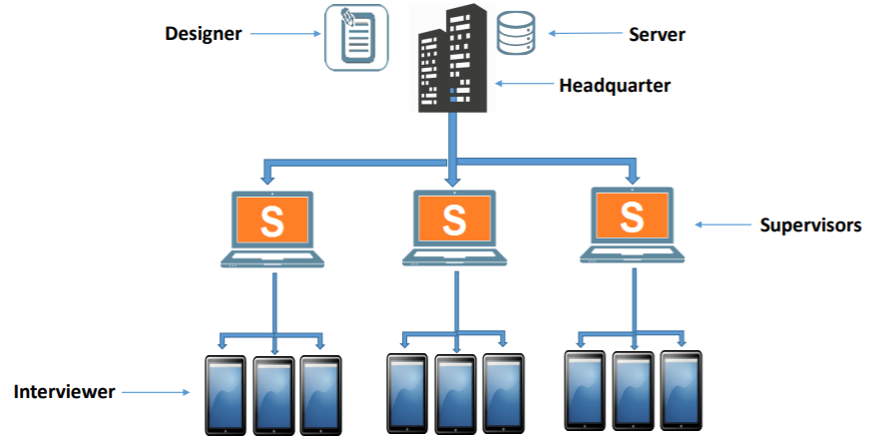

Supervisors will be the “first responders” to address Enumerators’ inquiries regarding any software or hardware issues that arise during the fieldwork. Besides assisting with such problems, your main task as a Supervisor will be to use the Survey Solution Supervisor interface to monitor the quality of your Enumerators work. The system will aid your activities by highlighting problematic parts of the questionnaires, that you certainly need to check, for example:
- Data errors
- Unanswered questions
- Any inconsistencies, where two answers are unlikely to be true simultaneously

Besides reviewing these flagged issues, you are expected to check and verify each completed questionnaire, especially with regard to more difficult and error-prone parts, such as for example the Labour Force module (responses and codes regarding occupation and industry).

Using your Supervisor access, you will be able to monitor progress of data collection by:

- Generating automatic progress reports
- Reviewing synchronisation logs, to ascertain that your Enumerators are connecting to the system every day and are uploading newly collected data as they are supposed to
- Use reporting tools to monitor data collection and identify problems immediately as they arise

For any questionnaire to be submitted in the central Census database, you will have to approve it first. You may reject any questionnaire if the questionnaire hasn’t been fully completed or has errors or inconsistencies that the Enumerator can’t adequately explain. Any rejection will go back to the Enumerator for rechecking and correction. These corrections may involve revisiting certain households and respondents.

When you approve a questionnaire, it is then transferred to the Census management team, where the Headquarter level controls are. They will conduct a final check on the submitted questionnaire and they will either approve or reject based on the outcome of their own check. Any rejection will come back to you, the Supervisor. You will have to try and rectify the errors (problem) identified (typically in consultation with the Enumerator who did the interview), or provide further explanations why certain suspicious data are indeed correct. Then this follows the same process as explained in the previous paragraph.

Let’s see how to operate this interface.

6.1 Supervisor Login to Survey Solutions

At first it may look a bit complicated, but soon it will become your routine; the below paragraphs describe the steps how you can log in and access your Supervisor interface on Survey Solutions. This is necessary to monitor the work of your Enumerators, your work will include interacting with this interface on a daily basis.

In order to log in, you will need a computer with reliable internet connection (a smartphone will also work, but handling the interface on such a small screen and without a mouse and proper keyboard will be extremely complicated and the screens will look differently). Use a laptop or a desktop computer, with any operating system (PC, Windows, Linux) – the app is browser-based.
The Census management team will provide you with a URL and a username and password to log in to the Survey Solution Server application. These credentials will give you Supervisor-level access to the system. You will see a screen like this, where you will have to enter your credentials and click log in.

Interviews tab
The Interviews tab is designed for taking action. Under the Interviews tab, users may search for survey cases, reallocate them to different Enumerators, review them for quality assurance, and even delete them if necessary. You can intuitively navigate to the Interviews tab by clicking on the ‘Interviews’ Tab at the top of the screen.

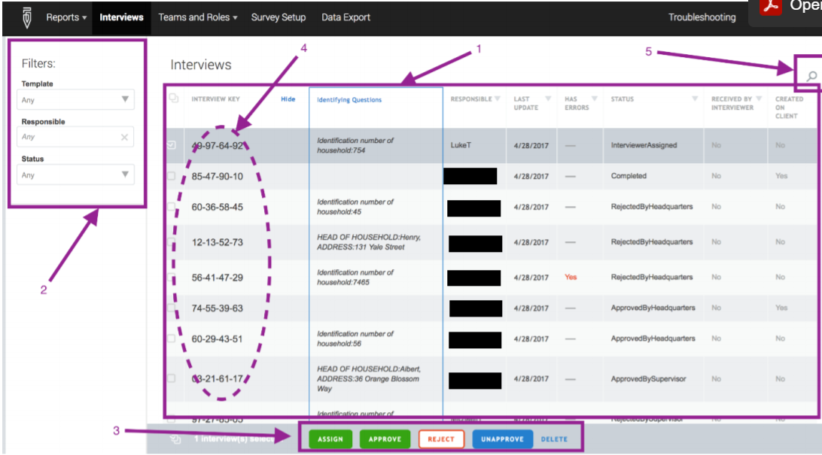

The Interviews tab consists of the following tools, using the numeric references on the image above:

1. List of Census records (households) with their identifying questions. The rows are Census records from the interview –The columns capture details about the units, such as the address of the dwelling, interview status, and an indicator that any Enumerator has or has not received the case.
2. Filters for querying the database. The database can be filtered using the left tab, to show only the cases of interest—for example, those with a particular status (i.e. “rejected”) or those done by a particular Enumerator.
3. Toolbar with a Delete, Approve, and Reject button. Cases can be deleted, approved, or rejected individually or as a group by selecting the check box next to each case. The toolbar will appear if one or more cases have been selected. If you would like to select all the cases displayed on that page, click on the first check box at the top of the list.
4. Interview Key. This is a system generated random number for each case. Completed cases can be reviewed in detail by clicking on the interview key for that case. This will open another interface that will be discussed below.
5. Search bar to navigate through the cases quickly

The middle section of the Interviews tab will show all the questionnaires from your team members and some summary data:
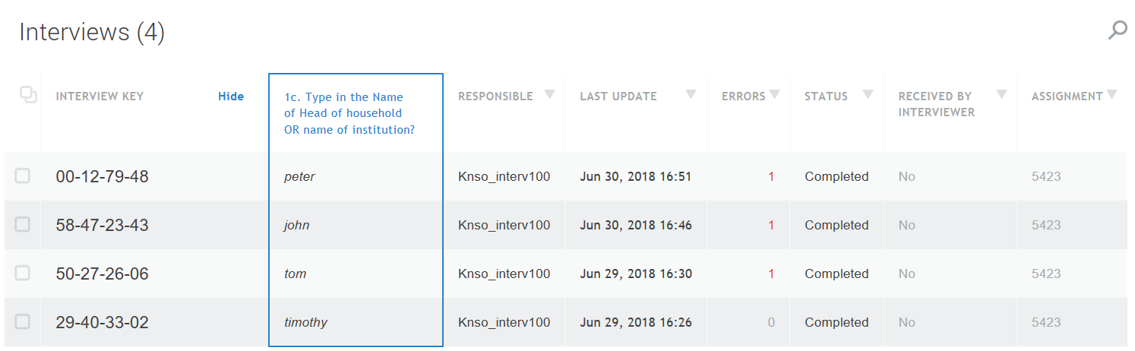

To open an interview for checking, right-click on the ‘Interview Key’ number of the interview.
Then select ‘open’. One the interview is opened, check the left tab for answered, not answered and invalid questions.

Click on the left screen or the question in red (invalid) to pull up the actual problem. Note the ‘Error’ column showing that there is one error in the first questionnaire on the list, which is shown open here below:

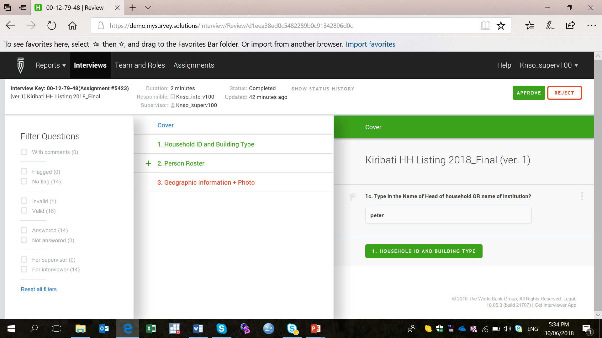

By clicking the questionnaire elements highlighted in red, you can navigate to the error that is flagged by the system and you can review the problem as well as the comment the Enumerator hopefully added to explain the reason for the error (which is flagged in his/her system, too).

6.2 How to review approve/reject a questionnaire

Supervisors will have to do a thorough check on the completed questionnaires for inconsistencies, even though most of the validation checks are in-built in the questionnaires. After a few numbers of questionnaires have been checked from each Enumerator, the Supervisor will be able to gauge which Enumerators are very efficient which they may do a random spot-check on these efficient ones and concentrate more thorough monitoring of the more problematic ones.

After reviewing all the sections (primarily those in red, but also the rest), the Supervisor may approve or reject an interview based on the quality of the information therein. This can be done either at the bottom of an opened interview (see image above) or via right-clicking the Interview Key in the first column of the list view, and selecting the appropriate status, as shown below:

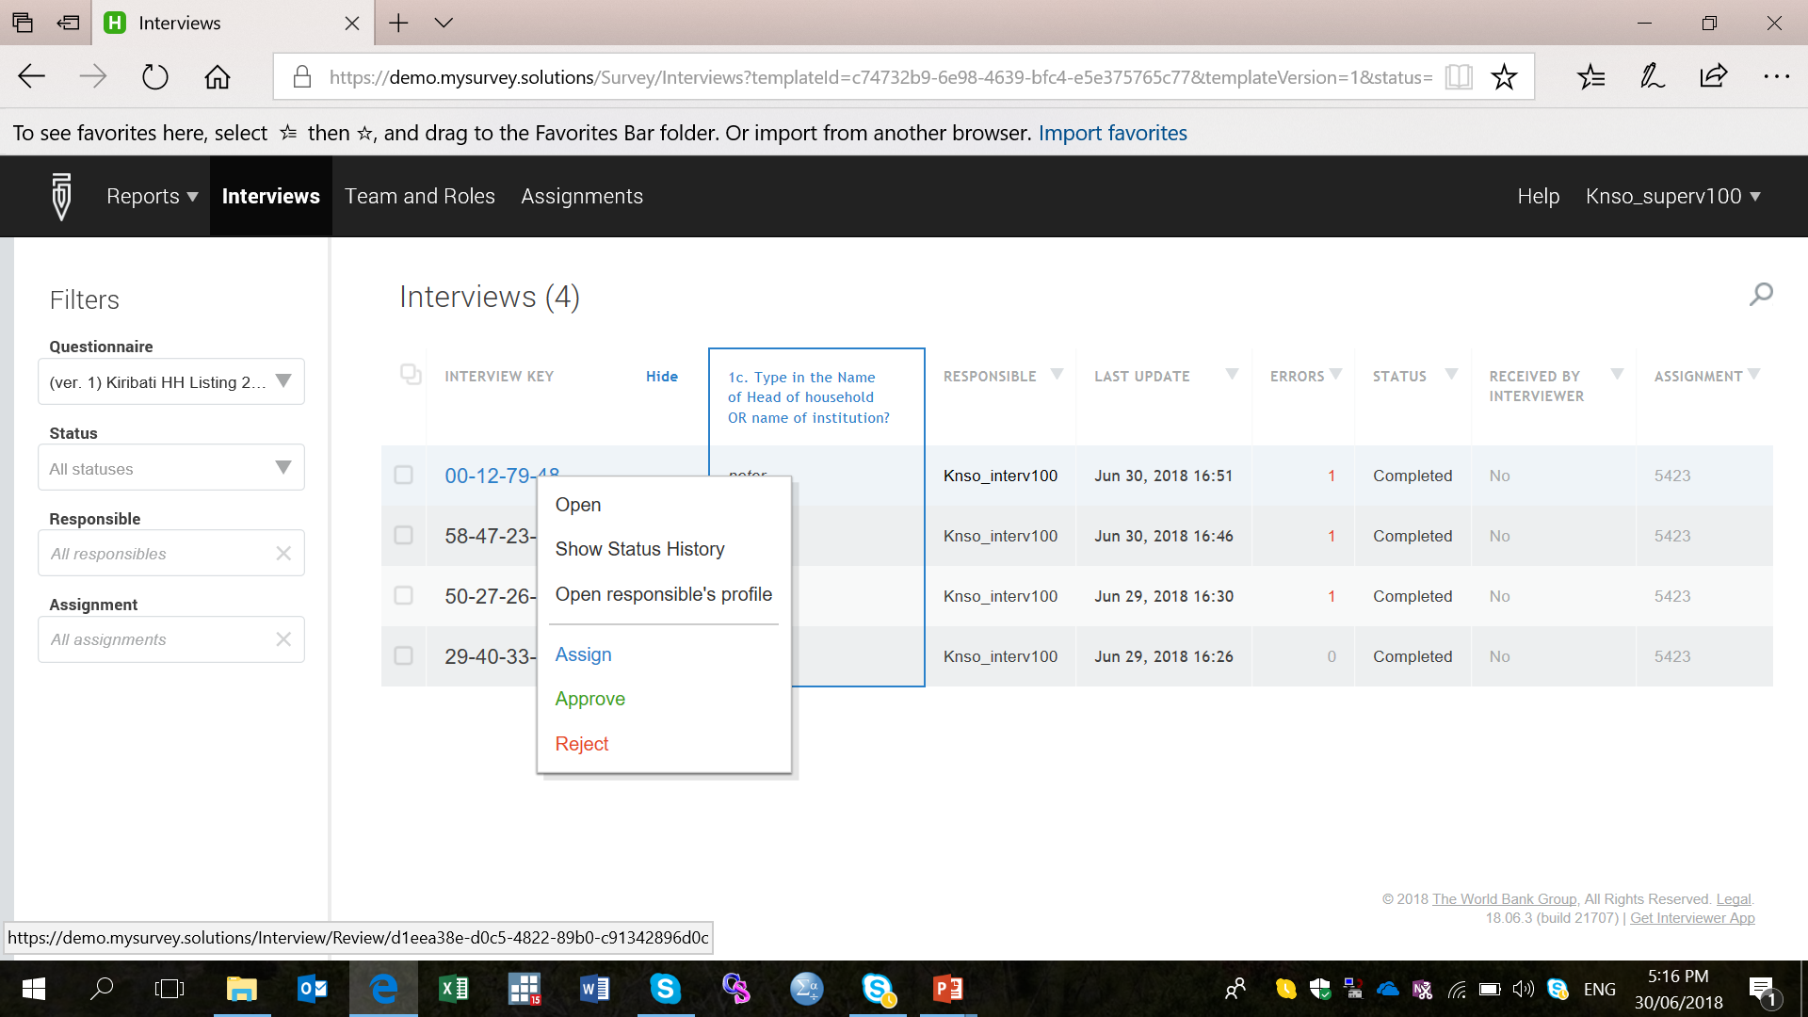

By approving, you declare that you reviewed the entire questionnaire, verified all entries and you found the entire questionnaire error-free, and ready to be submitted to the central Census database. Rejecting means there are still errors that need to be addressed by the Enumerator. Such interviews will bounce back to the Enumerator’s tablet, with the status “rejected”.

When rejecting interviews, Supervisor are requested state the reason(s) why the interview is rejected to the Enumerator in a way that helps the Enumerator to understand the problem and make the necessary adjustments in the data. In these comments you may also suggest how you expect the correction to be made, by revisiting the household, or any other way. Remember, you will be able to navigate to the problematic question by clicking the red in the interview view, and select Add comment to enter a “message” to the Enumerator.
To save time, cost and energy, Supervisors will need to be up to date in the monitoring and checking so that the Enumerators could do validation work during a rejection, while they are still close to the respective household. Any delays by the Supervisor will cause more work for the Enumerators as they will have to return to a household to verify information if there is a problem with any of the data recorded leading to you rejecting the interview.
The section of the Survey Solution manual that describes how to review interviews can be accessed at: https://docs.mysurvey.solutions/supervisor/review-an-interview/

6.3 How to check status and overall progress of data collection during fieldwork

Viewing Overall Status and Progress of Census during Fieldwork on the Surveys and Statuses screen. You get here by clicking the Reports link in the top black horizontal bar.

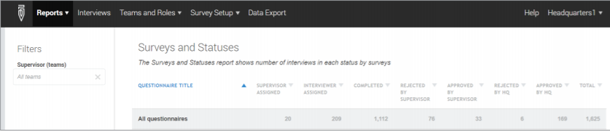

Survey Statuses After a case is completed by the interviewer, it needs to be approved by the Supervisor as well as by a Headquarters user to be considered to have passed the full quality control regime. By the end of fieldwork, all cases should have passed quality control. The default report “Surveys and Statuses” gives you an overview of how many interview cases are at each stage of completion and the quality control process, as shown in the figure above.

Supervisor Assigned. When using a sample with preloaded variables, this shows the cases assigned to the Supervisor and ready to be distributed to interviewers. If the sample has no preloaded variables, this column will always read “0”.

Interviewer Assigned. When using a sample with preloaded variables, this shows the number of cases sent to Enumerators’ tablets and awaiting completion. If the sample has no preloaded variables, this column will always read “0”.

Completed. An interview case is deemed to be completed after it has been finalized on the Enumerator tablet and synced (that is, synchronised). The completed status is also shown if an interview case has been rejected by the Supervisor, amended, and resynced. Any cases in this column are theoretically in the “to do” pile for Supervisors to check.

Rejected by Supervisor. This status arises when a Supervisor has checked an interview and found an issue or issues that warrant rejection. The next time the relevant Enumerator synchronises their tablet, the rejected case will be returned to him or her, along with comments from the Supervisor regarding corrections to be made. Cases in this column are in the “to do” pile for Enumerators.

Approved by Headquarters. These are the cases that Headquarters quality control staff have checked and found no problems with. These cases can be considered to have passed quality control and are final entries in the Census Dataset.

Enumerators are always reminded to synchronize completed questionnaires as and when they are completed, except for cases where there is poor or no internet connections. This is to ensure security of the data they do not lose the information.

6.4 Supervisor’s role: Monitoring of interviews
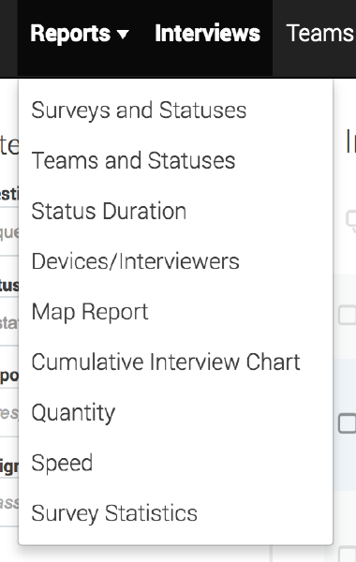
Supervisors’ tasks involve monitoring the activities of their team of Enumerators. You will monitor the progress and performance of each Enumerator including the number of households completed, how long it takes to complete each household, number of errors submitted / unanswered questions. The Supervisor screen has a Report Menu which the Supervisors could use to monitor the progress of each Enumerator in terms of number completed, number rejected, and number approved, the quantity completed for a particular day and the speed of completion of a questionnaire.

If you click the Reports tab in the upper horizontal bar, the second item in the dropdown menu where you will find links to the screens that provide an overview of your team’s performance. The Team and Statuses report provides a status report for each Enumerator.

The Status Duration report carefully flags lack of progress. While other reports count interview cases, this report includes both assignments and interview cases. By seeing how many days interviews stay in the same status, survey managers can see whether survey operations are moving forward, and identify any bottlenecks. By clicking on any cell in the report, managers can drill down to the details of which assignments/interviewers and/or field staff are behind interviews stagnating in the same status. Enumerators should minimize having a lot of ‘Started’ questionnaires (questionnaires that are still incomplete) in their tablets as this sometimes becomes tedious and confusing when there is a lot of rejections involved. Recommended that having at most 3-5 started interview is manageable. Again, those areas with poor or no internet will have more completed and started questionnaire opened due to inability to synchronize.

The Devices/Interviewers report compiles potential problems that can occur during data collection, such as never been able to synchronize with the server (Never Connected), using an outdated version of questionnaire (Old Version), etc. This information can make troubleshooting easier for survey managers. By clicking on any cell in the report, you can find the associated Enumerator names/accounts. Enumerators will need internet access to log in to the tablets and receive assignments and during the synchronization of completed questionnaires. Once they are logged in, they can continue conducting interviews even without internet access. Supervisors need to ensure all Enumerators have logged in – these will be shown in the Supervisor screen on which Enumerator has logged in and those that have not.

The Map Report shows the geographic location of all completed questionnaires on Google Maps. To use this report:

- Select Map Report from the Reports menu. This will open the interface for creating this type of report
- Select the questionnaire you want to map from the Questionnaire drop-down menu.
- Select the geo-location variable from the questionnaire that you wish to plot on the map. This will plot completed questionnaires on a map, showing their geographical location and providing some sense of where survey teams have and have not reached.

The Quantity report tab provides the following reports for each questionnaire template:

- Number of completed interviews: Provides the number of completed interviews for each data collection team. Interviews that have been rejected and then completed are counted as an additional completed interview.
- Number of interview transactions by HQ: Provides the number of headquarters approvals and rejections for each data collection team.
- Number of interviews approved by HQ: Provides the number of headquarters approved interviews for each data collection team.
- Number of interview transactions by supervisor: Provides the number of supervisor approvals and rejections on interviews collected by each data collection team.

The Speed report tab provides the following reports for each questionnaire template:
- Average interview duration: Provides the average time difference between the first recorded answer on a tablet and when the complete button is selected.
- Average HQ processing time: Provides the average time difference between a supervisor approval of a questionnaire and a HQ approval or rejection of that questionnaire.
- Average case assignment duration: Provides the average time difference between survey case assignment to an interviewer and the moment an interviewer sets the survey case as complete on a tablet.
- Average overall case processing time: Provides the average time difference between survey case assignment and survey case approval by HQ.

To generate Quantity and Speed reports, first select the appropriate tab from the Reports dropdown menu. Then, select the Type of report and the questionnaire you are monitoring. Select a start date for the report (From). Next, define the time interval– day, week, or month (Period), and the number of time intervals that you would like to display in the report (Period count). The maximum period count that can be defined is 9.

Quantity and Speed reports by default provide the tabulations at the Enumerator and Supervisor level.

